DRAFT Crosscutting Technical Position Paper No. 2
DEER Improvements Subcommittee
Proposal Overview
Throughout California’s long history as the standard bearer of energy efficiency (EE), the EE industry has relied on its ex ante framework to provide essential savings estimates and other parameters for portfolio planning. However, this ex ante framework in its current form no longer accomplishes the California Public Utilities Commission’s longstanding policy goals: The value development process is not collaborative; the repository of values is not transparent and associated documentation is not easily accessible to the public; the whole framework does not “balance the need for accurate ex ante values with the equally important need to continuously augment the portfolios with new technologies that offer promise.” Furthermore, public utilities, one-third of the electric load in the state, do not use the same energy savings values as the IOUs, which can only erode confidence that the savings values are rigorously developed and accurate.
The California Technical Forum (Cal TF) is proposing that the current framework be replaced with a single statewide web-based (hereafter referred to as electronic) Technical Reference Manual (TRM) that is populated and updated annually via a transparent and collaborative process with final approval from the Commission. The electronic TRM would leverage open source energy modeling tools (EnergyPlus), and an open source energy analysis and tracking tool suite (OpenStudio) platform developed and/or supported by the United States Department of Energy (US DOE). Cal TF staff is confident that the transition to the new electronic TRM can be successfully accomplished within two years. This process would prioritize creating workpapers for DEER measures, reviewing POU-developed measures, and consolidating the many measures that overlap, yet have different measure parameters and/or support.
Clear, consistent guidelines for measure development will be finalized and used to ensure that all measures meet the same consistent standards for documentation, transparency, and support by “best available information.” All stakeholders, including regulatory staff, will work together to build consensus for technical values, but the final TRM will be adopted by Commission decision for IOUs. POUs independently select what measure values to use; however, it is expected that POUs will willingly use the electronic TRM given their ongoing involvement in Cal TF, and the expected transparency, rigor, and ease-of-use of the electronic TRM. The electronic TRM will be developed through the collaborative, transparent process that has been developed through Cal TF. Updates will be made on a regular basis according to a documented process and timeline that is consistent and integrated into the framework of the new Rolling Portfolio paradigm.
The Cal TF proposal is laid out in this documents as follows:
- Subcommittee Process and Support describes the broad-based collaborative work that led to the current proposal and the rigorous analyses that support the subcommittee’s conclusions.
- Detailed Comparison of Status Quo and Electronic TRM Proposal evaluates both scenarios (status quo and alternative) at the structural level according to the state and industry’s:
  - Policy Objectives
  - Process and Operational Objectives
  - Technical Objectives
- Proposed Implementation Plan describes in detail how the electronic TRM proposal can be fully implemented in two years. This section also clearly delineates the roles and responsibilities of the various parties involved.
I. Subcommittee Process and Support
The Cal TF DEER Improvements subcommittee was formed in part as a response to Administrative Law Judge Edmister’s February 2015 questions to Rolling Portfolio Rulemaking stakeholders about the long-term value of continuing to maintain DEER; however, the creation of the subcommittee was also informed by the difficulties encountered by another Cal TF subcommittee as it attempted to analyze and document the underlying assumptions and data behind several DEER measures. The DEER Improvements subcommittee met regularly through the second two quarters of 2015 and held one all-day in person charrette that included several Cal TF members and other stakeholders in addition to the regular subcommittee members. The subcommittee’s work was also shared with the Cal TF Policy Advisory Committee and the group’s feedback and support was documented.
The subcommittee’s recommendations are largely informed by Cal TF staff’s thorough best practices analysis of over 20 Technical Reference Manuals currently in use across the nation. This research found that successful jurisdictions use clear, written technical guidelines, consolidated repositories, and effective processes concurrently to address complex technical questions and create effective ex ante frameworks. Therefore, all content, structure, and process components of the Cal TF’s electronic TRM proposal reflect best practices that have already led to success in other states. Key best practices that were repeatedly found in successful jurisdictions and were incorporated into this proposal include clear, easily accessible measure narratives directly linked to all parameters and sources, measure review through a public collaborative that includes regulatory staff, Commission approval of final values, and the recent popularity of web-based TRM platforms.
II. Detailed Comparison of Status Quo and Electronic TRM Proposal
The subcommittee developed criteria with which to evaluate and compare the status quo and the electronic TRM. The resulting analysis, laid out in the following tables, led the subcommittee to conclude that a) the current DEER-centric approach to developing and maintaining deemed values is irreparably broken, and b) California should develop, then adopt for statewide use, a statewide electronic TRM, supported by a public, collaborative process, consistent with best practices across the nation.
Table 1. Evaluation of Status Quo and Cal TF Proposal According to Policy Objectives
Evaluation Criteria |  |  | Status Quo | Electronic TRM Proposal
Policy Objectives |  | Publically available workpapers | DEER measures don’t have workpapers – documentation for DEER measures, if it exists, is very difficult to identify; IOU non-DEER workpapers (WP) are not public but retained and maintained by the sponsoring IOU. | Single publically available TRM with standard format for each measure, including narrative description, and embedded data sources.
 |  | Publically documented assumptions used to develop values | DEER contains extensive modeled values using DOE 2.2 – algorithms and default values used to generate values are not available. | EnergyPlus will be used to model values, where applicable. All algoritms for EnergyPlus are publically available for audit, as are all input assumptions.
 | State | SB 350: Double EE by 2030 | Very difficult if it takes years to introduce promising new measures (see Cal TF APS review memo) and core measures like LEDs are not in DEER or approved through IOU non-DEER workpapers. | Cal TF experience has been to review/approve measures within two meetings.
 |  | Depend on efficiency as a resource; Statewide consistency and coordination | Not possible if 30% of the load (POUs) uses different EE values. | Electronic TRM would meet needs of and be used by both IOUs and POUs.
 | CPUC | Collaborative | Virtually impossible for stakeholders to review materials, can’t meaningfully participate—see ORA and NRDC comments on 2016 DEER updates. | Will use proven public, open, transparent Cal TF process for measure review.
 |  | Transparent | Stakeholders must go through IOUs or CPUC staff to access existing WPs, are excluded from feedback on measures in development. | One publically available TRM, no need to check various repositories.
 |  | Well-Documented | Documentation virtually impossible to locate—see Cal TF POU TRM/DEER Documentation final report. | Single publically available TRM with standard format for each measure, including narrative description and embedded data sources.
 |  | Uses best available Information | IOUs are often required to develop or find new data for new measures. This increases costs and delays measure introduction. | Peer review from 35 highly qualified experts meets highest scientific standards for judging quality of engineering work consistent with written, Cal TF-developed guidelines on what constitutes “Best Available Information.”
 |  | Balances accuracy and cost | IOUs are often required to develop or find new data for new measures. This increases costs and delays measure introduction. | Open development and review process imposes discipline and prevents “perfect becoming enemy of the good.”
 |  | Minimizes ex-post risk | *** | ***

Table 2. Evaluation of Status Quo and Cal TF Proposal According to Process and Operational Objectives
Evaluation Criteria |  | Status Quo | Electronic TRM Proposal
Process and Operational Objectives | Is timely | No. Measure development and review takes months, sometimes years. Markets move faster than that. | Cal TF has demonstrated that it typically completes measure review in two meetings. Since meetings are held monthly, review can be completed in one month’s time.
 | Reduces measure development and updating costs | Fill in with current cost of updating VRF, HVAC QI/QM WPs. | EnergyPlus measure cost.
 | Reduces data management costs and risks | Single new measure can introduce hundreds of new line items to READi—see Laminar Flow Restrictor measure discussion. Risk of computational errors increases with volume of data entries. | OpenStudio allows for high-speed, high volume parametric analysis to identify what parameters cause significant variance; distinct measures and measure combinations only created if significantly different, thereby reducing unnecessary complexity.
 | Uses clear and actionable written guidelines | CPUC ex ante guidelines scattered and difficult to understand. Cal TF staff has spent months trying to locate and document DEER guidelines, despite seeking help from IOU technical staff and CPUC staff, and has found task extraordinarily difficult. | One publically available TRM developed consistent with pre-established written guidelines.
 | Allows for implementers and other non-IOU stakeholders to develop measures | Current process only allows for IOU measures; this stifles innovation and leads to a closed, insular, and non-public process. | Cal TF process allows any stakeholder to develop measures.
 | Involves CPUC staff in collaborative process | Measure development process currently only involves CPUC staff and PAs. | Cal TF process is already open to all who wish to participate in measure review. CPUC staff strongly encouraged to participate.
 | Final values approved by Commission | Individual values currently approved at CPUC staff/consultant level. | Central tenet of proposal. Commission would have access to easily understood development and review documentation in case of disputes.
 | Allows for meaningful stakeholder review | Virtually impossible for stakeholders to review materials so can’t meaningfully participate—see ORA and NRDC comments on latest DEER update. | Having one repository with measure narratives and clearly linked parameters and sources will help stakeholders review substance, trust each other and the process more.

Table 3. Evaluation of Status Quo and Cal TF Proposal According to Technical Objectives
Evaluation Criteria |  | Status Quo | Electronic TRM Proposal
Technical Objectives | Maximizes data quality – Facilitates data management | Risk of computational errors increases with volume of data entries; virtually impossible to QA/QC hundreds of line items for each new measure upload. | OpenStudio facilitates use of parametric analysis to reduce number of measures and measure combinations to those that are truly distinct.
 | Identifies and focuses resources on key inputs | Current system does not use analysis to determine what parameters impact results so that resources can be spent validating important parameters. Furthermore, current system requires distinct measure combinations and measure updates even when the measures are not statistically different from one another, which leads to “false precision,” over-complexity, and increased costs for administrating and managing the data. | DOE OpenStudio high-speed, high-volume parametric analysis allows for identification of values that significantly influence key results to that resources can be spent collecting data to validate parameters that are truly impactful.
 | Uses clear and high standards for technical information | No single, publically available repository of guidance for measure development makes it difficult for new PAs to develop measures. | One publically available TRM with all supporting guidance, no need to check various repositories.

Comparison Conclusion
The above evaluation tables show how the proposed Cal TF alternative is poised to out-perform the status quo according to most, if not all, evaluation criteria. The single repository for all values, sources, and assumptions would reduce the amount of resources devoted to data management and enable more broad-based and dependable regulatory and stakeholder review. This would be further aided by a collaborative review process in a single forum—the results of which would be clearly documented and accessible to the public and regulators—with a strong emphasis on consensus decision-making and balancing accuracy with the need to innovate.
III. Proposed Implementation Plan
Despite the over 600,000 measure combinations currently in DEER, Cal TF staff’s analysis shows that there are less than 200 discrete measures approved for use in California. This estimate is inclusive of DEER measures, IOU WP measures, and additional measures created for the POU TRM. This is also well within the number of measures already successfully managed by other state TRMs and the collaborative processes that support those platforms.
The following flow chart depicts an implementation plan designed by the subcommittee and Cal TF staff so that all California measures are fully transitioned to the electronic TRM within two years. The plan allows sufficient time and Cal TF review resources to ensure that all measures can be documented and reviewed as needed and migrated to the consolidated electronic repository. This is accomplished by the four-track approach, depicted and described below, that divides the type of existing measures according to existing documentation and review history in order to apply the right treatment to each set. Brown boxes denote the current state of California measures, divided into the four implementation tracks; yellow boxes are tasks to be performed by external consultants or PA staff; green denotes peer review and process management performed by the Technical Forum (TF) and Cal TF staff.
Table 4. Proposed Implementation Plan
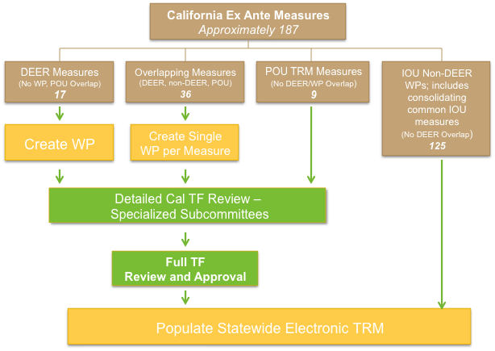
Track 1: DEER Measures
There are only 17 measures in DEER that do not have significant overlap with POU TRM measures or IOU WPs. While Cal TF staff has not attempted to locate the underlying data and modeling behind each of those measures, the overwhelming conclusions of the Cal TF POU TRM Review/DEER Documentation subcommittee suggest that those 17 measures are unlikely to be well documented, transparent, or replicable. Therefore, a new WP will have to be developed for each of those seventeen DEER measures. Those WPs would be created using EnergyPlus or other equally replicable modeling engines only when modeling is deemed sufficiently necessary. Engineering equations will be used for non-HVAC or lighting measures.
Once the WPs are completed they will be subject to two rounds of TF peer review: Detailed review in specialized subcommittees of TF members and other subject matter experts and final review and affirmation from the full TF. It will be vital to have active participation from CPUC Staff and their consultants at both stages of TF peer review. The TF works on a consensus-based decision making model, which emphasizes the importance of all feedback, even when conflicting, and has so far led to consensus solutions that satisfy all involved parties. Active involvement from CPUC Staff will ensure that their comments and requests can be addressed efficiently in a single forum.
Track 2: Overlapping Measures
There are roughly 36 measures that are covered in more than one of the three repositories currently available (DEER, POU TRM, and IOU WPs). The significant overlap between characterizations for these measures means that they too will need to be clearly documented with a new WP—also following the measure simplification and modeling tool guidelines explained under the Track 1 subheading. The creation of a new WP for the 36 overlap measures will have to be preceded by a consolidation effort to select the most appropriate data sources and estimation methodologies from the range already used in the overlapping characterizations. The final consolidated WPs will be migrated into the electronic TRM once they too undergo the two stages of TF peer review.
Track 3: POU TRM Measures
There are nine measure characterizations that were developed in their entirety for the POU TRM. These largely outdoor LED measures are not found in either DEER or IOU WPs, but are already well documented and publically available. These measures do not need to be documented any further, nor compiled or consolidated with any other documents, and are thus ready for peer review by the TF. Once the nine POU TRM measures are reviewed at both the subcommittee and full TF stages they will be completely ready for migration on to the electronic platform.
Track 4: IOU Non-DEER WPs
Of the four sets of measures, existing IOU WPs have been subject to the most extensive documentation requirements. IOU WPs have also already benefitted from one or more rounds of thorough review by CPUC Staff and their consultants. IOU non-DEER WPs will therefore be migrated directly to the electronic TRM platform to allow the TF to prioritize its limited time towards measures that have not already undergone review. Once the electronic TRM has been completely built out (at the two year mark), the former IOU WP measures will be subject to peer review by the TF as part of the regular TRM update process.
Roles and Responsibilities
The proposal would be chiefly implemented by three key groups: Cal TF staff, the Technical Forum with participation from CPUC Staff, and external contractors and PA staff. In its role as coordinator, Cal TF staff would manage the necessary WP development processes, while not actually performing the work and remaining impartial, and facilitate the timely peer review of measures at both the subcommittee and full TF levels. PA staff and/or consultants would consolidate measures and compile existing documentation. Consultants would be hired to develop WPs for the less documented measures. CPUC staff would participate actively in the peer review process.
The following Gantt chart illustrates how the three key groups interact across the different work streams of the proposed implementation plan.
Table 6. Proposed Implementation Plan Gantt Chart
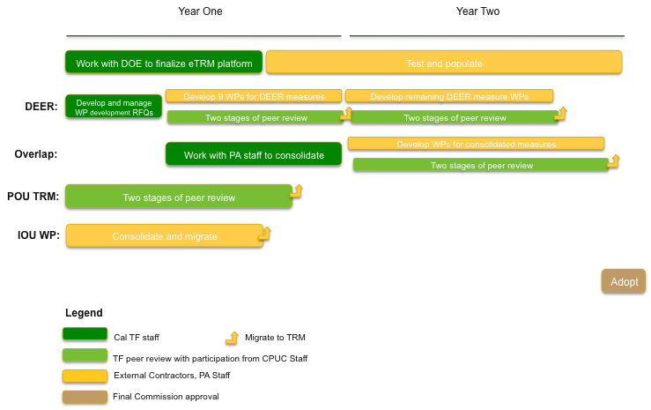
The Commission would grant final approval of the entire TRM and all forthcoming yearly updates. This is strongly in accordance with best practices in other successful jurisdictions. In cases of non-consensus, the Commission will have at their disposal the publically available, quantified, and documented options for their review and informed decision-making. However, non-consensus is rarely the case in other leading jurisdictions that employ this model; in the large majority of cases, consensus in the technical collaborative sends strong signals of support and trustworthiness to the decision makers, and disputes at the Commission level rarely occur.
Closing
The structural problems with California’s current DEER-based ex ante framework are so extensive that they can’t be fixed. The current fragmented and opaque two-repository system is prone to human error, extraordinarily expensive to manage, impossible to meaningfully review, leads to use of inconsistent statewide values, and excludes most stakeholders besides IOUs from introducing or updating new measures. The Commission has asked PAs and stakeholders to “jointly investigate and propose potential solutions to Commission Staff to improve the usability and transparency of all ex ante values.” The Cal TF’s electronic TRM proposal incorporates the best of California’s existing ex ante information into a single, manageable and transparent repository, leverages a state-of-the-art open source modeling tool and interface supported by long-term US DOE funding commitments, and is supported by an open and transparent collaborative process that has already been proven successful in California and other jurisdictions.
Date issued: | November 12th, 2015
Prepared by: | Alejandra Mejia, Annette Beitel
Approved by:
Prior versions:

Appendix:
Status Quo vs. Proposal “Steady State” Process Comparison
Once the new statewide electronic TRM is fully populated, the annual updating process will be even more streamlined and easy to manage. The following image compares the projected annual TRM update timeline to the DEER and subsequent IOU WP update process approved in D15-10-028.
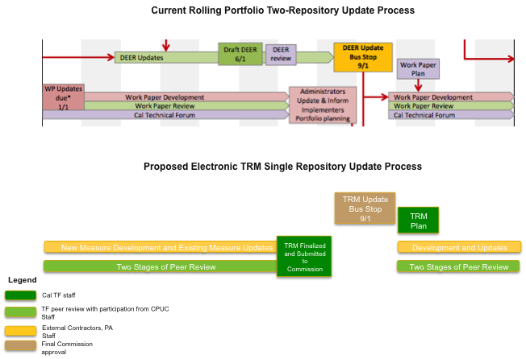

Cal TF and Consistency with CPUC Directives on Ex Ante Values/DEER, Cal TF at p. 1-2. Avail at: http://static1.squarespace.com/static/53c96e16e4b003bdba4f4fee/t/54a331c6e4b03ccd29f8dc1b/ 1419981254762/CPUC+Directives+on+Ex+Ante+and+DEER+memorandum.pdf. See also Table 1 in this document.
D.12-05-015 at p. 297
The Cal TF has used this collaborative, consensus-based model successfully for over a year.
Administrative Law Judge’s Ruling Regarding Comments on Phase II Workshop I, March 18 2015, at 6.
See Cal TF POU TRM Review/DEER Documentation Subcommittee Summary, Avail at: http://www.caltf.org/s/Cal-TF-Subcommittee-Summary_POU-TRM-DEER-Measure-Review_ver-6-a9g7.pdf
Subcommittee Co-Champions: Beckie Menten (PAC Member – MCE), Alice Stover (MCE). Subcommittee Members: Christopher Rogers, Ron Ishi, Tom Eckhart, Srinivas Katipamula, Martin Vu, Gary Fernstrom, Bryan Warren, Ryan Hoest. Additional Charrette Attendees: Grant Brohard, Yeshpal Gupta, Doug Mahone, Pierre Landry, Ed Reynoso, Alina Zohrabian, Armen Saiyan, Larry Brackney (Non-TF – National Renewable Energy Laboratory), Amir Roth (Non-TF – US DOE), Andrew Parker (Non-TF – National Renewable Energy Laboratory), Gay Powel (Non-TF – Pacific Gas & Electric), Pete Ford (Non-TF – San Diego Gas & Electric), Chan Paek (Non-TF – Southern California Gas), Jason Wang (Non-TF – Southern California Edison).
Cal TF PAC members: Anthony Andreoni (California Municipal Utilities Association), Sylvia Bender and Martha Brook (California Energy Commission), Jan Berman (Pacific Gas & Elecric), Michael Campbell (CPUC Office of Ratepayer Advocates), Jonathan Changus (Northern California Power Agency), Howard Choy (City and County of Los Angeles), Bryan Cope (Southern California Public Power Authority), Lisa Davidson (San Diego Gas & Electric), Bob Emmert and John Goodin (California Independent System Operator), Steve Galanter (Southern California Edison), Margie Gardner (California Energy Efficiency Industry Council), Don Gilligan (National Association of Energy Services Companies), Rachel Huang (Sacramento Municipal Utility District), David Jacot (Los Angeles Department of Water and Power), Beckie Menten (MCE), Peter Miller (Natural Resources Defense Council), Mary Ann Piette (Lawrence Berkeley National Lab), Dan Rendler (Southern California Gas Company), and Hanna Grene (Center for Sustainable Energy).
Ex Ante Alternatives Initial “Best Practices” Findings from TRM Research, Cal TF Staff. Avail at: http://static1.squarespace.com/static/53c96e16e4b003bdba4f4fee/t/55cce7c5e4b01e36b698bc5d/1439492037958/Ex+Ante_TRM+Findings.pdf
Cal TF Staff Memo on Residential Tier 2 APS EULs, June 9th 2015, Avail. at: http://static1.squarespace.com/static/53c96e16e4b003bdba4f4fee/t/55a7ea3ee4b0b94ca087499c/1437067838281/Memo+on+APS+EULs+-+Res+Tier+2+Post+June+Cal+TF+Meeting.pdf
The Office of Ratepayer Advocate’s Comments on the Administrative Law Judge’s E-Mail Requesting Comments on Additional Proposed Changes to the Database for Energy Efficiency Resources, June 29th 2015, p. 2; Comments of The Natural Resources Defense Council on Energy Efficiency Potential and Goals and DEER Updates, June 8th 2015, p. 7.
Fill in citation when ready
California Technical Forum October 22nd, 2015 Meeting Notes, Avail. at: http://static1.squarespace.com/static/53c96e16e4b003bdba4f4fee/t/563ae86fe4b0e0b24e44796d/1446701167702/October+TF+Notes_Final.pdf
Ex Ante Abstract and Workpaper Development: CPUC-Approved Values, Methods, Data and Quality Expectations, and Development Guidelines, Jenny Roecks, Avail. at: http://static1.squarespace.com/static/53c96e16e4b003bdba4f4fee/t/53e3c4d9e4b0ffafde9a5663/1407435993806/WP+Requirements_Website.pdf
Opening Comments of the California Energy Efficiency Industry Council on Proposed Decision Regarding Energy Efficiency Goals for 2016 and Beyond and Energy Efficiency Rolling Portfolio Mechanics, September 8th, 2015, p. 7.
The Office of Ratepayer Advocate’s Comments on the Administrative Law Judge’s E-Mail Requesting Comments on Additional Proposed Changes to the Database for Energy Efficiency Resources, June 29th 2015, p. 2; Comments of The Natural Resources Defense Council on Energy Efficiency Potential and Goals and DEER Updates, June 8th 2015, p. 7.
Delineating between overlapping documents and defining discrete measures involved some engineering judgment. See Cal TF staff Statewide Measure List, Avail. at: http://www.caltf.org/s/Statewide-Measure-List_ver-2.xlsx
Fill in citation when ready
D15-10-028, Decision Regarding Energy Efficiency Goals for 2016 and Beyond and Rolling Portfolio Mechanics, October 28th 2015, Ordering Paragraph 19.

