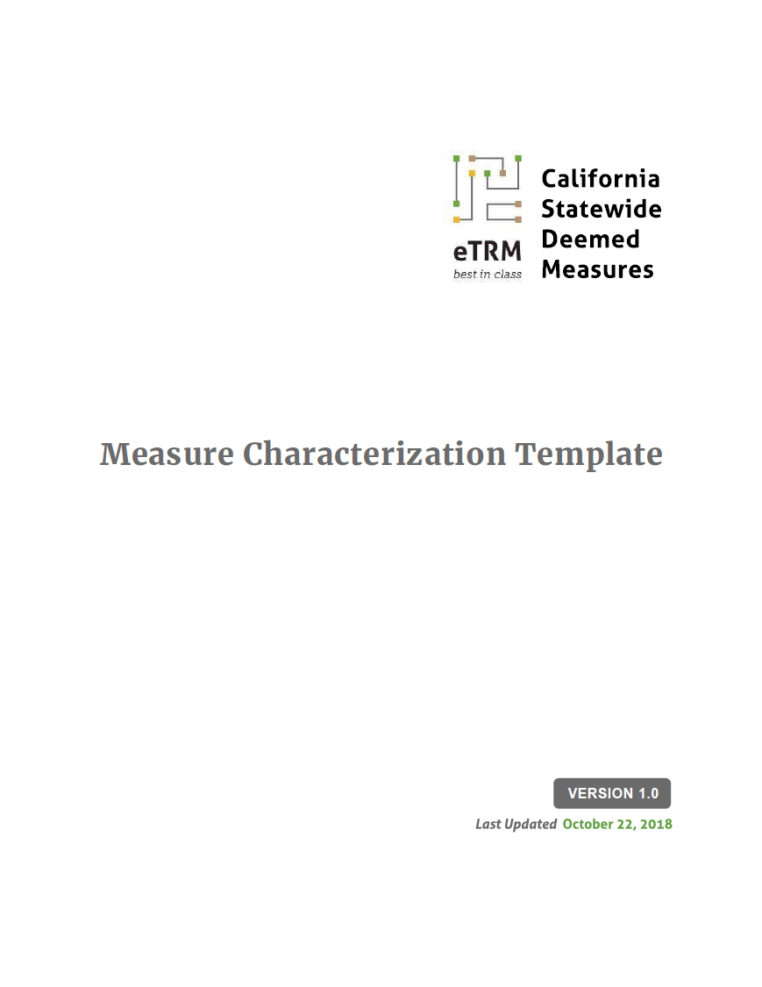



|  |
| --- |
| End Use  Measure Name |

CONTENTS

Statewide Measure ID 2

Measure Version 2

Measure Status 2

Effective Date 2

Sunset Date 2

Technology Summary 2

Measure Case Description 2

Base Case Description 2

Code Requirements 2

Normalizing Unit 3

Program Requirements 3

Program Exclusions 3

Data Collection Requirements 3

Use Category 4

Electric Savings (kWh) 4

Peak Electric Demand Reduction (kW) 4

Gas Savings (therms) 4

Life Cycle 4

Base Case Material Cost ($/unit) 5

Measure Case Material Cost ($/unit) 5

Base Case Labor Cost ($/unit) 5

Measure Case Labor Cost ($/unit) 5

Net-to-Gross 5

Gross Savings Installation Adjustment 6

Non-Energy Impacts 6

DEER Differences Analysis 6

Revision History 7

Statewide Measure ID

Measure Version

Measure Status

Effective Date

Sunset Date

Technology Summary

Measure Case Description

Measure Case Specification

|  |  |  |
| --- | --- | --- |
|  |  |  |
|  |  |  |
|  |  |  |

Base Case Description

Base Case Specification

|  |  |  |
| --- | --- | --- |
|  |  |  |
|  |  |  |
|  |  |  |

Code Requirements

Applicable State and Federal Codes and Standards

| **Code** | **Applicable Code Reference** | **Effective Date** |
| --- | --- | --- |
| CA Appliance Efficiency Regulations – Title 20 (yyyy) |  |  |
| CA Building Energy Efficiency Standards – Title 24 (yyyy) |  |  |
| Federal Standards |  |  |

Normalizing Unit

Program Requirements

Measure Implementation Eligibility

*Boilerplate text 🡪* All measure application type, delivery type, and sector combinations established for this measure are specified below. Measure application type is a categorization based on the circumstances and timing of the measure installation; each measure application type is distinguished by its baseline determination, cost basis, eligibility, and documentation requirements.  Delivery type is the broad categorization of the delivery channel through which the market intervention strategy (financial incentives or other services) is targeted. This table also designates the broad market sector(s) that are applicable for this measure.

Implementation Eligibility   
*[add rows to table as needed to display all unit combinations of application type, delivery type, and sector]*

|  |  |  |
| --- | --- | --- |
| **Measure Application Type** | **Delivery Type** | **Sector** |
|  |  |  |

Eligible Products

Eligible Building Types and Vintages

Eligible Climate Zones

*[Boilerplate text, modify accordingly.] 🡪* This measure is applicable in any California climate zones.

Program Exclusions

Data Collection Requirements

Use Category

Electric Savings (kWh)

Peak Electric Demand Reduction (kW)

Gas Savings (therms)

Life Cycle

*Boilerplate text 🡪* Effective useful life (EUL) is an estimate of the median number of years that a measure installed through a program is still in place and operable. Remaining useful life (RUL) is an estimate of the median number of years that a technology or piece of equipment replaced or altered by an energy efficiency program would have remained in service and operational had the program intervention not caused the replacement or alteration.

*Boilerplate text except for AOE and AR measures 🡪* Note that RUL is only applicable for add-on equipment and accelerated replacement measures and not applicable for this measure.

*Boilerplate text if AOE and AR measures 🡪* The methodology to calculate the RUL conforms with Version 5 of the Energy Efficiency Policy Manual, which recommends “one-third of the effective useful life in DEER as the remaining useful life until further study results are available to establish more accurate values.”[1] This approach provides a reasonable RUL estimate without the requiring any a priori knowledge about the age of the equipment being replaced.[2] Further, as per Resolution E-4807, the California Public Utilities Commission (CPUC) revised add-on equipment measures so that the EUL of the measure is equal to the lower of the RUL of the modified system or equipment or the EUL of the add-on component.” [3]

*[Explain derivation of any proposed EUL/RUL value if and EUL ID for the measure does not exist or if adopting an EUL ID of a different measure.]*

*[After this table is completed the measure developer should confirm 1st baseline and 2nd baseline years]*

Effective Useful Life and Remaining Useful Life  
*[Modify table as needed: add rows for additional measure offerings and/or add columns if EUL ID differs by fuel type or sector. If EUL varies by building type (i.e., lighting measures), indicate as such.]*

|  |  |  |  |
| --- | --- | --- | --- |
| **Measure Offering** | **EUL ID** | **EUL Value (yrs)** | **Source** |
| *[Measure Offering]* |  |  |  |
| *[Measure host equipment – AOE only]* |  |  |  |

Base Case Material Cost ($/unit)

Measure Case Material Cost ($/unit)

Base Case Labor Cost ($/unit)

Measure Case Labor Cost ($/unit)

Net-to-Gross

The net-to-gross (NTG) ratio represents the portion of gross impacts that are determined to be directly attributed to a specific program intervention. ***[****Explain source and rationale for NTG value(s)****]***

*Boilerplate text for default NTGs (modify accordingly if specifying residential default values) 🡪* These NTG values are based upon the average of all NTG ratios for all evaluated 2006 – 2008 commercial, industrial, and agriculture sector programs, as documented in the *2011 DEER Update Study* conducted by Itron, Inc. These sector average NTGs (“default NTGs”) are applicable to all energy efficiency measures that have been offered through commercial, industrial, and agriculture sector programs for more than two years and for which impact evaluation results are not available.

Net-to-Gross Ratios *[Add rows to table if needed]*

|  |  |  |
| --- | --- | --- |
| **NTG ID** | **Value** | **Source** |
|  |  |  |
|  |  |  |

Gross Savings Installation Adjustment

The gross savings installation adjustment (GSIA) rate represents the ratio of the number of verified installations of the measure to the number of claimed installations reported by the utility. This factor varies by end use, sector, technology, application, and delivery method. ***[****Explain source and rationale for GSIA value(s)****]***

*[Boilerplate text for default GSIA] 🡪*  This GSIA rate is the current “default” rate specified for measures for which an alternative GSIA has not been estimated and approved.

Gross Savings Installation Rate Adjustments *[Add rows to table if needed]*

|  |  |  |
| --- | --- | --- |
| **GSIA ID** | **Value** | **Source** |
|  |  |  |
|  |  |  |

Non-Energy Impacts

*[Boilerplate text] 🡪* Non-energy benefits for this measure have not been quantified.

DEER Differences Analysis

*[Boilerplate text] 🡪* This section provides a summary of DEER-based inputs and methods, and the rationale for inputs and methods that are not DEER-based.

DEER Difference Summary

|  |  |
| --- | --- |
| **DEER Item** | **Comment / Used for Workpaper** |
| Modified DEER methodology |  |
| Scaled DEER measure |  |
| DEER Base Case |  |
| DEER Measure Case |  |
| DEER Building Types |  |
| DEER Operating Hours |  |
| DEER eQUEST Prototypes |  |
| DEER Version |  |
| Reason for Deviation from DEER |  |
| DEER Measure IDs Used |  |

Revision History

Measure Characterization Revision History

|  |  |  |  |
| --- | --- | --- | --- |
| **Revision Number** | **Date** | **Primary Author, Title, Organization** | **Revision Summary and Rationale for Revision**  **Effective Date and Approved By** |
| 01 | mm/dd/yyyy | Name, Title  Organization | Revision Summary & Rationale: Text  Approved By: Name, Title, Organization  Effective Date: mm/dd/yyyy |
| 02 |  |  |  |

1. California Public Utilities Commission (CPUC), Energy Division. 2013. Energy Efficiency Policy Manual Version 5. Page 32.
2. KEMA, Inc. 2008. "Summary of EUL-RUL Analysis for the April 2008 Update to DEER." Memorandum submitted to Itron, Inc.
3. California Public Utilities Commission (CPUC). 2016. Resolution E-4807. December 16. Page 13.  