Work Paper SCE13LG123

**Revision 0**

**Southern California Edison**

**Interior LED Parking Garage External Driver Lamp-Style Retrofit Kits (UL Type C)**

# At-a-Glance Summary

|  |  |
| --- | --- |
| **Measure Codes** | SCE   1. **LT- 12500:** Four foot 2-lamp LED External Driver Lamp-Style Retrofit Kit (UL Type C) fixture with bi-level control in day lit zone 2. **LT-12501:** Four foot 2-lamp LED External Driver Lamp-Style Retrofit Kit (UL Type C) fixture with bi-level control in non-day lit zone |
| **Measure Description** | 1. Four foot 2-lamp LED External Driver Lamp-Style Retrofit Kit (UL Type C) fixture with bi-level control in day lit zone 2. Four foot 2-lamp LED External Driver Lamp-Style Retrofit Kit (UL Type C) fixture with bi-level control in non-daylit zone |
| **Base Case Description** | 1. Four foot 2-lamp 2nd generation normal light output (NLO) F32T8 Linear Fluorescent fixture with bi-level control in daylit zone 2. Four foot 2-lamp 2nd generation normal light output (NLO) F32T8 Linear Fluorescent fixture with bi-level control in non-daylit zone |
| **Units** | Fixture |
| **Energy Savings** | **Non-Day Lit Zones:** 103 kWh  **Day Lit Zones:** 46 kWh |
| **Peak Demand Reduction** | **Non-Day Lit Zones:** 0.01377 kW  **Day Lit Zones:** 0 kW |
| **Full Measure Cost ($/unit)** | Same as IMC |
| **Incremental Measure Cost ($/unit)** | $89.76 per fixture |
| **Effective Useful Life** | **Non-Daylit Zones:** Need New EUL ID from EAR team 8.3 years  **Daylit Zones:** ILtg-Lfluor-fix: 16 years |
| **Measure Installation Type** | Replace on Burnout (ROB) |
| **Net-to-Gross Ratio** | All-Default<=2yrsSource: 0.70 |
| **Important Comments** | This work paper has a complementary Ex Ante Database data set that will be provided in a separate submission to the California Public Utilities Commission (CPUC). |

# Revision History

|  |  |  |  |
| --- | --- | --- | --- |
| **Rev** | **Date** | **Author** | **Summary of Changes** |
| 0 | 7/26/2016 | RMS Energy Consulting, LLC | New Workpaper |

# Commission Staff and Cal TF Comments

|  |  |  |  |  |  |
| --- | --- | --- | --- | --- | --- |
| **Rev** | **Party** | **Submittal Date** | **Comment Date** | **Comments** | **WP Developer Response** |
| 0 | CS | 6/20/2016 | 7/26/2016 |  |  |
| 0 | Cal TF | 5/26/2016 | 7/26/2016 |  |  |
|  |  |  |  |  |  |

Cal TF website: <http://www.caltf.org/>

The Cal TF approved the version 0 of this workpaper found under the “Approved Measures” section of the website, <http://www.caltf.org/approved-measures/>

# Section 1. General Measure & Baseline Data

## 1.1 Measure Description & Background

This work paper details the replacement of a four foot 2-lamp 2nd generation normal light output (NLO) F32T8 Linear Fluorescent base case fixture retrofitted with a four foot 2-lamp LED External Driver Lamp-Style Retrofit Kit (UL Type C) measure case fixture in both day lit and non-day lit parking garage zones. Both base case and measure case fixtures are assumed to be controlled by bi-level occupancy sensors in non-day lit zones and photocells and bi-level occupancy sensors in day lit zones as required by Title 24.

**Table 1.** Base, Standard, and Measure Cases

|  |  |
| --- | --- |
| **Case** | **Description of Typical Scenario** |
| Measure | 1. Four foot 2-lamp LED External Driver Lamp-Style Retrofit Kit (UL Type C) fixture with bi-level occupancy sensor and photocell controls in day lit zones 2. Four foot 2-lamp LED External Driver Lamp-Style Retrofit Kit (UL Type C) fixture with bi-level occupancy sensing control in non-day lit zones |
| Existing Condition | 1. Four foot 2-lamp 2nd generation normal light output (NLO) F32T8 Linear Fluorescent fixture with bi-level occupancy sensor and photocell controls in day lit zones 2. Four foot 2-lamp 2nd generation normal light output (NLO) F32T8 Linear Fluorescent fixture with bi-level occupancy sensing control in non-day lit zones |
| Code/Standard | 1. Four foot 2-lamp 2nd generation normal light output (NLO) F32T8 Linear Fluorescent fixture with bi-level occupancy sensor and photocell controls in day lit zones 2. Four foot 2-lamp 2nd generation normal light output (NLO) F32T8 Linear Fluorescent fixture with bi-level occupancy sensing control in non-day lit zones |
| Industry Standard Practice | 1. High-Intensity Discharge (HID) with no bi-level occupancy sensing or daylighting controls and 2. Linear fluorescent technologies with no bi-level occupancy sensing or daylighting controls are both widely available and commonly used. |

Table 2. Measures and Codes

|  |  |  |  |  |
| --- | --- | --- | --- | --- |
| **Measure Codes** | | | | **Measure Name** |
| SCG | SDG&E | SCE | PG&E |
| N/A | TBD | LT-12500 | TBD | Four foot 2-lamp LED External Driver Lamp-Style Retrofit Kit (UL Type C) fixture with bi-level occupancy sensor and photocell controls in day lit zones |
| N/A | TBD | LT-12501 | TBD | Four foot 2-lamp LED External Driver Lamp-Style Retrofit Kit (UL Type C) fixture with bi-level occupancy sensing control in non-day lit zones |

**Eligibility requirements**:

To qualify for incentives, Interior LED Parking Garage Retrofit Kits must be:

* 4-foot in length
* designated as UL Type C (External Driver Lamp-Style Retrofit Kits)
* One for one replacement for a linear fluorescent fixture with two T8 lamps
* Dimming options must include 0-10 volt, digital, and phase cut
* Design Lights Consortium (DLC) approved Integrated Retrofit Kit for Parking Garages
* DLC-listed initial light output must be ≥ 2300 lm and ≤ 6500 lm
  + 5-year warranty minimum
  + The LED fixture must be listed under the Primary Use Category “2-lamp External driver Lamp-style retrofit kits (UL Type C)” on the DLC’s Qualified Products List (QPL) and meet additional criteria outlined below. The LED T8 Lamp specification sheet must also list all of the compatible ballast model numbers to ensure proper operation of the measure.
  + The products on the QPL will be filtered and must meet the specs as listed below.

**Table 3.** Program Requirements

|  |  |  |  |
| --- | --- | --- | --- |
| **Performance Metric** | **DLC Requirement** | **DLC Tolerance** | **Program Requirement (no tolerance)** |
| Luminaire Efficacy | ≥100 LPW | -3% | ≥100 LPW |
| CRI | ≥80 | -2 points | ≥80 |
| CCT | ≤ 5,000K | N/A | ≤ 5,000K |
| Power Factor | ≥0.9 | -3% | ≥0.9 |
| Total Harmonic Distortion | ≤20% | +5% | ≤20% |
| Lumen Maintenance | L70>50,000 | N/A | L70>50,000 |
| Minimum Warranty | 5 years | N/A | 5 years |

**Implementation and installation requirements**:

* The measures in this work paper are eligible in all applicable Non-Residential and Residential Multifamily (8-units or more) building types with totally enclosed or open parking garages in all climate zones located within the following space types:
  + driving areas;
  + entrances and exits, or
  + parking areas or parking stalls.

**Other program restrictions and guidelines**

* Linear LED replacement lamps and self-ballasted or screw-based lamps do not qualify
* Parking garage space types excluded from this workpaper include:
  + Elevators and elevator lobbies
  + Stairs and stair vestibules
  + Mechanical rooms and mechanical shafts
  + Electrical rooms and electrical shafts
  + Storage rooms (usually for maintenance and cleaning equipment)
  + Fire pump room
  + Garbage and dumpster storage areas
  + Unusable and/or inaccessible areas
  + Top deck parking garage lighting typically requiring exterior pole lighting
  + Rentable space at the street level, as for retail or hospitality functions

## Technical Description

Linear LED retrofit kits are designed to replace existing fluorescent lamps and require some form of rewiring such as replacing the ballasts. Each Linear LED retrofit kit typically comes prepackaged with all the required components to complete the retrofit, making the installation easier. Linear LED retrofit kits come in two forms: either as an LED retrofit kit, such as light bar and lamp-style replacement, or as an LED troffer retrofit kit with new doorframe and lens assemblies.

Within each Linear LED retrofit kit, the TLED lamp is a type of tubular linear LED light source specifically designed to replace tubular fluorescent lamps in existing luminaires. They are designed to fit into the existing fluorescent sockets, effectively converting the light fixture from fluorescent to LED. There are four primary types of TLEDs:

* **Type A:** A TLED designed to operate on the existing fluorescent ballast. Although the fluorescent ballast is not necessary and actually wastes energy, the “plug and play” simplicity and avoidance of electrician cost is appealing.
* **Type B:** A TLED that fits into the existing fluorescent sockets, but requires them to be rewired to bypass the ballast (preferably, remove the ballast as well).
* **Type C:** A TLED that fits into existing fluorescent sockets, but requires the existing fluorescent ballast to be replaced by a dedicated LED driver.
* **Type A and B:** A TLED designed to be wired in either Type A (operates on electronic ballast) or Type B (direct AC power wire to socket).

This workpaper measure focuses on including a four foot 2-lamp External Driver Lamp-Style Linear LED Retrofit Kit (UL Type C) fixture. Products in this category employ lamp holders to connect to the fixture being retrofitted, do not operate off the existing fluorescent ballast, and require rewiring of the existing fixture to replace the ballast with an external driver. The lamp holders are then wired to receive only the low-voltage electricity that is supplied by that external driver.

## 1.3 Installation Types and Delivery Mechanisms

The Installation Type for this workpaper measure is:

• Replace on Burnout (ROB)

The Delivery Methods for this workpaper measure are:

• Financial Support / Direct Install

• Financial Support / Down-Stream Incentive – Deemed

**Table 4.** Installation Type Descriptions

|  |  |  |  |  |
| --- | --- | --- | --- | --- |
| **Installation Type** | **Savings** | | **Life** | |
| 1st Baseline (BL) | 2nd BL | 1st BL | 2nd BL |
| Replace on Burnout (ROB) | Above Code or Standard | N/A | EUL | N/A |

A delivery mechanism is a delivery method paired with an incentive method. Delivery mechanisms are used by programs to obtain program participation and energy savings.

**Table 5.** Delivery Method Descriptions

|  |  |
| --- | --- |
| **Delivery Method** | **Description** |
| Financial Support | The program motivates customers, through financial incentives such as rebates or low interest loans, to implement energy efficient measures or projects. |

**Table 6.** Incentive Method Descriptions

|  |  |
| --- | --- |
| **Incentive Method** | **Description** |
| Down-Stream Incentive | The customer installs qualifying energy efficient equipment and submits an incentive application to the utility program. Upon application approval, the utility program pays an incentive to the customer. Such an incentive may be deemed or customized. |
| Direct Install | The program implements energy efficiency measures for qualifying customers, at no cost to the customer. |

* **Commercial Downstream Deemed Program** requires applicants to submit manufacturer’s specification sheets detailing Linear LED retrofit kit fixture type and circling the applicable fixture type based on day lit spaces versus non-day lit spaces. Linear LED retrofit kit fixtures without this information available will not be eligible for the program. Linear LED retrofit kit fixtures will be checked during inspections aligned with current program inspection policies.
* **Commercial Direct Install Program** contractors have extensive knowledge of the lighting products they use for the direct install (DI) Program.  DI contractors can confirm Linear LED retrofit kit fixtures installed are compatible per manufacturer’s specifications. Documentation can be provided regarding the lamp/ballast compatibility for the various components used and encountered in their Direct Install. The sampling rate for pre-inspection is 6% and post-inspection between 10-20%.
  + **The Multifamily Energy Efficiency Rebate (MFEER) Program** offers rebates on a wide variety of energy-saving products and services to motivate the multifamily property owners/managers to install energy efficient products in both common and dwelling areas of multifamily complexes. The MFEER program addresses the ongoing concern with “split incentives” where the residents are not the owners of the property, so they lack the motivation to improve their energy usage patterns. Similarly, the property owners do not live on-site and pay higher utility expenses due to inefficient appliances; thus, lack any motivation to make improvement upgrades. The MFEER program is designed to drive this customer segment toward participation by offering property owners a variety of energy efficiency measures and services.
  + The MFEER program also offers select energy-efficient products and services at “no-cost” to customers implemented via DI. DI measures are implemented by authorized-program contractors who perform program outreach and provide project management which includes energy audits, customer enrollment, product procurement, installation and quality assurance.
  + The MFEER program quality control ensures product eligibility by verifying qualified products lists and product specifications of the energy efficient product installed. Pre-inspections are not performed, but data is collected. All projects that receive over $20,000 in incentives require a 100% post-inspection while all others will require 10% post-inspection. The MFEER program requires a detailed Product Location Form (PLF) for each project submitted for rebate or incentive. The PLF is an Excel spreadsheet with a tab for measures installed. Consistent with program policies and procedures, field inspections are also conducted to verify installations and accuracy of the information provided in submitted incentive applications.
  + To ensure proper operation of the measure technology, customers will be required to submit the product specification sheet to ensure that eligible Linear LED retrofit kit fixtures are installed at their location.

## 1.4 Measure Parameters

### 1.4.1 DEER Data

The existing DEER measures for LED luminaires are not applicable. Within DEER, there are forty DEER measures for Commercial Indoor General Lighting with Tech Types equal to LED_fixt. Thirteen of those forty references HID base case fixtures, which are not applicable here for this workpaper.

Of the twenty-seven remaining DEER measures, all have measure wattages less than 26 Watts or more than 130 Watts. The larger wattage measures generally came from workpapers for high-bay fixtures, and the lower wattage measures generally have medium screw-base lamps as their base case. None of the DEER measures are applicable to this specific LED fixture application replacing linear fluorescent T8 fixtures in the 1’x4’, 2’x4’ fixture sizes in parking garages.

Additionally, DEER does not include parking garages as a building type. The DEER operating hours for other DEER building types do not take into account code requirements and occupancy for parking garages. The DEER operating hours are not applicable because the hours are focused on lighting for interior commercial spaces, which are typically lower in hours compared to parking garages.

Table 7. DEER Difference Summary

|  |  |
| --- | --- |
| **DEER Item** | **Used for Workpaper?** |
| Modified DEER methodology | No |
| Scaled DEER measure | No |
| DEER Base Case | No |
| DEER Measure Case | No |
| DEER Building Types | No |
| DEER Operating Hours | No |
| DEER eQUEST Prototypes | No |
| DEER Version | Non-DEER |
| Reason for Deviation from DEER | DEER does not contain this type of measure. |
| DEER Measure IDs Used | N/A |

**Net-to-Gross Ratio**

The NTG values were obtained using the DEER READI tool. The relevant NTG values for the measures in this work paper are listed in Table 8.

Table 8. Net-to-Gross Table

|  |  |  |  |  |  |
| --- | --- | --- | --- | --- | --- |
| **NTGR ID** | **Description** | **Sector** | **BldgType** | **Measure Delivery** | **NTGR** |
| All-Default<=2yrs | All other EEM with no evaluated NTGR; new technology in program for 2 or fewer years | Any | Any | Any | 0.70 |
| Res-Default-HTR-di | All other EEM with no evaluated NTGR; direct install hard-to-reach only. | Res | Any | DirInstall | 0.85 |
| Com-Default-HTR-di | All other EEM with no evaluated NTGR; direct install to hard-to-reach only. | Com | Any | DirInstall | 0.85 |

Note: Direct install measures that are not hard-to-reach will use the default NTG value.

**Multi-Family Energy Efficiency Rebate (MFEER) Direct Install Program**

This work paper includes measures that are offered via direct install activities into hard-to-reach (HTR) customer homes. “Final Resolution E-4700”, dated December 18, 2014, defines specific criteria to classify customer homes as HTR. The “Required Corrections to Measure Level Input Parameters Identified by Commission Staff per D.14-10-046 Order Paragraph 16”, dated November 3, 2014, includes additional clarification for the geographic criteria.

SCE’s Multi-Family Energy Efficiency Rebate (MFEER) program addresses the ongoing concern with “split incentives”, where the residents are not the owners of the property, so they lack incentive to improve their energy usage. Similarly, the property owners do not live on-site and pay higher utility expenses due to inefficient appliances, thus lack any incentive to upgrade. The MFEER is designed to drive this customer segment toward participation by offering property owners a variety of energy efficiency measures and services.

The MFEER program will offer and track measure installations in multifamily complexes (8 units or more) with parking garages. Measures offered via direct install activities in multifamily complexes will receive the HTR NTG. Other measures in the MFEER program will receive default NTG (NTGR_ID: Res-Default>2), unless otherwise specified in DEER.

**Commercial Direct Install Program (including Partnership Direct Install Programs)**

This work paper includes measures that are offered via direct install activities into hard-to-reach (HTR) customer facilities. “Final Resolution E-4700”, dated December 18, 2014, defines specific criteria to classify customer facilities as HTR and also states that two criteria are sufficient to identify HTR customers if one of the criteria met is the geographic criteria.

SCE’s Commercial Direct Install program delivers free and low cost energy efficiency hardware retrofits through installation contractors to reduce peak demand and energy savings for small and medium commercial customers. The barriers for customer participation include limited capital resources, lack of expertise and understanding of the understanding of the benefits of energy efficiency, a suspicion of the “free offer” and its legitimacy, and language and cultural barriers. The program also addresses the ongoing concern with “split incentives”, where the customer is not the owner of the property, and therefore, lack incentive to improve their energy usage.

SCE’s Commercial Direct Install program will track the following three (3) customer data points to identify direct install activities in HTR customer facilities. If geography and business size criteria are satisfied, SCE will identify the customer as HTR. If geography and language criteria are satisfied, SCE will identify the customer as HTR. Other measures in the Commercial Direct Install program will receive default NTG (NTGR_ID: Com-Default>2), unless otherwise specified in DEER.

* **Business Size** – Customer must have less than ten employees
* **Language** – Customer’s primary language spoken is not English
* **Geography** – Businesses in areas other than the United States Office of Management and Budget (OMB) Combined Statistical Areas (CSA) of the San Francisco Bay Area, the Greater Los Angeles Area and the Greater Sacramento Area or the OBM metropolitan statistical areas or San Diego County.

The “Required Corrections to Measure Level Input Parameters Identified by Commission Staff per D.14-10-046 Order Paragraph 16”, dated November 3, 2014, includes additional clarification for the geographic criteria:

“*Notes on OMB CSA designations: The OMB has designated a 12-county CSA titled the San Jose-San Francisco-Oakland, CA Combined Statistical Area which includes the nine counties of Alameda, Contra Costa, Marin, Napa, San Francisco, San Mateo, Santa Clara, Solano, and Sonoma which border the San Francisco Bay plus the three counties of San Joaquin, Santa Cruz, and San Benito that are economically tied to the nine counties that that border the San Francisco Bay.” The OMB definition of this CSA includes Los Angeles, Orange, San Bernardino, Riverside and Ventura counties. The OMB definition of this CSA includes Sacramento, Yolo, El Dorado, Placer, Sutter, Yuba, and Nevada counties.”*

**Spillage Rate**

Spillage rates are not tracked in work papers; they are tracked in an external document which will be supplied to the Commission Staff.

**Installation Rate**

The installation rate (IR) values were obtained using the DEER READI tool. The relevant IR values for the measures in this work paper are in Table 9.

Table 9. GSIA Table

|  |  |  |  |  |  |
| --- | --- | --- | --- | --- | --- |
| **GSIA ID** | **Description** | **Sector** | **BldgType** | **ProgDelivID** | **GSIAValue** |
| Def-GSIA | Default GSIA values | Any | Any | Any | 1 |

**Effective and Remaining Useful Life**

The effective useful life (EUL) is an estimate of the median number of years that an installed measure will remain in place and is operational. The EUL and remaining useful life (RUL) values are typically obtained using the DEER READI tool. DEER defines the RUL as 1/3 of the EUL value. The RUL value is only applicable to the first baseline period for an RET measure with an applicable code baseline. The effective useful life (EUL) and remaining useful life (RUL) values were obtained using the DEER 2016, READI v2.4.5 tool.

For linear fluorescent and linear LED fixtures, the EUL is based on taking the rated fixture life divided by the annul hours of operation. Here, the rated fixture life for the Linear LED External Driver Lamp-Style Retrofit Kit (UL Type C) fixture is 50,000 hours. The equivalent average annual hours of operation is 6,045 hours in non-day lit zones and 2,760 hours in day lit zones.

Within DEER 2016 READI v2.4.5, the closest EUL ID applicable for this measure is ILtg-Lfluor-fix with an EUL value of 16 years. Because the EUL calculation for LED parking garage fixtures in day lit zones exceeds the DEER value for similar linear fluorescent fixtures, this workaper conservatively assumes an EUL value of 16 years for LED parking garage fixtures in day lit zones. **Please refer to Section 1.5 for further details on how the EUL value for this measure was arrived at.**

* EUL = (DLC-Minimum Fixture Life (hours)) / (Average Operating Hours per Year)
* EUL = (50,000 life hours) / (2,760 equivalent average annual hrs.) = 18.1 yrs. (day lit zones)
  + The DEER EUL value of 16 years will be used instead of the calculated 18.1 years for LED parking garage fixtures in day lit zones.
* EUL = (50,000 life hours) / (6,045 equivalent average annual hrs.) = 8.3 yrs. (non-day lit zones)

The relevant EUL and RUL values for the measures in this work paper are in the table below.

Table 10. EUL/RUL Table

|  |  |  |  |  |  |  |
| --- | --- | --- | --- | --- | --- | --- |
| **Measure Description** | **EUL ID** | **Description** | **Sector** | **UseCategory** | **EUL (Years)** | **RUL (Years)** |
| Interior LED Parking Garage External Driver Lamp-Style Retrofit Kits (UL Type C) – **Day lit Zone** | ILtg-Lfluor-fix | Linear Fluorescent – Fixtures | Com | Lighting | 16 | N/A |
| Interior LED Parking Garage External Driver Lamp-Style Retrofit Kits (UL Type C) – **Non Day lit Zone** | New EUL ID Needed | Linear Fluorescent – Fixtures | Com | Lighting | 8.3 | N/A |

### 1.4.2 Codes and Standards Analysis

Title 24 2013 [355], Section 141.0(b) 2I states:

**Lighting System Alterations** shall meet the applicable requirements in TABLE 141.0-E and the following:

1. Lighting System Alterations include alterations where an existing lighting system is modified, luminaires are replaced, or luminaires are disconnected from the circuit, removed and reinstalled, whether in the same location or installed elsewhere.

**EXCEPTION 1 to Section 141.0(b) 2Iii:** Alterations that qualify as a Luminaire Modification-in-

Place.

**EXCEPTION 2 to Section 141.0(b) 2Iii:** Portable luminaires, luminaires affixed to moveable partitions, and lighting excluded in accordance to Section 140.6(a) 3.

**Luminaire Modifications-in-Place** shall meet the applicable requirements in TABLE 141.0-F and the following:

1. To qualify as a Luminaire Modification-in-Place, luminaires shall only be modified by one or more of the following methods:
   1. Replacing lamps and ballasts with like type or quantity in a manner that preserves the original luminaire listing.
   2. Changing the number or type of light source in a luminaire including: socket renewal, removal or relocation of sockets or lamp holders, and/or related wiring internal to the luminaire including the addition of safety disconnecting devices.
   3. Changing the optical system of a luminaire in part or in whole.
   4. Replacement of whole luminaires one for one in which the only electrical modification involves disconnecting the existing luminaire and reconnecting the replacement luminaire.
2. Luminaire Modifications-In-Place shall include only alterations to lighting system meeting the following conditions:
   1. Luminaire Modifications-in-Place shall not be part of or the result of any general remodeling or renovation of the enclosed space in which they are located.
   2. Luminaire Modifications-in-Place shall not cause, be the result of, or involve any changes to the panelboard or branch circuit wiring, including line voltage switches, relays, contactors, dimmers and other control devices, providing power to the lighting system.

**EXCEPTION to Section 141.0(b) 2Iiii2.** Circuit modifications strictly limited to the addition of occupancy or vacancy sensors and class two lighting controls are permitted for Luminaire

Modifications-in-Place

Title 20 2015 [493] includes regulations to fluorescent lamp ballasts, replacement fluorescent lamp ballasts, and lamps.

2012 Federal Standards for General Service Fluorescent Lamps issued by Department of Energy effective July 14, 2012 contains Energy Conservation Standards that applies to various linear fluorescent lamp types [[1]].

Table 11. Code Summary

|  |  |  |
| --- | --- | --- |
| **Code** | **Reference** | **Effective Dates** |
| Title 24 (2013) | Section 141.0(b)2Iii Lighting System Alterations, 141.0(b)2Iii Luminaire Modifications-in-Place | July 1, 2014 |
| Title 20 (2015) | 2015 Appliance Efficiency Regulations | July 1, 2015 |
| NEMA (2012) | Federal standards for general service fluorescent lamps issued by DOE | July 14, 2012 |
| California State Fire Marshal  CODE INTERPRETATION (14-010) | 2013 California Building Code (CBC) §1006.1, Energy Code §130.1(c) | November 24, 2014 |

## 1.5 EM&V, Market Potential, and Other Studies – Base Case and Measure Case Information

### Studies Supporting Average Operating Hours and Effective Useful Life

**1.5.1 CPUC 2015 Workpaper Guidance – Lighting Retrofits, dated January 27, 2015.**

According to the CPUC 2015 Workpaper Guidance – Lighting Retrofits, dated January 27, 2015, the guidance document listed a parking garage lighting category called “ParkGar” which was established based on lighting workpapers submitted by California program administrators (PAs) in 2013 and 2014. The hours of use for “ParkGar” were set at 8,760 because the ex-ante review (EAR) team “passed through” this value as proposed by California PAs.

However, in the June 23, 2016 Commission Staff Observations for Interior Parking Garage Linear Fluorescent to LED Luminaires or Retrofit Kits document, the EAR team indicated that they had not researched or reviewed the assumptions or data sources for the value of 8,760 hours and would not require this value to be used and does not consider this value to be the best available information.

Therefore, the EAR Team indicated in this document that CalTF should consult other data for the appropriate parking garage hours of use. Based on the EAR team’s input, further data sources were researched to support an appropriate annual operating hour estimate for this workpaper.

**1.5.2 California Marshal 2014 Code Interpretation Means of Egress Illumination**

On November 24, 2014, the California State Fire Marshal issued a code interpretation regarding the Title 24 Energy Code §130.1(C) requirement that all lighting including emergency lighting must shut off when the building is unoccupied using occupancy sensing, automatic time switch or building system signal. The 2014 California Marshal Code Interpretation document indicated that “The California Building Code (CBC) requirements for Means of Egress Illumination Section (§1006) supersede the California Energy Code. The requirements of CBC §1006 are applicable when applying the California Energy Code…and the means of egress illumination level shall not be less than 1 foot candle at the walking surface, where required per CBC.”

Consequently, it is commonly interpreted by architects, engineers and contractors to avoid motion sensing lighting controls for the means of egress unless the minimum lighting levels are at least twice the necessary minimum. In such circumstances, lights can be “partially off” and still meet CBC §1006 in the “low” power mode. Side lit daylighting controls are less of a challenge because CBC §1006 does not specify that the lighting levels be provided by electric light.

Therefore, if there are luminaires in the primary or secondary side lit zone, and the sensor is located and set properly, the minimum egress lighting levels can be met with electric or natural light. With the exception of primary and secondary side lit zones, it can reasonably be inferred that parking garage fixtures must be on 24/7 or 8,760 annual operating hours for safety reasons based on this 2014 California Marshal Code Interpretation.

**1.5.3 California Utilities Codes and Standards Team 2011 Statewide Parking Garage Lighting and Controls Codes and Standards Enhancement (CASE) Initiative Draft Measure Report**

According to the 2011 California Utilities Codes and Standards Team Statewide Parking Garage Lighting and Controls Codes and Standards Enhancement (CASE) Initiative Draft Measure Report (page 17), most parking garages are not secure facilities, and it is not possible to be certain that a vehicle or pedestrian will not enter the building. Furthermore, the Draft Report implied that because of these potential safety concerns, parking garages are mostly operated in a 24/7 (8,760 annual hours) manner with the only controls in the spaces employed in the adaptation zone near the entry.

Based on this information, it can be reasonably inferred that the 2011 Statewide Parking Garage Lighting and Controls CASE Initiative Draft Measure Report supports the 8,760 annual hours estimate primarily because most parking garages operate 24/7 or 8,760 annual hours due to safety and security concerns.

**1.5.4 Energy Solutions’ 2012 Energy Technology Assistance Program Field Study Final Report (ETAP Report)**

#### Low and High Power Modes

The 2012 ETAP Report concentrated on metering bi-level lighting for parking lots, garages, stairwells, and walkways and monitored a total of 157 bi-level fixtures across 30 parking garages. The 2012 ETAP report (page 35) indicated that the majority of parking garage fixtures is on 24/7, and that the monitored data indicated that the average percent time these bi-level fixtures were on in low power and high power modes were 62% and 38%, respectively. Page 4 of the ETAP Report indicated that

*monitoring efforts provided crucial new empirical data on the performance of bi-level, or adaptive, lighting in parking garages. The data shows that bi-level light fixtures operated at the low output level 62% of the time in parking garages, which is a significantly higher percentage than previous industry assumptions. The measured data showing more time spent in low power mode means that actual savings for bi-level lighting were higher than originally estimated, and increasing the associated utility incentives could be justified if necessary to motivate more customers to install this measure.*



**Figure 1.** Bi-level Fixtures Monitored in the 2012 ETAP Report



**Figure 2.** Bi-level Fixtures Percent Time in Low Power in the 2012 ETAP Report

#### Rated Life, Equivalent Annual Operating Hours and EUL Calculation

##### Rated Life

Rated life for DLC-listed products varies between 50,000 hours and 500,000 hours. However, the rated life for these products is assumed to be 50,000 hours, which is the minimum DLC specification. The rated LED fixture life can be extended if fixtures are dimmed. According to the National Lighting Product Information Program (NLPIP) Lighting Research Center[2],

*It has been observed that when some fluorescent lighting systems are frequently dimmed, they might exhibit reduced reliability and lamp life. This is not the case for LEDs. Life and light output degradation are determined largely by the junction temperature, with higher temperatures resulting in reduced life characteristics. Since dimming, either by reducing current or by pulse width modulation, results in lower overall junction temperatures, it will have no negative impact on LED life; it might even extend life.*

##### Day Lit Zones Annual Operating Hours

Based on the 2012 ETAP Report (footnote page 35), the monitoring report indicated that 7 PM – 7 AM reflects the average operating hours for a fixture with a photocell throughout the year. Based on this 12 hour usage per day, the annual operating hours for day lit zones are estimated at 12 hours/day and 365 days per year or **4,380 annual operating hours**.

##### Non-Day Lit Zones Annual Operating Hours

Based on the 2012 ETAP Report (page 33), the bi-level fixture monitored data indicated that high power mode (100% power) on average occurred 38% of the time or 3,329 annual hours. The 2012 ETAP Report also indicated that low power mode occurred the remaining 62% of the time or 5,431 annual hours.

##### Day Lit Zones with Photocells EUL Calculation

The 2012 ETAP Report (page 35) indicated that

*while the majority of parking garage fixtures are on 24/7, some fixtures are photocell controlled and do not operate during daylight hours. There was a substantial difference in percent of time in low-power mode between day (7 AM – 7 PM) and night (7 PM – 7 AM). On average, garage fixtures were in low power mode for 47% of the day and 74% of the night. This variation has implications for night-only fixtures, because they operate in low power mode roughly 12% more than a standard 24/7 fixture (74% vs 62%). When installing photocell-controlled night-only fixtures, it is recommended that decision makers assume a higher percent time in low-power mode than they would for a 24/7 fixture.*

Thus, fixtures with photocell controls in day lit zones are estimated to be in high power mode for an estimated 1,139 hours (4,380 hours*26%) and low power mode 3,241 annual hours (4,380 hours*74%).

At 50% power during low power mode, the life of the Linear LED retrofit kit fixture in day lit zones can be extended and mathematically equate to half of 3,241 hours or 1,621 equivalent hours. Therefore, for EUL calculation purposes, the equivalent average annual hours for this LED measure in day lit zones are estimated at 2,760 annual operating hours (1,139 hours + 1,621 hours).

This calculation was based on the bi-level monitored data showing that LED parking garage fixtures in day lit zones operated in high power mode for 1,139 annual hours and at low power mode for 1,621 equivalent annual hours for a total of 2,760 equivalent average annual operating hours.

EUL = (DLC-Minimum Fixture Life (hours)) / (Average Operating Hours per Year)

EUL = (50,000 life hours) / (1,139 high power mode hrs. + 1,621 low power mode hrs.)

EUL = (50,000 life hours) / (2,760 equivalent average annual hrs.) = 18.1 yrs.

Within the DEER 2016, READI v2.4.5 tool, the closest EUL ID applicable for this measure is the ILtg-Lfluor-fix EUD ID with an EUL value of 16 years. Because the EUL calculation for Linear LED retrofit kit fixtures in day lit zones exceeds the DEER value for similar linear fluorescent fixtures, **this workpaper conservatively assumes an EUL value of 16 years for Linear LED retrofit kit parking garage fixtures in day lit zones.**

##### Non-Day Lit Zones with No Photocells EUL Calculation

At 50% power during low power mode, the life of the Linear LED retrofit kit fixture can be extended and mathematically equate to half of 5,431 hours or 2,716 hours. Therefore, for EUL calculation purposes, the equivalent average annual hours for this measure are estimated at 6,045 annual operating hours as shown below.

This calculation was based on the bi-level monitored data showing that LED parking garage fixtures in non-day lit zones operated in high power mode 3,329 annual hours and at low power mode for 2,715 equivalent annual hours for a total of 6,045 equivalent average annual operating hours.

EUL = (DLC-Minimum Fixture Life (hours)) / (Average Operating Hours per Year)

EUL = (50,000 life hours) / (3,329 high power mode hrs. + 2,716 low power mode hrs.)

**EUL = (50,000 life hours) / (6,045 equivalent average annual hrs.) = 8.3 yrs.**

### Studies Supporting Baseline Assumptions and Industry Standard Practice

**1.5.5 DOE’s July 2015 Adoption of Light-Emitting Diodes in Common Lighting Applications**

The DOE’s July 2015 Adoption of Light-Emitting Diodes in Common Lighting Applications study indicated that while HID lamps are used for lighting parking garage structures, the low-mounting heights of lighting fixtures require a large number of fixtures in order to meet desired illumination distributions. These conditions favor linear fluorescent fixtures, although metal halide and HPS are also prominent in this market.

Although this wp focuses on using the ROB measure application, the DOE’s July 2015 Adoption of Light-Emitting Diodes in Common Lighting Applications study supports the notion that the wp could be an early retirement (ER) measure application type because of desired illumination distributions.

**1.5.6 California Utilities Codes and Standards Team 2011 Statewide Parking Garage Lighting and Controls Codes and Standards Enhancement (CASE) Initiative Draft Measure Report**

According to the 2011 California Utilities Codes and Standards Team Statewide Parking Garage Lighting and Controls Codes and Standards Enhancement (CASE) Initiative Draft Measure Report (page 23), linear fluorescent appears to be the most prevalent light source technology employed in the State, especially in the warmer environments and because linear fluorescent is a very common and low-cost method of illuminating parking garages.

Additionally, the report indicated (page 69) that in colder climates, fluorescent lighting has posed an issue to due limited start-up capabilities at cold ambient temperatures. The report (page 94) further states that in low ambient temperature conditions, fluorescent dimming can be limited at the low end, and lamps may not be able to start when subject to extremely cold temperatures. Most fluorescent dimming ballasts are designed for interior spaces, and thus have high minimum case temperatures which are difficult to achieve in exterior luminaires such as those found in parking garages.

Based on this information, it can be reasonably inferred that lower wattage Linear Fluorescent fixtures using 25W or 28W are not recommended from a lighting design standpoint because these lamps may not be able to start when subjected to extremely cold temperatures. Given that most parking garages are open because of cost considerations and ventilation requirements, 25W and 28W lamps would likely be exposed to cold temperatures posing safety risks because the lamps may not start up. Therefore, a base case assumption using lower wattage Linear Fluorescent lamps is unlikely due to safety risk associated with lamps being exposed to colder temperatures.

**1.5.7 Energy Solutions’ 2012 Energy Technology Assistance Program Field Study Final Report (ETAP Report)**

The 2012 ETAP Report (Page 31) indicated that extra efficient fluorescent T8 fixtures were one of the most common technologies installed in ETAP parking garage projects. This gave ETAP Technical staff considerable exposure to projects that used T8 products for exterior bi-level applications. One key lesson learned regarding the technology indicated that some lamps and ballasts are not well-suited to lower temperatures common at parking facilities. Site temperatures and recommended operating temperature of the equipment should be reviewed carefully. In several instances, ETAP Project Leads reviewed proposals, which did not consider the recommended operating temperature of the equipment. This could lead to premature failures if left uncorrected.

Based on the 2012 ETAP Report, it can be reasonably inferred that the report findings further corroborates that Linear Fluorescent fixtures using lower wattage lamps (25W and 28W) are not well suited because these fixtures could lead to premature failures.

**1.5.8 Benya Burnett Consultancy Parking Garage Lighting Background and Basis of Recommendations**

#### Baseline Fixtures

The 2016 Benya Burnett Consultancy Energy Workpaper Parking Garage Lighting Background and Basis of Recommendations document (page 4) indicated that nationally, high pressure sodium (HPS) lighting was probably the most common due to its wide temperature tolerance and high efficacy, but a white light was preferred to create an improved sense of safety and security. The Benya Burnett Consultancy document further references a Parking Structure Design Guidelines report prepared for the City of Lincoln, Nebraska. On page 34 of the Parking Structure Design Guidelines document, Benya Burnett Consultancy references that “metal halide lighting was the common choice for those garages for which white light as preferred, as it is close to HPS in efficiency.”

##### Regional Fixture Baselines Choices

The document further states that fluorescent lamp systems are less expensive and easier to accommodate alternative emergency power sources. But fluorescent systems are temperature sensitive, more likely to be used in low-lying coastal and inland areas and less likely in foothills and mountain regions in Southern California and many portions of Northern California.

Because of temperature sensitivity, 25- and 28-watt fluorescent replacement lamps are ill-advised as starting may not occur with temperatures below 60 degrees Fahrenheit. In Southern California, the limited temperature extremes historically made fluorescent lighting the favored choice, as it was essentially as efficacious as HPS, offered very long lamp life, and was more economical. It also offered immediate starting, allowing for much more economical emergency lighting.

Among HID luminaires, HPS lamps are preferred over metal halide due to longer life and greater energy efficiency. Metal halide lamps are preferred for color rendering of cars and for improved perception of security. HID luminaires of both types make emergency lighting expensive and problematic, but with the ability to start at -20F and below, HID are common where low temperatures are often present.

All system types generally meet Title 24 without difficulty. Fluorescent systems are generally the most efficient, metal halide the least.

In most parking garages not yet converted to LED lighting, the existing lighting is most likely one of the following:

* Two lamp fluorescent strip lights, typically end-to-end 8’ units, bare lamp or with antenna guard, 2-F32T8 lamps and instant start 1st generation .88 BF ballast (59-60 watts)
* Two lamp vapor tight wraparound fluorescent luminaires, 4’units, 2-F32T8 lamps and instant start 1st generation .88 BF ballast (59-60 watts). Program start and rapid start ballasts (including all dimming ballasts) can introduce temperature performance problems below 60F, essentially making instant start technology necessary.
* One lamp high pressure sodium parking garage luminaire 70 to 150 watts, magnetic ballast
* One lamp metal halide parking garage luminaire 70-175 watts, pulse start magnetic ballast

The Benya Burnett Consultancy document indicated that there are two commonly used fluorescent luminaires in garages in Southern California:

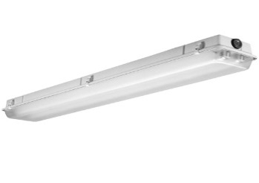**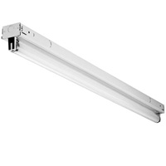Type 1:** Strip fluorescent luminaires, 4’ single lamp installed in 8’ long “tandem” configuration, sharing a single 2-lamp ballast. Because the working life of a fluorescent lighting system is 20 years+ (ballast and luminaire) and 5 years+ (lamp) the most likely combination in service employs T-8 first generation instant start technology, drawing 59 watts to drive two standard lamps at a ballast factor of 88%. Lamps are most likely F32T87xx lamps with 2,725 initial lumens.

**Type 2:** Vapor tight wraparound T8 fluorescent luminaires, with (2) 4’ lamps sharing a single 2-lamp ballast. Ordinary wraparounds will collect too much dirt as assumed to use same technology as above.

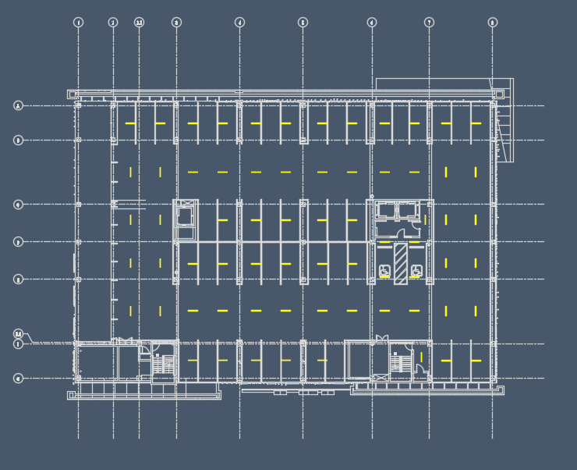

**Figure 3.** Lighting plan and floor plan of AC Hotel with open garage on 75% of the enclosing walls.

The Benya Burnett Consultancy document used the floor plan of an AC Hotel project because it was deemed a representative model of a conventional floor plan. It is a variation on the single threaded helix in which the parking areas are flat and the risers are on the ends (left and right).

A downtown infill project with inadequate site for ground parking, the hotel’s lobby is on the first floor, the garage constituting floors 2-5, and the guest floors are above the garage. The entrance and exit ramps are on the first floor, leading directly to the actual garage on the second floor and above. Each floor constitutes about 20,825 sf. For standardizing the parking garage model, Benya Burnett Consultancy allocated the ramp among the parking floors, increasing the average floor model to 22,325 sf. The average area per parking stall is 485 sf. This garage is particularly inefficient, largely due to its small floor plate size.

The Benya Burnett Consultancy document then created a more general model assuming a 100,000 sf floor plate. They believed this would be representative of more typical garages and would permit the square-feet-per-stall areas values listed in Table 12. As the garage gets larger, the percentage of parking area increases and the percentage of drive aisles decreases thus decreases the gross sf per stall. The two variations are summarized in Table 12.

Table 12. Approximate Space Types and Areas for Parking Garages

|  |  |  |  |  |
| --- | --- | --- | --- | --- |
|  | **Small Garage** | | **Big Garage** | |
| Space | Area SF | % | Area SF | % |
| Gross Floor Plate | 20,825 | 93.28% | 96,000 | 96.0% |
| Pro rata entrance and exit | 1,500 | 6.72% | 4,000 | 4.0% |
| Total Gross Area | 22,325 | 100.00% | 100,000 | 100.0% |
| Stairs HVAC elevators | 1,180 | 5.29% | 5,000 | 5.0% |
| Park | 7,420 | 33.24% | 45,000 | 45.0% |
| Entrance Exit | 1,500 | 6.72% | 4,000 | 4.0% |
| Drive aisle and ramps | 12,225 | 54.76% | 47,500 | 47.5% |
| Day lit zone | 2,955 | 13.24% | 10,896 | 10.9% |
| Stall area | 162 | n/a | 162 | n/a |
| Stalls/floor | 46 | n/a | 280 | n/a |
| SF/stall | 485 | n/a | 357 | n/a |

For the purposes of lighting analysis, the Benya Burnett Consultancy document assumed a user comfort factor 4 (9’ wide stall) with 90 degree parking. The AC Hotel garage design used these same values. The document indicated that compact car stalls and accessible parking stalls are not specifically addressed. However, based on their lighting design experience with parking garages, on the average, compact car stalls and accessible parking stalls are typically worked into the design using compact stalls (which are narrower) to offset accessible stalls (which are wider).

## Alternative Designs

All of the following designs were analyzed for a nominal 90 foot long by 62 foot wide parking garage with an 8’ flat ceiling, clean natural concrete ceiling, floors and walls, 70% lumen maintenance factor. **Note that the lighting power density is for the parking and aisle areas only.**

The overall power density of the entire garage floor is larger due to the need for higher light levels around elevator and lobby cores and circulation areas. Title 24-2016 Area Category Method allows 0.14 w/sf lighting power density (LPD) for the garage floor, not including transition zones, stairs or enclosed spaces such as mechanical rooms. The whole building LPD is 0.20 w/sf. This approach is adequate for most garages and requires fewer code compliance documents.

**Also note: these designs assume a flat ceiling. Beams can seriously reduce lighting levels and/or create dark spots, and will cause higher lighting power use.**

For this reason alone, the Title 24 allowance of .14 w/sf is necessary. The following designs illustrate different methods of complying with IES RP-20-14 and building energy efficiency standards using fluorescent lighting. Designs 1a and 1b cannot use motion sensors per the energy code, and are not required to use daylight sensors.

### 

**Figure 4.** Design 1a – Lowest cost and power with strip lights

### 

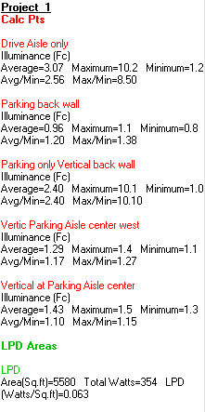

**Figure 5.** Design 1b – Lowest cost and power with vaportight lights

Designs 2a and 2b may use motion sensors and/or daylight sensors for the luminaires over the parking stalls but not over the drive aisles.

### 

**Figure 6.** Design 2a – 50% cost increase over Design 1a using strip lights but permits lighting controls for 2/3 of the luminaires

### 

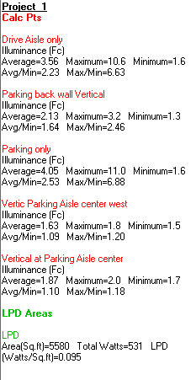

**Figure 7.** Design 2b – 50% cost increase over Design 1b using vapor tight lights but permits lighting controls for 2/3 of the luminaires

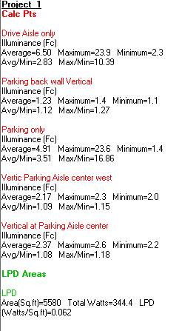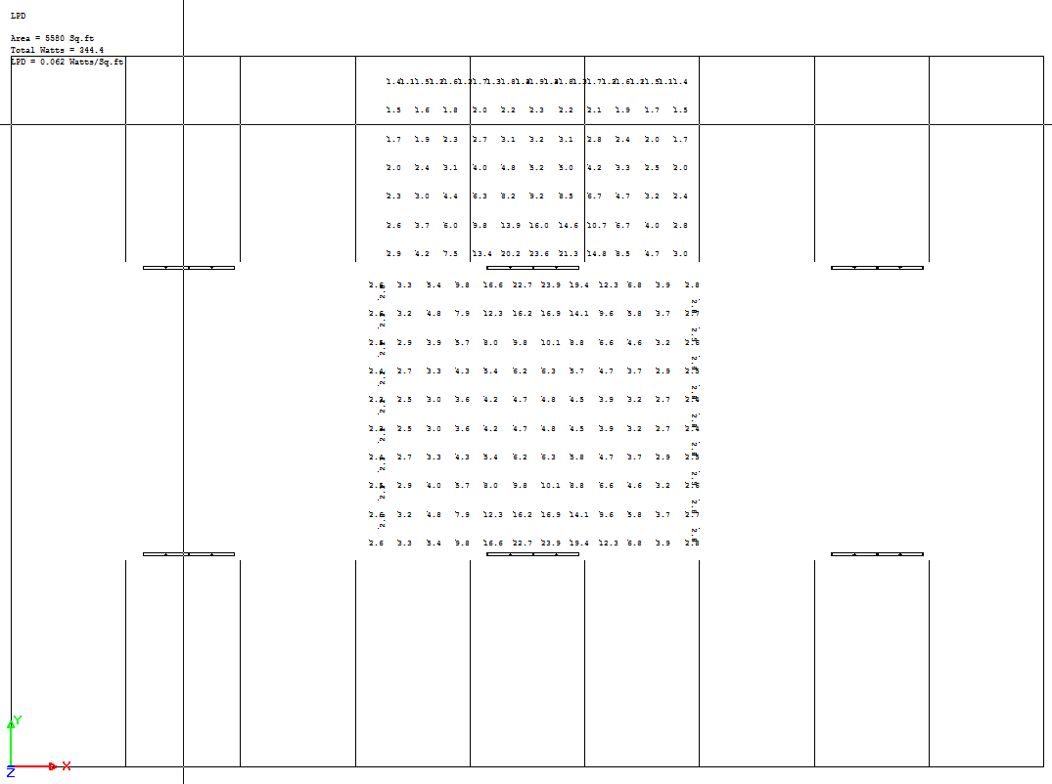

**Figure 8.** Design 3– Design 1 with LED Vapor tights

## Other Design Considerations

It is important to avoid drawing conclusions from these model calculations. In reality, any number of factors could increase or decrease the actual lighting power needed to meet IES RP-20-14 and the CBC. Also, the lighting needed for other parts of the parking garage generally serve to increase the lighting power density significantly. The Benya Burnett Consultancy document also examined the impact of painting the ceiling white as compared to raw concrete. It appears to create 20-21% increased light levels and therefore, potential energy savings.

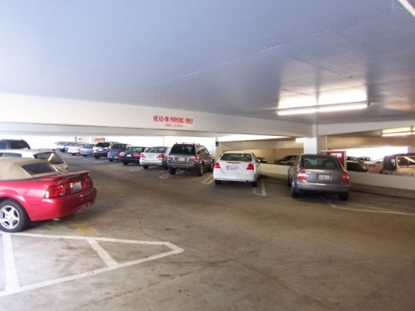

**Figure 9.** Parking Garage with New Coat of White Paint on Ceilings and Walls.

##### Daylighting

Garages can be totally enclosed, but open garages are more common because they are less costly, employ natural ventilation and reducing the cost of enclosing walls. For this reason, most garages are open on at least a part of two sides to enable cross ventilation. Often the end walls are at least partly enclosed in order to fit into a block or streetscape next to neighboring structures, although in very open areas they are often open on most sides.

Daylighting can be useful in parking garages, but it important to remember that direct sunlight is often not available and it is certainly not constant. Title 24-2016 has a very explicit section, §130.1(d) 3, describing specific daylighting controls for lights in the primary or secondary day lit zone. It is common for the head height of the aperture to be between 6’ and 8’, resulting in a primary side lit zone extending about 6’ to 8’ into the structure and a secondary side lit zone about 14’ to 18’ into the structure. There are seldom any luminaires in either zone, but automatic daylighting controls may still be beneficial.

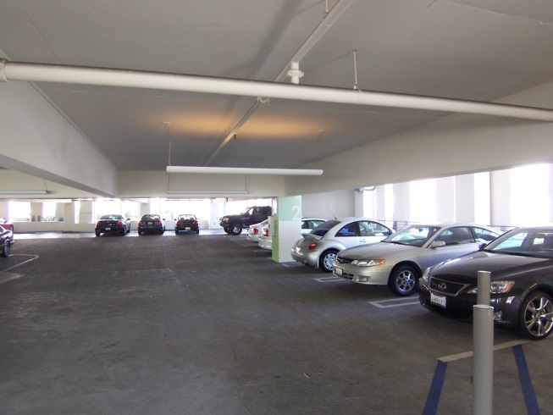

**Figure 10.** Garage with opening head height is 7’6” and the primary side lit zone consists of parking stalls. The lighting system is not in the primary side lit zone but daylighting controls were employed.

##### Correlated Color Temperature (CCT)

The American Medical Association released an article[3] claiming that

*High-intensity LED lighting designs emit a large amount of blue light that appears white to the naked eye and create worse nighttime glare than conventional lighting. Discomfort and disability from intense, blue-rich LED lighting can decrease visual acuity and safety, resulting in concerns and creating a road hazard.*

*In addition to its impact on drivers, blue-rich LED streetlights operate at a wavelength that most adversely suppresses melatonin during night. It is estimated that white LED lamps have five times greater impact on circadian sleep rhythms than conventional street lamps. Recent large surveys found that brighter residential nighttime lighting is associated with reduced sleep times, dissatisfaction with sleep quality, excessive sleepiness, impaired daytime functioning and obesity*.

The AMA article clearly focuses on street lighting applications. Further studies need to be done before any conclusions can be drawn. However, the wp is mindful of these evolving issues and addresses this potential concern in section 1.1 under the eligibility requirements. Section 1.1 indicates that Linear LED retrofit kit fixtures must have < 5,000K to be eligible for incentives. Based on the DLC filtered list for Linear LED External Driver Lamp-Style Retrofit Kits (UL Type C), the CCT for qualified products in this product category range from 3,089K and 4,950K with an average CCT of 2,620K.

**1.5.9 Southern California Edison (SCE) 2013-2015 Custom Project Files**

SCE’s custom project files were reviewed to assess baseline conditions based on pre-installation inspections verifying base case fixtures for customers who pursued an incentive. The five highest energy savings impact custom projects that used SCE’s Solution Code LT-47463 (Interior Parking Garage) were sampled. As shown in the subsequent figures, three of the five custom projects had 2-lamp or 4-lamp F32T8 Linear Fluorescent Fixtures as the base case. The other two projects consisted of 219W (connected load) high pressure sodium fixtures or 215W (connected load) pulse-start metal halide fixtures. None of the five custom projects sampled had baselines that had LED or lower wattage (28W or 25W) T8 Linear Fluorescent Fixtures as the base case.

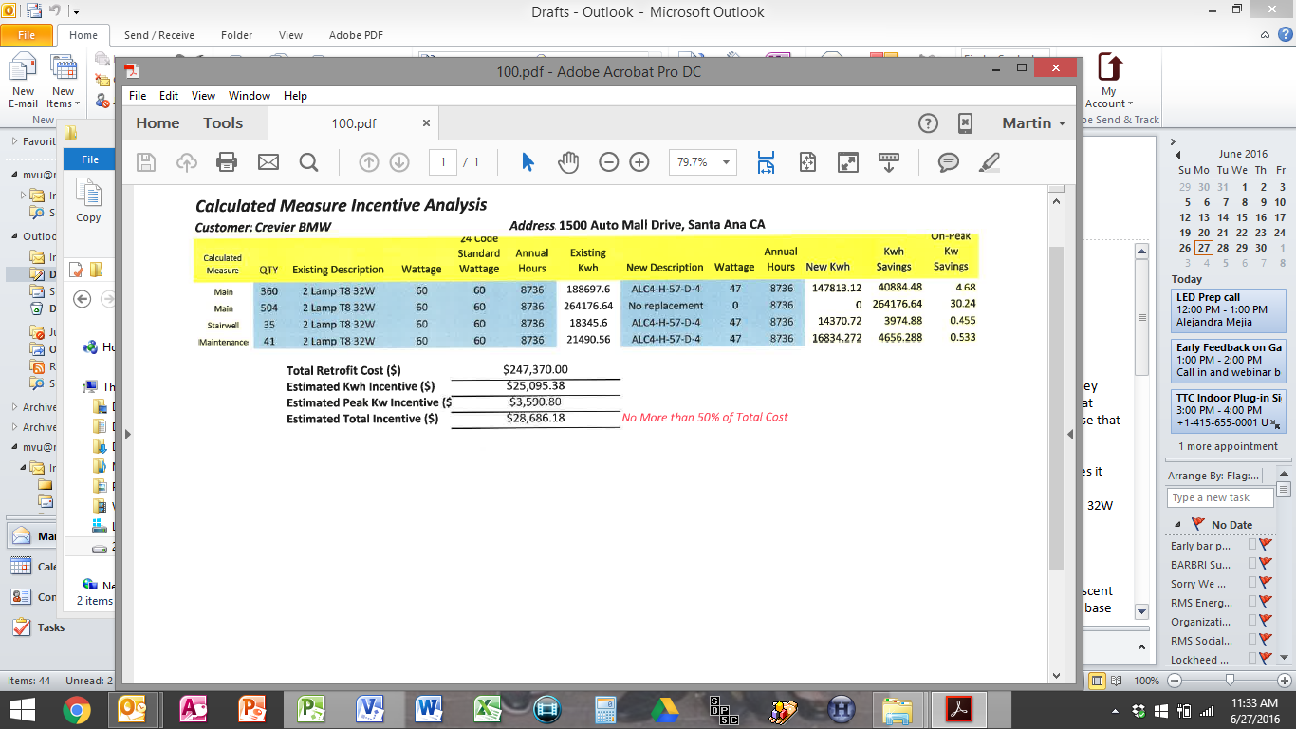

**Figure 11.** SCE Custom Project 500552314 (360) 2-lamp T8 32W Base Case Fixtures

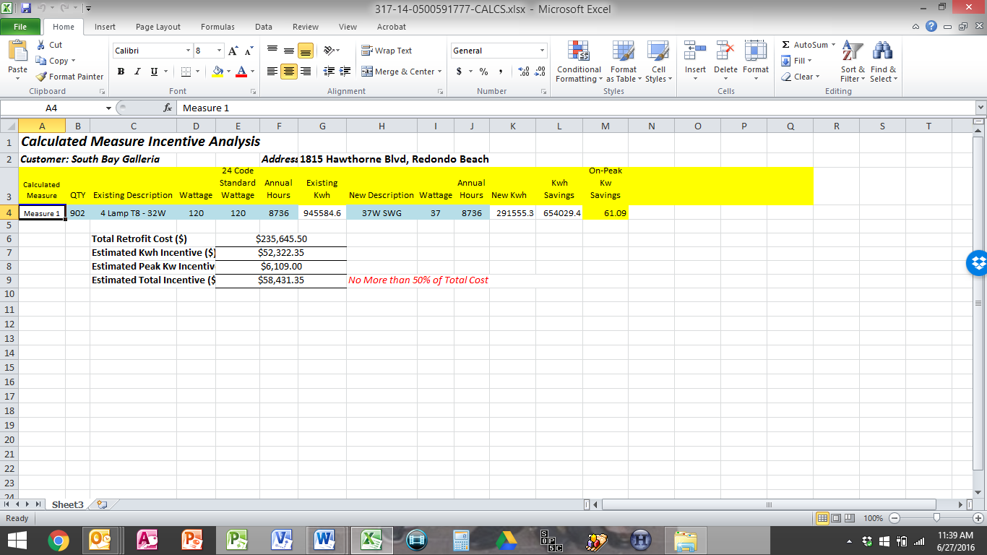

**Figure 12.** SCE Custom Project 500591777 (902) 4-lamp T8 32W Base Case



**Figure 13.** SCE Custom Project 500413678 (960) 219W HPS Base Case



**Figure 14.** SCE Custom Project 500358294 (3,251) 32W T-83 Base Case Fixtures



**Figure 15.** SCE Custom Project 500244613 (296) 175W PSMH Base Case Fixtures

### 1.6 Data Quality and Future Data Needs

**1.6.1 Commission Staff Observations for Interior Parking Garage Linear Fluorescent to LED Luminaires or Retrofit Kits – July 13, 2016 Email**

Although this workpaper focuses only on replace on burnout (ROB) applications, early retirement (ER) would be a realistic application because the studies referenced in this workpaper evidence that the baseline mixture primarily consist of 1st generation F32T8 fluorescent fixtures and HID fixtures.

However, in an email from the EAR team to CalTF staff on July 13, 2016, an EAR team representative indicated that the EAR team observes the standard practice is changing extremely rapidly on this technology. The EAR team representative indicated that when determining industry standard practice, to consider limiting the time frame to the last ~1 year (summer of 2015 to present day) due to the uncertainty of whether a project designed or retrofit today would normally install T8s or LEDs.

Therefore, to help substantiate the energy savings for an early retirement option, baseline data can be collected during program implementation as a future data collection effort.

**1.6.1 DOE’s July 2015 Adoption of Light-Emitting Diodes in Common Lighting Applications**

Although the study does not fall in the ideal time frame between the summer of 2015 to present day, the DOE’s July 2015 Adoption of Light-Emitting Diodes in Common Lighting Applications study is the closet data point to this desired time frame and found that there were 37 million parking garage installations in the U.S. of which 1.8 million were LED installations. Based on this 2014 study, LED parking garage installations represented less than 5% of all parking garage installations.

The study estimated that if all 37 million installations were to switch to LEDs overnight, it would save 14 TWh of site electricity nationwide (Table 3.9 from the DOE’s Study).[4] This would correspond to 1.68 TWh statewide and 1.26 TWh in IOU service territories. At 5% fixture stock turnover annually, this market could generate savings of 63 GWh.

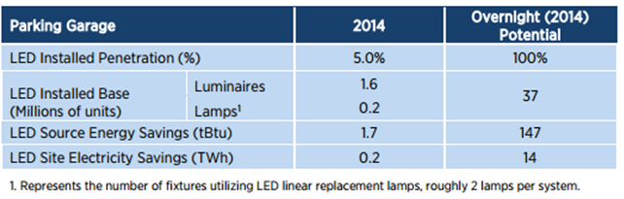

**Figure 16.** DOE’s Adoption of Light-Emitting Diodes in Common Lighting Applications Study LED Parking Garage Energy Savings Summary

Because the 2013 Title 24 Code became effective on July 1, 2014, the summer of 2015 was the beginning of the turning point for new construction in parking garages. Based on the DOE’s July 2015 Adoption of Light-Emitting Diodes in Common Lighting Applications study, LED parking garage installations represented less than 5% of all parking garage installations.

However, it was not clear on whether these LED installations were a part of new construction parking garage projects or in existing parking garages. The major energy savings opportunities are found in existing parking garages where the cost effectiveness of LED fixtures instead of fluorescent have yet to be determined. Consequently, the CalTF recommended collecting baseline data during program implementation to support a future early retirement (ER) application type for consideration in a future workpaper update to address current industry standard practice and because of the higher energy savings opportunity.

# Section 2. Calculation Methodology

## Base Case

Based on the studies referenced in Section 1.5 of this workpaper, the two commonly used fluorescent luminaires in garages are:

1. strip fluorescent luminaires (two 4’ single lamp installed in 8’ long tandem sharing one ballast) and
2. vapor tight wraparound T8 fluorescent luminaires (two 4’ lamps installed side by side within the fixture housing sharing a single ballast).

Base Case wattages were taken from the IOU Table of Standard Fixture Wattages. As shown in Figure 17, the connected load for a four foot 2-lamp 2nd generation F32T8 NLO fixture consumes 0.059 kW. Because of code, base case fixtures are assumed to be controlled with bi-level occupancy sensing controls for non-day lit zones and bi-level occupancy sensing and photocell controls for day lit zones. As described in Section 1.5 of this workaper, bi-level occupancy sensing controls would put existing fixtures in low power mode when the parking garage is unoccupied.



**Figure 17.** IOU Table of *S*tandard Fixture Wattages

Based on 2012 ETAP Report, this workpaper estimates that existing fixtures located in non-day lit zones are in low power mode 62% of the time. Low power mode is estimated to be 50% of full power. The fixture is in high power mode for 38% at full power. Equation 1 exhibits the calculation for estimating annual baseline energy consumption for a fixture located in a non-day lit zone.

[(0.059 kW*0.5*8760*0.62) + (0.059 kW*1.0*8760*0.38)] = 357 kWh

**Equation 1.** Baseline kWh for a four foot 2-lamp 2nd generation F32T8 NLO fixture in non-day lit zones

As indicated in the 2012 ETAP Report, this workpaper estimates that existing fixtures located in day lit zones are in low power mode 74% of the time. Low power mode is estimated to be 50% of full power. The fixture is in high power mode for 26% at full power. Equation 2 exhibits the calculation for estimating annual baseline energy consumption for a fixture located in a day lit zone.

[(0.059 kW*0.5*4380*0.74) + (0.059 kW*1.0*4380*0.26)] = 160 kWh

**Equation 2.** Baseline kWh for a four foot 2-lamp 2nd generation F32T8 NLO fixture in day lit zones

## Measure Case

The Northeast Energy Efficiency Partnership (NEEP) is a multi-state consortium of agencies and utilities that turned to its Design Lights Consortium (DLC). DLC created a Qualified Products List (QPL), which is an up-to-date non-commercial listing service that confirms LED lighting products have performance data tested by accredited laboratories. Qualified products are listed on the QPL database. Being listed in the database is generally used throughout the USA as a minimum criterion to qualify for incentive programs. DLC frequently reports manufacturer misrepresentations and maintains firm control over the use of its logo and claims of QPL listing.

To ensure that the Linear LED retrofit kit fixtures provides equal performance to the fluorescent lighting being replaced, External Driver Lamp-Style Retrofit Kits (UL Type C) filtered from the DLC’s QPL must provide at least 2,300 lumens (2-lamp configuration). From this filtered list, the External Driver Lamp-Style Retrofit Kits (UL Type C) are about 20% more efficacious than Type A TLED’s or the most efficacious high performance fluorescent lamps and ballasts and are likely to save considerable energy in most applications. As shown in Table 13, the average LED lamp generates 2,620 lumens and consumes 20.8 watts. The driver loss is included in the system rating. Since there are no standards for TLEDs, Table 13 provides a provisional reference table to aid in policy decisions.

**Table 13.** Filtered DLC QPL External Driver Lamp-Style Retrofit Kits (UL Type C)

|  |  |  |  |  |
| --- | --- | --- | --- | --- |
| **Lamp Manufacturers** | **CCT** | **CRI** | **Lumens** | **Watts** |
| Teslights | 4952K | 84 | 3093 | 21.3 |
| LTF | 3959K | 81 | 2493 | 18.3 |
| Ecolight | 3943K | 84 | 2505 | 18.2 |
| Benwei | 3089K | 82 | 2325 | 18.6 |
| Green Bay | 3990K | 81 | 2951 | 22 |
| Aura Light | 3987K | 84 | 2382 | 18.2 |
| James | 3941K | 81 | 2759 | 18.1 |
| BTS | 4118K | 84 | 2451 | 24.2 |
| Topbrand | 4082K | 83 | 2676 | 20.7 |
| Linmore | 3389K | 83 | 2801 | 22.4 |
| ATG | 3995K | 83 | 2322 | 23.2 |
| GE | 3485K | 84 | 2758 | 20.6 |
| Espen | 3399K | 86 | 2549 | 24.2 |
| **Average** | | | **2620** | **20.8** |

Similar to the baseline energy savings calculation estimates, based on 2012 ETAP Report, this workpaper estimates that new Linear LED External Driver Lamp-Style Retrofit Kits (UL Type C) located in non-day lit zones are in low power mode 62% of the time. Low power mode is estimated to be 50% of full power. The fixture is in high power mode for 38% at full power. Equation 3 exhibits the calculation for estimating annual measure case energy consumption for a fixture located in a non-day lit zone.

[(0.042 kW*0.5*8760*0.62) + (0.042 kW*1.0*8760*0.38)] = 254 kWh

**Equation 3.** Measure Case kWh for a four foot 2-lamp 2nd generation F32T8 NLO fixture in non-day lit zones

As indicated in the 2012 ETAP Report, this workpaper estimates that new Linear LED External Driver Lamp-Style Retrofit Kits (UL Type C) fixtures located in day lit zones are in low power mode 74% of the time. Low power mode is estimated to be 50% of full power. The fixture is in high power mode for 26% at full power. Equation 4 exhibits the calculation for estimating annual measure case energy consumption for a fixture located in a day lit zone.

[(0.042 kW*0.5*4380*0.74) + (0.042 kW*1.0*4380*0.26)] = 114 kWh

**Equation 4.** Measure Case kWh for a four foot 2-lamp 2nd generation F32T8 NLO fixture in day lit zones

Based on the analysis above, the energy savings are shown in Table 14.

**Table 14.** Energy Savings Table

|  |  |
| --- | --- |
| **Technology** | **Average Watts** |
| Four foot 2-lamp LED External Driver Lamp-Style Retrofit Kit (UL Type C) fixture with bi-level occupancy sensing control in non-day lit zones | 357 kWh – 254 kWh = 103 kWh |
| Four foot 2-lamp LED External Driver Lamp-Style Retrofit Kit (UL Type C) fixture with bi-level occupancy sensing and photocell controls in day lit zones | 160 kWh – 114 kWh = 46 kWh |

## Peak Demand Reduction

The Peak Demand Reduction calculation is based on taking the difference between the existing four foot 2-lamp 2nd generation normal light output (NLO) F32T8 Linear Fluorescent fixture with the new four foot 2-lamp LED External Driver Lamp-Style Retrofit Kit (UL Type C) fixture as shown in Table 15.

**Table 15.** Measure and Base Wattage

|  |  |
| --- | --- |
| **Technology** | **Average Watts** |
| Four foot 2-lamp 2nd generation normal light output (NLO) F32T8 Linear Fluorescent fixture with bi-level control in non-day li zone | 59 |
| Four foot 2-lamp LED External Driver Lamp-Style Retrofit Kit (UL Type C) fixture with bi-level control in non-day lit zone | 42 |

Demand reduction estimates must consider the DEER peak demand period, which is 2:00 PM to 5:00 PM during specific weekday periods and varies by climate zone:

**Table 16.** DEER Peak Periods by Climate Zone

|  |  |
| --- | --- |
| **Climate Zone** | **3-Weekday Period** |
| 1 | Sep 16 – Sep 18 |
| 2 | July 8 – July 10 |
| 3 | July 8 – July 10 |
| 4 | Sep 1 – Sep 3 |
| 5 | Sep 8 – Sep 10 |
| 6 | Sep 1 – Sep 3 |
| 7 | Sep 1 – Sep 3 |
| 8 | Sep 1 – Sep 3 |
| 9 | Sep 1 – Sep 3 |
| 10 | Sep 1 – Sep 3 |
| 11 | July 8 – July 10 |
| 12 | July 8 – July 10 |
| 13 | July 8 – July 10 |
| 14 | Aug 26 – Aug 28 |
| 15 | Aug 25 – Aug 27 |
| 16 | July 8 – July 10 |

Based on the 2012 ETAP report (page 33), the report indicated that

“*during peak hours (Mon-Fri, 2-5pm), bi-level fixtures in garages were in low-power mode an average of 38% of the time. For 70% of monitored garages, the average time that sampled fixtures were in low-power mode was above 50%. The maximum that any garage's sampled fixtures spent in low power mode was 87%, while the minimum was 25%.*”

Based on this information the peak demand reduction for non-day lit zones was calculated as follows:

**Peak Demand Reduction:**

Peak Demand Reduction [kW] = (∆kW) x (Lighting Coincident Demand Factor) x (Power Mode)

[(0.059 kW- 0.042 kW) (0.38) (0.5)] + [(0.059 kW- 0.042 kW) (0.62) (1)] = 0.01377 kW

**Equation 5.** Peak Demand Reduction in non-day lit zones

Based on the 2012 ETAP Report (page 35), the report indicated *while the majority of parking garage fixtures are on 24/7, some fixtures are photocell controlled and do not operate during daylight hours.* Therefore, it is assumed that fixtures with bi-level controls in day lit zones only operated between the hours of 7PM and 7AM and with zero peak demand reduction savings*.*

# Section 3. Load Shapes

The ideal load shape net benefits estimates would represent the difference between the base case and measure case. The closest load shapes that are applicable to the measures in this work paper are listed in the table below.

The ideal load shape for net benefits estimates would represent the difference between the base case and measure case. The closest load shapes that are applicable to the measures in this work paper are listed in the table below.

Table 17. Building Types and Load Shapes

|  |  |  |
| --- | --- | --- |
| **Building Type** | **Load Shape** | **E3 Alternate Building Type** |
| Education - Community College | DEER:Indoor_Non-CFL_Ltg | NON_RES |
| Education - University | DEER:Indoor_Non-CFL_Ltg | NON_RES |
| Health/Medical - Hospital | DEER:Indoor_Non-CFL_Ltg | NON_RES |
| Lodging - Hotel | DEER:Indoor_Non-CFL_Ltg | NON_RES |
| Manufacturing - Bio/Tech | DEER:Indoor_Non-CFL_Ltg | NON_RES |
| Manufacturing - Light Industrial | DEER:Indoor_Non-CFL_Ltg | NON_RES |
| Office - Large | DEER:Indoor_Non-CFL_Ltg | NON_RES |
| Retail - Multistory Large | DEER:Indoor_Non-CFL_Ltg | NON_RES |
| Residential Multi-family | DEER:Indoor_Non-CFL_Ltg | NON_RES |

# Section 4. Costs

This wp consulted two readily available sources to document base case, measure case and incremental measure costs including:

1. 2010-2012 Work Order 17 Ex-Ante Measure Cost Study Final Report, and
2. Applicable IOU lighting workpapers.

## 4.1 Base Case Costs

**2010-2012 Work Order 17 Ex-Ante Measure Cost Study Final Report**

The 2010-2012 Work Order 17 (WO17) Ex-Ante Measure Cost Study Final Report was first consulted to see if updated base case costs were provided for:

## A four foot 2-lamp 2nd generation normal light output (NLO) F32T8 Linear Fluorescent fixture with bi-level occupancy sensing and photocell controls in day lit zones, or

## A four foot 2-lamp 2nd generation normal light output (NLO) F32T8 Linear Fluorescent fixture with bi-level occupancy sensing control in non-day lit zones.

## As described in section 1.5.8, existing T8 parking garage fixtures are typically configured as a strip fluorescent luminaires (two 4’ single lamp installed in 8’ long tandem sharing one ballast) or a vapor tight wraparound T8 fluorescent luminaires (two 4’ lamps installed side by side within the fixture housing sharing a single ballast) without bi-level occupancy sensing or photocell controls. W017 does provide baseline fixture costs for T8, 48 inch, 2-lamp 32 watt, instant start ballast, surface mounted wrap (lamps not included) without controls, which one of the configurations as described above.

## However, a Type C LED External Driver Lamp Style Retrofit Kit triggers code under the Luminaire Modification in Place definition because it requires existing fluorescent ballasts to be replaced by a dedicated LED driver. Therefore, the base case costs was estimated using WO17 baseline fixture costs for a T8, 48 inch, 2-lamp 32 watt, instant start ballast, surface mounted wrap (lamps not included) and adding the costs for lamps and sensors as shown in Table 18. It is assumed the labor cost of replacing the measure case fixture would be the same as the base case fixture. The base case and measure case costs include just material equipment costs. The base case costs for F32T8 lamps were taken from online retailer websites and confirmed with manufacturer representatives where possible.

Table 18 – F32T8 Linear Fluorescent Fixture Material Equipment Cost

|  |  |  |  |
| --- | --- | --- | --- |
| **Measure Description** | | **Base Case Equipment Cost** | **Cost Source** |
| F32T8 Linear Fluorescent Fixture Material Costs in  **Day Lit Zone** | T8, 48 inch, 2-lamp 32 watt, instant start ballast, surface mounted wrap (lamps not included) | $56.87 | WO17 |
| (2) F32T8 Lamps | $12.00 | Online Retailers |
| Occupancy Sensor Pack-1000 SF assume ceiling mounted | $138.20 | WO17 |
| Day Lighting Control Side Lighting, 2-step control | $115.39 | WO17 |
| **Total** | **$322.46** | |
| F32T8 Linear Fluorescent Fixture Material Costs in  **Non Day Lit Zone** | T8, 48 inch, 2-lamp 32 watt, instant start ballast, surface mounted wrap (lamps not included) | $56.87 | WO17 |
| (2) F32T8 Lamps | $12.00 | Online Retailer |
| Occupancy Sensor Pack-1000 SF assume ceiling mounted | $138.20 | WO17 |
| **Total** | **$207.07** | |

## 4.2 Measure Costs

DEER 2016 does not have cost data for LED External Driver Lamp-Style Retrofit Kit (UL Type C) fixtures. The measure equipment costs were averaged from online retailer websites**[5]** and confirmed with manufacturer representatives where possible.

Table X - LED External Driver Lamp-Style Retrofit Kit (UL Type C)

|  |  |  |  |
| --- | --- | --- | --- |
| **Measure Description** | | **Measure Equipment Cost** | **Cost Source** |
| LED External Driver Lamp-Style Retrofit Kit Fixture Material Costs in  **Day Lit Zone** | Four foot 2-lamp LED External Driver Lamp-Style Retrofit Kit (UL Type C) Fixture Material Equipment Cost | $158.63 | Online Retailer[6] |
| Occupancy Sensor Pack-1000 SF assume ceiling mounted | $138.20 | WO17 |
| Day Lighting Control Side Lighting, 2-step control | $115.39 | WO17 |
| **Total** | **$412.22** | |
| LED External Driver Lamp-Style Retrofit Kit Fixture Material Costs in  **Non-Day Lit Zone** | Four foot 2-lamp LED External Driver Lamp-Style Retrofit Kit (UL Type C) Fixture Material Equipment Cost | $158.63 | Online Retailer[7] |
| Occupancy Sensor Pack-1000 SF assume ceiling mounted | $138.20 | WO17 |
| **Total** | **$296.83** | |

## 4.3 Incremental & Full Measure Costs

## 4.3.1 Full Measure Cost

The Full Measure Cost (FMC) is applicable to Direct Install programs. There is an effort on updating systems to collect actual costs from implementers. Until such time, the following costs will be used for direct install.

FMC = Measure Equipment Cost + Measure Labor Cost

Table 9 - LED External Driver Lamp-Style Retrofit Kit (UL Type C) Fixture Full Measure Cost

|  |  |  |  |
| --- | --- | --- | --- |
| **Measure Description** | **Measure Equipment Cost** | **Measure Labor Cost[8]** | **Full**  **Measure Cost** |
| Four foot 2-lamp LED External Driver Lamp-Style Retrofit Kit (UL Type C) Fixture Material Costs in  Day Lit Zone | $412.22 | $99.52 | $511.74 |
| Four foot 2-lamp LED External Driver Lamp-Style Retrofit Kit (UL Type C) Fixture Material Costs in  Non-Day Lit Zone | $296.83 | $99.52 | $396.35 |

## 4.3.2 Incremental Measure Costs

The labor costs for measure and base cases are equivalent. Incremental cost (IMC) = Measure Cost – Base Case Cost.

Table 10 - LED External Driver Lamp-Style Retrofit Kit (UL Type C) Fixture Incremental Cost

|  |  |
| --- | --- |
| **Measure Description** | **Incremental Measure Cost** |
| Four foot 2-lamp LED External Driver Lamp-Style Retrofit Kit (UL Type C) Fixture Material Costs in Day Lit Zone | $412.22 - $322.46 = $89.76 |
| Four foot 2-lamp LED External Driver Lamp-Style Retrofit Kit (UL Type C) Fixture Material Costs in Non-Day Lit Zone | $296.83 - $207.07 = $89.76 |

# APPENDIX A

**Online Retailer Website Linear LED External Driver Lamp-Style Retrofit Kit (UL Type C) Fixture Material Equipment Cost**

|  |  |
| --- | --- |
| Linear LED External Driver Lamp-Style Retrofit Kit (UL Type C) Fixture Description | Online Retailer Website Material Costs |
| [Philips 501734 LED Retrofit kit,3500k,110 lm,31w](https://www.google.com/shopping/product/10211721798487398115?q=evokit+led+retrofit&espv=2&biw=1280&bih=595&bav=on.2,or.&bvm=bv.128153897,d.cGc&ion=1&tch=1&ech=1&psi=w72WV4jRHuWqjQPJpbPADA.1469496766618.5&prds=paur:ClkAsKraX_iG9mgIWlbnYx2V5z0kCFKiLo5gtPlj_HZhQFQQKEfXyb0cAsgiis0kZ0shVDtVkTkpriN_jxqQ_VjVElwRIn4ZKAESAygSc9Hey41oAVV5pwoj7BIZAFPVH71y2fzcaOJJ-CylEvkzrrJRbx0JsQ&sa=X&ved=0ahUKEwjo7eSN_o_OAhVhHGMKHa3lDZMQ8wIIlgIwAA) | $ 152.05 |
| [Philips 506881 led retrofit kit,4000k,3600 lm,31w](https://www.google.com/shopping/product/17804107371891870663?q=evokit+led+retrofit&espv=2&biw=1280&bih=595&bav=on.2,or.&bvm=bv.128153897,d.cGc&ion=1&tch=1&ech=1&psi=w72WV4jRHuWqjQPJpbPADA.1469496766618.5&prds=paur:ClkAsKraXyoWqDURiNYK8Sv1Y8vrPt7y_rt1b1qEttij6c40G_tgdMKzHeAgWlBAJEk98esSqM_fFO1Ea_WwvUmFtj0GhktHGJ8XCEYY9ijlqShY2BZ4-RbYqxIZAFPVH73-Bs2j0VM4Z-E-zbB5-EPRELh0Dw&sa=X&ved=0ahUKEwjo7eSN_o_OAhVhHGMKHa3lDZMQ8wIInQIwAQ) | $ 176.30 |
| [philips 506766 led retrofit kit,4000k,3200 lm,28w](https://www.google.com/shopping/product/3152433530888449364?q=evokit+led+retrofit&espv=2&biw=1280&bih=595&bav=on.2,or.&bvm=bv.128153897,d.cGc&ion=1&tch=1&ech=1&psi=w72WV4jRHuWqjQPJpbPADA.1469496766618.5&prds=paur:ClkAsKraX-Q3vWwyaBVV6xj7P3bcEVi5JmUy2vKWW7rRH9wWvgXyNXnaL3q4VazTMJLFtfJv1GtqKAjOwjW1dzmj9YlrYekjuUZdIUlnSYpzIo1Mlid0b6LLshIZAFPVH70pAX08__htlyQzSq7Ps5JU-4Teug&sa=X&ved=0ahUKEwjo7eSN_o_OAhVhHGMKHa3lDZMQ8gIIowIwAg)   |  | | --- | | [Philips 506766 led retrofit kit,4000k,3200 lm,28w](https://www.google.com/shopping/product/3152433530888449364?q=evokit+led+retrofit&espv=2&biw=1280&bih=595&bav=on.2,or.&bvm=bv.128153897,d.cGc&ion=1&tch=1&ech=1&psi=w72WV4jRHuWqjQPJpbPADA.1469496766618.5&prds=paur:ClkAsKraX-Q3vWwyaBVV6xj7P3bcEVi5JmUy2vKWW7rRH9wWvgXyNXnaL3q4VazTMJLFtfJv1GtqKAjOwjW1dzmj9YlrYekjuUZdIUlnSYpzIo1Mlid0b6LLshIZAFPVH70pAX08__htlyQzSq7Ps5JU-4Teug&sa=X&ved=0ahUKEwjo7eSN_o_OAhVhHGMKHa3lDZMQ8wIIpAIwAg) | | $ 124.99 |
| [Philips 507038 led retrofit kit,4000k,4200 lm,36w](https://www.google.com/shopping/product/17703307574718433548?q=evokit+led+retrofit&espv=2&biw=1280&bih=595&bav=on.2,or.&bvm=bv.128153897,d.cGc&ion=1&tch=1&ech=1&psi=w72WV4jRHuWqjQPJpbPADA.1469496766618.5&prds=paur:ClkAsKraX4Wc1mWYLQFKnITAZ5Ib5NX7X5XPXZjcIy4jRrlya_MTkqc8xMa8zZGP4pnx2_eo-zXPprsrqwLauufH_cJx57oPodxW3hTrmQbQ8hBMfa2PgOrHtxIZAFPVH70z1ox77V6DKSKgKKyvvCcTJQadwg&sa=X&ved=0ahUKEwjo7eSN_o_OAhVhHGMKHa3lDZMQ8wIIqwIwAw) | $ 176.30 |
| [Philips 506840 led retrofit kit,4000k,3259 lm,31w](https://www.google.com/shopping/product/1212035769781967238?q=evokit+led+retrofit&espv=2&biw=1280&bih=595&bav=on.2,or.&bvm=bv.128153897,d.cGc&ion=1&tch=1&ech=1&psi=w72WV4jRHuWqjQPJpbPADA.1469496766618.5&prds=paur:ClkAsKraX70LtZ0tMx09-kmm2WyA32tn6Lsp8aOXdMoIQkE1n3yFlnIKlsqLCprVO9s6X5hP_ZuhF_lNzPXMOuFMp1T8i14ovGCKcHdbKFlT2piWF84kZZdQHhIZAFPVH73f7QPun1pw-heT0Bkitj9xGHSWPQ&sa=X&ved=0ahUKEwjo7eSN_o_OAhVhHGMKHa3lDZMQ8wIIsgIwBA) | $ 151.12 |
| [Philips 501817 LED Retrofit kit,3500k,110 lm,39w](https://www.google.com/shopping/product/10878707592925660935?q=evokit+led+retrofit&espv=2&biw=1280&bih=595&bav=on.2,or.&bvm=bv.128153897,d.cGc&ion=1&tch=1&ech=1&psi=w72WV4jRHuWqjQPJpbPADA.1469496766618.5&prds=paur:ClkAsKraX0q2JQEmpgYRdtiTPgnzhyQmXFNhCO9KAQmjf2M0WgG36LTDjxYh3pKhx49SEqUGfDeJvRM5TNwc-vlvb2yCehFMTERBhmsNW2sTEcLm-Rij3T2WwBIZAFPVH73-jCJ6S0nI9fEEjiChpW1gIEtD4Q&sa=X&ved=0ahUKEwjo7eSN_o_OAhVhHGMKHa3lDZMQ8wIIuQIwBQ) | $ 152.10 |
| [Philips 506964 led retrofit kit,3500k,4200 lm,38w](https://www.google.com/shopping/product/18004974828336718480?q=evokit+led+retrofit&espv=2&biw=1280&bih=595&bav=on.2,or.&bvm=bv.128153897,d.cGc&ion=1&tch=1&ech=1&psi=w72WV4jRHuWqjQPJpbPADA.1469496766618.5&prds=paur:ClkAsKraX8rE2G_ZsdAhex8i5qXxadQMZ3gc2_nQJI0kFg5MELGxQzkDjSyQ3EjuEOiNk586JdZMlTLLXkVs1-roHtSKmmfqPGhloJItU6wiz7OQ_o09Gk8SixIZAFPVH72okpurNVEfOc-ha0v9fvfCWGgnXA&sa=X&ved=0ahUKEwjo7eSN_o_OAhVhHGMKHa3lDZMQ8wIIwAIwBg) | $ 176.30 |
| [Philips 506741 led retrofit kit,3500k,3200 lm,30w](https://www.google.com/shopping/product/3839586057037998914?q=evokit+led+retrofit&espv=2&biw=1280&bih=595&bav=on.2,or.&bvm=bv.128153897,d.cGc&ion=1&tch=1&ech=1&psi=w72WV4jRHuWqjQPJpbPADA.1469496766618.5&prds=paur:ClkAsKraXx01fPovDHD2uyZEdCubZEYBD8FtOekh_tz2cAY51HZD7tBXsJil_hMrebXiPCWrqti9y_68tlKNox52sSZf0CMAkXj715B2dfdr_X-NvwvN9ooa7RIZAFPVH71PClhUseuZku2prEWE5ABfO4egiw&sa=X&ved=0ahUKEwjo7eSN_o_OAhVhHGMKHa3lDZMQ8wIIxwIwBw) | $ 151.12 |
| [Philips 501874 LED Retrofit kit,3500k,110 lm,40w](https://www.google.com/shopping/product/16844586790537780315?q=evokit+led+retrofit&espv=2&biw=1280&bih=595&bav=on.2,or.&bvm=bv.128153897,d.cGc&ion=1&tch=1&ech=1&psi=w72WV4jRHuWqjQPJpbPADA.1469496766618.5&prds=paur:ClkAsKraX_G_iyc5OspC4HaSZg_jdUt-PMGclYifFag5dBeh9mQ3lQxfHzR7dBjM-cUh0OrVUepFLhz4vpuhcJB5suVgc7ILnFj-pVvXYNckYozREIHxpfV6yhIZAFPVH70h070fcCdcNuY_IqhkgNU_hhYp0g&sa=X&ved=0ahUKEwjo7eSN_o_OAhVhHGMKHa3lDZMQ8wIIzgIwCA) | $ 168.17 |
| [Philips 501924 LED Retrofit kit,3500k,110 lm,42w](https://www.google.com/shopping/product/18036831267870621114?q=evokit+led+retrofit&espv=2&biw=1280&bih=595&bav=on.2,or.&bvm=bv.128153897,d.cGc&ion=1&tch=1&ech=1&psi=w72WV4jRHuWqjQPJpbPADA.1469496766618.5&prds=paur:ClkAsKraX4F9lNxWhFPWTxhGUhVLcP8xdFEEQAz3gdAXEDKk8ia-aNvu2Uxu_W0h5r_CyhIEuH85pNB65I49_1UjPls7O0vJ5he2sP2tCjw2cAmYlC90vG5oGBIZAFPVH72V2lh8ORO0ZaxxySdzo7cpv3DeoA&sa=X&ved=0ahUKEwjo7eSN_o_OAhVhHGMKHa3lDZMQ8wII1QIwCQ) | $ 168.17 |
| [Philips 506865 led retrofit kit,3500k,3600 lm,32w](https://www.google.com/shopping/product/1770337416226854957?q=evokit+led+retrofit&espv=2&biw=1280&bih=595&bav=on.2,or.&bvm=bv.128153897,d.cGc&ion=1&tch=1&ech=1&psi=w72WV4jRHuWqjQPJpbPADA.1469496766618.5&prds=paur:ClkAsKraXzscuEFZlPirepruQJfoKkTSt7UkeSK_XPHBWELeSoVPh5jIlGLjwq_46CDqaLXDNOZ0yNF3ue28hC2wIwS0PRkXmkdNp71uyiVBT4b5M9Fg8luaJhIZAFPVH71Det8w8SB_OwNoXEXnIROWItpNBw&sa=X&ved=0ahUKEwjo7eSN_o_OAhVhHGMKHa3lDZMQ8wII3AIwCg) | $ 176.30 |
| [Philips 501791 LED Retrofit kit,3500k,110 lm,34w](https://www.google.com/shopping/product/9323393797507987597?q=evokit+led+retrofit&espv=2&biw=1280&bih=595&bav=on.2,or.&bvm=bv.128153897,d.cGc&ion=1&tch=1&ech=1&psi=w72WV4jRHuWqjQPJpbPADA.1469496766618.5&prds=paur:ClkAsKraX3VW10oRxU41sZJNkzcp4JdwPs1iSgfeyNWVVMStqzA3X2aWmAMYntCOG8yuOgKyZLs9OdJVqD4T7DhmP1ZcjM-EuyvNRLgpjhslpQ6lPInGgXLTVBIZAFPVH71VjGC0Ntl_Pf6X1_SYM2HCwOh6IA&sa=X&ved=0ahUKEwjo7eSN_o_OAhVhHGMKHa3lDZMQ8wII4wIwCw) | $ 168.17 |
| [Philips Evokit2x4p42l36w840 2 X 4 Led Layin Retrofit Evo Kit 36 Watt](https://www.google.com/aclk?sa=L&ai=DChcSEwjJgOeN_o_OAhUKhH4KHR6hCWkYABAs&sig=AOD64_05Q254QbJ6xglaKeGNswzYKZQ_lQ&ctype=5&q=&ved=0ahUKEwjo7eSN_o_OAhVhHGMKHa3lDZMQ2CkI6gIwDA&adurl=) | $ 150.00 |
| [Philips EVOKIT2X4P42L36W840 2 X 4 LED Layin Retrofit Evo Kit 36 Wat](https://www.google.com/aclk?sa=l&ai=DChcSEwjJgOeN_o_OAhUKhH4KHR6hCWkYABAu&sig=AOD64_1365Z40KMDHYiI-tviAS2gxPxbFw&ctype=5&q=&ved=0ahUKEwjo7eSN_o_OAhVhHGMKHa3lDZMQ2CkI8QIwDQ&adurl=) | $ 150.00 |
| [Philips EVOKIT2X4P42L36W840 2 X 4 LED Layin Retrofit Evo Kit 36 Wa](https://www.google.com/aclk?sa=l&ai=DChcSEwjJgOeN_o_OAhUKhH4KHR6hCWkYABAw&sig=AOD64_0hI1rgMh1RqHmLRwd4KGKQMZr71A&ctype=5&q=&ved=0ahUKEwjo7eSN_o_OAhVhHGMKHa3lDZMQ2CkI-AIwDg&adurl=) | $ 150.00 |
| [Philips 501783 LED Retrofit Kit, 4000K, 110 lm, 32W](https://www.google.com/aclk?sa=l&ai=DChcSEwjJgOeN_o_OAhUKhH4KHR6hCWkYABAy&sig=AOD64_0xrm2JDTUqri0y83g2IMfMDkpnlA&ctype=5&q=&ved=0ahUKEwjo7eSN_o_OAhVhHGMKHa3lDZMQ2CkI_wIwDw&adurl=) | $ 195.69 |
| [Philips Evokit 2x4 P 36l 31w 840 2 X 4 Led Layin Retrofit Evo Kit 31](https://www.google.com/aclk?sa=L&ai=DChcSEwjJgOeN_o_OAhUKhH4KHR6hCWkYABA0&sig=AOD64_0wzVup4-6LaT1XQFEbgzUd_TYYFA&ctype=5&q=&ved=0ahUKEwjo7eSN_o_OAhVhHGMKHa3lDZMQ2CkIhwMwEA&adurl=) | $ 109.99 |
| **Average** | **$ 158.63** |

# Attachments

   

# References

1. <http://www.ncaee.org/modules/info/files/files_4adcd38174d01.pdf>
2. <http://www.lrc.rpi.edu/programs/nlpip/lightinganswers/led/dimmingLampLife.asp>
3. http://www.ama-assn.org/ama/pub/news/news/2016/2016-06-14-community-guidance-street-lighting.page
4. Adoption of Light-Emitting Diodes in Common Lighting Applications, U.S.DOE 2015 Report. Accessed at <http://energy.gov/sites/prod/files/2015/07/f24/led-adoption-report_2015.pdf>, page 39
5. <https://www.google.com/webhp?sourceid=chrome-instant&ion=1&espv=2&ie=UTF-8#q=evokit+led+retrofit&tbm=shop&spd=0>
6. <https://www.google.com/webhp?sourceid=chrome-instant&ion=1&espv=2&ie=UTF-8#q=evokit+led+retrofit&tbm=shop&spd=0>
7. <https://www.google.com/webhp?sourceid=chrome-instant&ion=1&espv=2&ie=UTF-8#q=evokit+led+retrofit&tbm=shop&spd=0>
8. Work Order 17 Labor Cost Study to install bi-level fluorescent fixtures in parking garages