Work Paper SCE13LG118
Revision 0

Southern California Edison Company

LED Troffer Retrofit Kit

At-a-Glance Summary
Solution and Measure Codes: | LT-99582, LT-74020, LT-74149, LT-56525, LT-53191, LT-86635, LT-61332, LT-88771, LT-93173
Measure Description: | LED 2x4 Luminaire Retrofit Kit
Base Case Description: | 2/3/4 Lamp T12/32W, T8/32 W, T8/28W Linear Fluorescent Fixtures
Units: | Per fixture
Energy Savings: | Refer to Excel Calculation Attachment
Gross Measure Cost ($/unit): | Refer to Excel Calculation Attachment
Measure Incremental Cost ($/unit): | Refer to Excel Calculation Attachment
Effective Useful Life: | LED Fixture – 12 years
Measure Application Type: | Retrofit (RET)
Net-to-Gross Ratio: | All-Default<=2yrs: 0.7, Res-Default-HTR-di: 0.85
Important Comments: | This work paper document does not contain a data set in conformance with the 4/1/2014 Ex Ante Database Specification provided by the California Public Utilities Commission (CPUC) Commission Staff (CS); SCE will provide that data set separately.

Document Revision History
Revision # | Revision Date | Author (Affiliation) | Summary of Changes
0 | 3/2/15 | Yun Han (SCE) | - New WP for 2015 cycle  - WP effective 1/1/15-12/31/15

Section 1: General Measure & Baseline Data

1.1 Measure Description & Background
This work paper details the retrofit of 2’x4’ interior T8 and T12 2/3/4-lamp linear fluorescent fixtures with 2’x4’ LED Luminaire Retrofit Kits. Linear fluorescent T12 fixture (F42EE) consists of energy saver lamps on a magnetic energy saver ballast, T8 32W fixture on a standard lamp and ballast (F42ILL), and T8 28W fixture on premium energy saver lamp and programmed rapid start ballast.

Table 1: Measures and Codes
Solution Code | Measure Name
LT-99582 | LED 2x4 Retrofit Kit Replacing 2-Lamp T8 28W
LT-74020 | LED 2x4 Retrofit Kit Replacing 3-Lamp T8 28W
LT-74149 | LED 2x4 Retrofit Kit Replacing 4-Lamp T8 28W
LT-56525 | LED 2x4 Retrofit Kit Replacing 2-Lamp T8 32W
LT-53191 | LED 2x4 Retrofit Kit Replacing 3-Lamp T8 32W
LT-86635 | LED 2x4 Retrofit Kit Replacing 4-Lamp T8 32W
LT-61332 | LED 2x4 Retrofit Kit Replacing 2-Lamp T12
LT-88771 | LED 2x4 Retrofit Kit Replacing 3-Lamp T12
LT-93173 | LED 2x4 Retrofit Kit Replacing 4-Lamp T12

To qualify for incentives, the LED Retrofit Kits must be listed on Design Light Consortium’s (DLC) Qualified Products List (QPL) [486], under the category “Retrofit Kits for 2x4 Luminaires for Ambient Lighting of Interior Commercial Spaces” and also be provided with a lens from the manufacturer. All existing interconnects, sockets, lens, and ballasts must be removed. The product must also have an integrated dimming capability to comply with the Title 24 2013 standards. Additionally, as the measures in this work paper are specifically targeting a certain footcandle level, the qualifying products have been filtered as shown in the attachment [Attachment 3].

The School Energy Efficiency Program (SEEP) will implement this measure in the following manner:

A trained program lighting auditor will identify the fixture where the retrofit kit will be installed, ensuring that the base case fixture falls within the identified parameters (as described throughout this work paper). The auditor will make sure that the fixture is functioning properly and will record the details of the existing fixture, along with baseline lighting level readings, taken at desk height. The auditor will also take photographs of the fixture, along with photographs of existing lamps and ballasts.

Independent of the existing fixture type, the appropriate measure will be selected based on the targeted footcandle level. At the time of installation, a trained program installer will install the identified retrofit kit according to the manufacturer specifications. Upon completion, the installer will test the fixture to ensure that it is functioning properly and will then take lighting level readings at desk height. The installer will provide the customer with a manufacturer specification sheet, along with warranty information for the retrofit kit. Post-installation inspections for quality and completeness of installation will be conducted by Southern California Edison representatives as determined by the contract program manager. This measure applies to classrooms in Education – Primary School, Secondary School, and Relocatable Classroom.

1.2 Technical Description
A 2’x4’ LED Retrofit Kit is a kit designed to replace components of an existing linear fluorescent luminaire. The LED components consist of an LED driver, modules (light source), and mounting brackets and must come with a lens to be installed as shown in Figure 1.

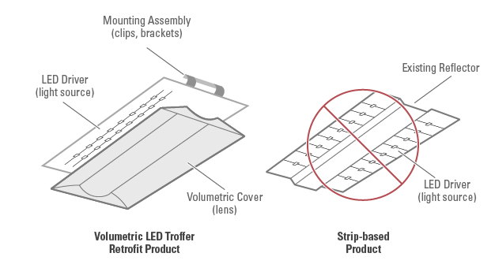
Figure 1: Typical LED Troffer Retrofit Kit Product

DLC’s 2x4 LED Retrofit Kit minimum criteria is shown below:

Lumens: 3,000
Spacing Criteria: 0-180°: 1.0-2.0, 90-270°: 1.0-2.0
Zonal Lumen Density: ≥75%: 0-60°
Efficacy: 85 lumens per Watt
Allowable Correlated Color Temperature (CCT): ≤5000 K
Minimum Color Rendering Index (CRI): 80
L70 Lumen Maintenance: 50,000 hrs
Warranty: 5 years

1.3 Application Types and Delivery Mechanisms
See Appendices A and B for definitions of application types and delivery mechanisms.
The delivery method that is available for these measures is:
- Financial Support – Direct Install

The program/install type for the above measure is:
- Early Retirement
  - Please see the Direct Install Program’s influence document [Attachment 2].

1.4 Measure and Base Case Cost Effectiveness Data

1.4.1 DEER Measure and Base Case Analysis

Table 2: DEER Difference Summary
DEER Difference Summary Table
Referenced versions of DEER and READI | N/A
Summary of deviation from DEER | DEER does not contain LED troffers or retrofit kits
DEER measures scaled? | No
DEER eQUEST prototypes used? | No
DEER operating hours used? | Yes

Net-to-Gross Ratio
The NTG values were obtained using the DEER READI tool. The relevant NTG values for the measures in this work paper are in the table below.

Table 3: Net-to-Gross Ratio
NTGR ID | Description | Sector | BldgType | ProgDelivID | NTG
All-Default<=2yrs | All other EEM with no evaluated NTGR; new technology in program for 2 or fewer years | All | Any | Any | 0.7
N/A* | School Program | Com | School | DirInstall | 0.85
Note: Direct install measures that are not hard-to-reach will use the default NTG value.

*NTG of 0.85 is taken from OP 9 of D.14-10-046:
9. For all projects undertaken by schools, and for programs targeting specific transmission, distribution, or generation constrained areas (other than bottoming-cycle combined heat and power projects), the following rules shall apply:

- For purposes of determining net savings, default ex ante lockdown rules apply, except that a Net-to-Gross ratio of .85 (before spillover effects) is “locked down” for all projects.
- The only eligible measures are those that are above code.
- The cap on expected useful life shall be 30 years for removed equipment only (not the equipment replacing the removed equipment).
- Customer incentives shall be the higher of 75% of incremental measure cost, or what is available under prior policies.
- All K-12 and community college energy efficiency projects, not just those funded by Proposition 39, are eligible for the treatment specified in subsections (a)-(d) above.

Installation Rate
The IR values were obtained using the DEER READI tool. The relevant IR values for the measures in this work paper are in the table below.

Table 4: Installation Rate
GSIA ID | Description | Sector | BldgType | ProgDelivID | GSIAValue
Def-GSIA | Default GSIA values | Any | Any | Any | 1

Spillage Rate
Spillage rates are not tracked in work papers; they are tracked in an external document which will be supplied to the Commission Staff.

Technology Fields
The Technology Fields were obtained from the Ex Ante Database Specification. The relevant Use Category, Use Sub-category, Technology Group, and Technology Type values for the measures in this work paper are in the table below.

Table 5: Technology Fields
Classification | Value
Measure Case UseCategory | Lighting
Measure Case UseSubCats | Indoor General Lighting
Measure Case TechGroups | Lighting - Fixtures
Measure Case TechTypes | LED Fixture
Base Case TechGroups | Lighting – Fixtures
Base Case TechTypes | Linear Fluorescent Fixture

Effective and Remaining Useful Life
The EUL and RUL values were obtained using the DEER READI tool. The RUL value is only applicable to the first baseline period for an RET measure with an applicable code baseline. The relevant EUL and RUL values for the measures in this work paper are in the table below.

Table 6: EUL and RUL
EUL ID | Description | Sector | UseCategory | EUL (Years) | RUL (Years)
ILtg-Com-LED-50000hr | LED Fixture - Indoor- Commercial | Com | Lighting | 12 | 5

1.4.2 Codes and Standards Analysis
Title 24 2013 [355] Section 141.0(b)2 contains codes related to Nonresidential lighting as shown below. The measures in this work paper do change the type of light source in a luminaire which triggers Luminaire Modifications-in-Place. Triggering Modifications-in-Place requires mandatory control provisions in Section 130.1(a)(b)(c)(d) for each enclosed space that includes Area, Shut-off, Multi-level, and if applicable, Daylighting Controls.

Lighting System Alterations shall meet the applicable requirements in TABLE 141.0-E and the following:
- Lighting System Alterations include alterations where an existing lighting system is modified, luminaires are replaced, or luminaires are disconnected from the circuit, removed and reinstalled, whether in the same location or installed elsewhere.
EXCEPTION 1 to Section 141.0(b)2Iii: Alterations that qualify as a Luminaire Modification-in-
Place.
EXCEPTION 2 to Section 141.0(b)2Iii: Portable luminaires, luminaires affixed to moveable partitions, and lighting excluded in accordance to Section 140.6(a)3.

Luminaire Modifications-in-Place shall meet the applicable requirements in TABLE 141.0-F and the following:
- To qualify as a Luminaire Modification-in-Place, luminaires shall only be modified by one or more of the following methods:
  - Replacing lamps and ballasts with like type or quantity in a manner that preserves the original luminaire listing.
  - Changing the number or type of light source in a luminaire including: socket renewal, removal or relocation of sockets or lamp holders, and/or related wiring internal to the luminaire including the addition of safety disconnecting devices.
  - Changing the optical system of a luminaire in part or in whole.
  - Replacement of whole luminaires one for one in which the only electrical modification involves disconnecting the existing luminaire and reconnecting the replacement luminaire.
- Luminaire Modifications-In-Place shall include only alterations to lighting system meeting the following conditions:
  - Luminaire Modifications-in-Place shall not be part of or the result of any general remodeling or renovation of the enclosed space in which they are located.
  - Luminaire Modifications-in-Place shall not cause, be the result of, or involve any changes to the panelboard or branch circuit wiring, including line voltage switches, relays, contactors, dimmers and other control devices, providing power to the lighting system.

EXCEPTION to Section 141.0(b)2Iiii2. Circuit modifications strictly limited to the addition of occupancy or vacancy sensors and class two lighting controls are permitted for Luminaire
Modifications-in-Place

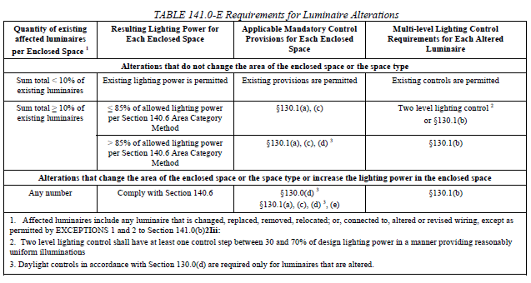
Figure 2: Title 24 Table 141.0-E
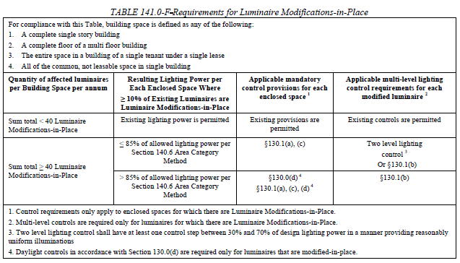
Figure 3: Title 24 Table 141.0-F

Table 7 Code Summary
Code | Applicable Code Reference | Effective Dates
Title 24 (2013) | 2013 Non-Residential Compliance manual Tables 141.0 E & F | July 1, 2014

1.4.3 Non-DEER Study Review
N/A.

Section 2: Calculation Methodology
The performance of the LED Retrofit Kit is based on the Illuminating Engineering Society (IES) minimum standard for classrooms [485]. The IES Lighting Handbook recommends horizontal illuminance target of 500 lux which equates to 46 footcandles. A classroom with a dimension of 30x30 feet (or 23x39 feet for 900 ft² area), 10 foot ceiling height, and 12 fixtures per room was simulated [Attachment 4] on the AGI32 Software [490] as shown in Figure 4. AGI32 is a software tool that determines the photometric performance of a fixture in a simulated space. Based on the results, the LED Retrofit Kits’ lumen output ranges from 3,900 to 4,200 lumens to provide an average intensity distribution between 45 and 46 footcandles, averaging 41 Watts per kit [Attachment 3]. The baseline wattage values are not greater than the LED wattages being installed. T12 and T8 fixtures provide average footcandles anywhere between 54 and 108. The spaces in the projects conducted must be within the same square footage with the same number of light fixtures as it was simulated.

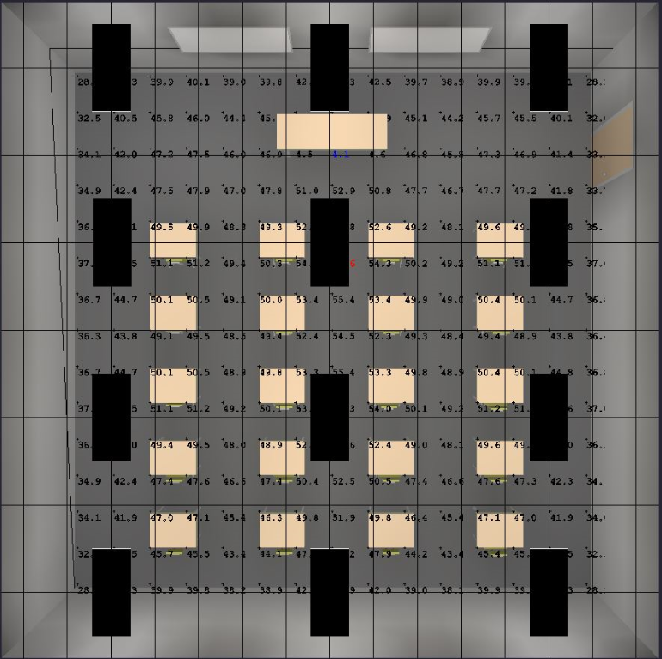
Figure 4: Classroom Simulation

The allowed lighting power density (LPD) of a classroom is 1.2 Watts/ft². The proposed measure at an average of 41 Watts results in 0.54 Watts/ft² which according to Title 24 2013 [355] is ≤85% of allowed lighting power per Section 140.6 Area Category Method. The multilevel lighting control is relaxed to an option of having “two level lighting control with at least one step between 30% and 70% of design lighting power in a manner providing reasonable uniform illuminations.”

Table 8 shows the base wattages with the fixture code taken from the 2013 Table of Standard Fixture Wattages [431], including the measure and delta wattages.

Table 8 1st Baseline Delta Watts
Measure Name | Fixture Code | Existing kW | Measure kW | Delta kW
LED 2x4 Retrofit Kit Replacing 2-Lamp T8 28W | F42WLL | 0.05 | 0.041 | 0.009
LED 2x4 Retrofit Kit Replacing 3-Lamp T8 28W | F43WLL | 0.074 | 0.041 | 0.033
LED 2x4 Retrofit Kit Replacing 4-Lamp T8 28W | F44WLL | 0.099 | 0.041 | 0.058
LED 2x4 Retrofit Kit Replacing 2-Lamp T8 32W | F42ILL | 0.059 | 0.041 | 0.018
LED 2x4 Retrofit Kit Replacing 3-Lamp T8 32W | F43ILL | 0.089 | 0.041 | 0.048
LED 2x4 Retrofit Kit Replacing 4-Lamp T8 32W | F44ILL | 0.112 | 0.041 | 0.071
LED 2x4 Retrofit Kit Replacing 2-Lamp T12 | F42EE | 0.072 | 0.041 | 0.031
LED 2x4 Retrofit Kit Replacing 3-Lamp T12 | F43EE | 0.115 | 0.041 | 0.074
LED 2x4 Retrofit Kit Replacing 4-Lamp T12 | F44EE | 0.144 | 0.041 | 0.103

Table 9 shows the code baseline wattages where the code applies. Code baseline is based on a 900 ft² area and a minimum 1.2 W/ft² LPD that results in 1,080 Watts divided by 12 fixtures that provides 90 Watts per fixture.

Table 9 2nd Baseline Delta Watts
Measure Name | Fixture Code | Code kW | Measure kW | Delta kW
LED 2x4 Retrofit Kit Replacing 2-Lamp T8 28W | F42WLL | 0.05 | 0.041 | 0.009
LED 2x4 Retrofit Kit Replacing 3-Lamp T8 28W | F43WLL | 0.074 | 0.041 | 0.033
LED 2x4 Retrofit Kit Replacing 4-Lamp T8 28W | LPD | 0.09 | 0.041 | 0.049
LED 2x4 Retrofit Kit Replacing 2-Lamp T8 32W | F42ILL | 0.059 | 0.041 | 0.018
LED 2x4 Retrofit Kit Replacing 3-Lamp T8 32W | F43ILL | 0.089 | 0.041 | 0.048
LED 2x4 Retrofit Kit Replacing 4-Lamp T8 32W | LPD | 0.09 | 0.041 | 0.049
LED 2x4 Retrofit Kit Replacing 2-Lamp T12 | F42EE | 0.059 | 0.041 | 0.018
LED 2x4 Retrofit Kit Replacing 3-Lamp T12 | LPD | 0.09 | 0.041 | 0.049
LED 2x4 Retrofit Kit Replacing 4-Lamp T12 | LPD | 0.09 | 0.041 | 0.049

2.1 Energy Savings Estimation Methodologies
The following is a sample energy savings calculation of RET 1st baseline for LED 2’x4’ Retrofit Kit Replacing 3-Lamp T12 in Education – Primary School Building Type in Climate Zone 6.

$$EnergySavings\left[\frac{kWh}{Unit×Year}\right]=\frac{\left(74\right)×\left(2135.2\right)×(1.1641)}{1,000\left(\frac{Watthours}{kWh}\right)}$$
$$EnergySavings\left[\frac{kWh}{Unit×Year}\right]=183.93$$

The following is a sample energy savings calculation of RET 2nd baseline and ROB 1st baseline for LED 2’x4’ Retrofit Kit Replacing 3-Lamp T12 in Education – Primary School Building Type in Climate Zone 6. The code baseline uses the LPD method based on a 900ft² space. The 900ft² space with 1.2 W/ft² and 12 fixtures results in 90 Watts per fixture. This calculation uses the occupancy sensor operating hours for the chosen building type to calculate the energy savings due to code.

$$EnergySavings\left[\frac{kWh}{Unit×Year}\right]=\frac{\left(49\right)×\left(1950.0\right)×(1.1641)}{1,000\left(\frac{Watthours}{kWh}\right)}$$
$$EnergySavings\left[\frac{kWh}{Unit×Year}\right]=111.23$$

2.2 Demand Reduction Methodologies
The following is a sample demand reduction calculation of RET 1st baseline for LED 2’x4’ Retrofit Kit Replacing 3-Lamp T12 in Education – Primary School Building Type in Climate Zone 6.

$$DemandReduction\left[\frac{kW}{Unit}\right]=\frac{(74)×(0.61448)×(1.2977)}{1,000\left(\frac{Watthours}{kWh}\right)}$$
$$DemandReduction\left[\frac{kW}{Unit}\right]=0.05901$$

The following is a sample demand reduction calculation of RET 2nd baseline and ROB 1st baseline for LED 2’x4’ Retrofit Kit Replacing 3-Lamp T12 in Education – Primary School Building Type in Climate Zone 6. The code baseline uses the LPD method based on a 900ft² space. The 900ft² space with 1.2 W/ft² and 12 fixtures results in 90 Watts per fixture. This calculation uses the occupancy sensor coincident diversity factor for the chosen building type to calculate the energy savings due to code.

$$DemandReduction\left[\frac{kW}{Unit}\right]=\frac{\left(49\right)×\left(0.55113\right)×(1.2977)}{1,000\left(\frac{Watthours}{kWh}\right)}$$
$$DemandReduction\left[\frac{kW}{Unit}\right]=0.03504$$

2.3 Therm Savings Methodologies
The following is a sample therm savings calculation of RET 1st baseline for LED 2’x4’ Retrofit Kit Replacing 3-Lamp T12 in Education – Primary School Building Type in Climate Zone 6.

$$Therm Savings\left[\frac{Therms}{Unit}\right]=\frac{(ΔWatts)×(Operating Hours)×(Interactive Effects)}{1,000\left(\frac{Watthours}{kWh}\right)}$$
$$Therm Savings\left[\frac{Therms}{Unit}\right]=\frac{(74)×(2135.2)×(-0.0042973)}{1,000\left(\frac{Watthours}{kWh}\right)}$$
$$Therm Savings\left[\frac{Therms}{Unit}\right]=-0.679$$

The following is a sample therm savings calculation of RET 2nd baseline and ROB 1st baseline for LED 2’x4’ Retrofit Kit Replacing 3-Lamp T12 in Education – Primary School Building Type in Climate Zone 6. The code baseline uses the LPD method based on a 900ft² space. The 900ft² space with 1.2 W/ft² and 12 fixtures results in 90 Watts per fixture. This calculation uses the occupancy sensor operating hours for the chosen building type to calculate the energy savings due to code.

$$Therm Savings\left[\frac{Therms}{Unit}\right]=\frac{(ΔWatts)×(Operating Hours)×(Interactive Effects)}{1,000\left(\frac{Watthours}{kWh}\right)}$$
$$Therm Savings\left[\frac{Therms}{Unit}\right]=\frac{(49)×(1950)×(-0.0042973)}{1,000\left(\frac{Watthours}{kWh}\right)}$$
$$Therm Savings\left[\frac{Therms}{Unit}\right]=-0.411$$

Savings for other measures in different building types and climate zones can be found in the attachment [Attachment 1].

Section 3: Load Shapes
The ideal load shape for net benefits estimates would represent the difference between the base case and measure case. The closest load shapes that are applicable to the measures in this work paper are listed in the table below.

Table 10: Building Types and Load Shapes
Building Type | Load Shape | E3 Alt. Building Type
Education - Primary School | DEER:Indoor_Non-CFL_Ltg | NON_RES
Education - Secondary School | DEER:Indoor_Non-CFL_Ltg | NON_RES
Education - Relocatable Classroom | DEER:Indoor_Non-CFL_Ltg | NON_RES

Section 4: Base Case & Measure Costs
For Direct Install measures, SCE directly utilizes one or more contractors as part of the program. The actual cost can vary by contractor, the date in which the work occurred, and by the volume of business. Contractor costs are confidential information and are based upon contractually agreed upon pricing as established in their purchase order with SCE; therefore, the SCE program tracking system is the only source for this data.

4.1 Base Case Cost
Base case cost is taken from the Statewide Lighting Cost Study [Attachment 5].

Table 11 Base Cost
Measure Name | Base Cost | Labor Cost | Total
LED 2x4 Retrofit Kit Replacing 2-Lamp T8 28W | 63.69 | 26.18 | 89.87
LED 2x4 Retrofit Kit Replacing 3-Lamp T8 28W | 45.74 | 22.98 | 68.72
LED 2x4 Retrofit Kit Replacing 4-Lamp T8 28W | 71.27 | 28.61 | 99.88
LED 2x4 Retrofit Kit Replacing 2-Lamp T8 32W | 21.43 | 32.40 | 53.83
LED 2x4 Retrofit Kit Replacing 3-Lamp T8 32W | 25.50 | 32.40 | 57.90
LED 2x4 Retrofit Kit Replacing 4-Lamp T8 32W | 25.03 | 32.40 | 57.43
LED 2x4 Retrofit Kit Replacing 2-Lamp T12 | 21.43 | 32.40 | 53.83
LED 2x4 Retrofit Kit Replacing 3-Lamp T12 | 25.50 | 32.40 | 57.90
LED 2x4 Retrofit Kit Replacing 4-Lamp T12 | 25.03 | 32.40 | 57.43

4.2 Measure Case Cost
Measure case cost is taken from various online retailers [Attachment 3].

Table 11 Measure Cost
Measure Name | Measure Cost | Labor Cost | Total
LED 2x4 Retrofit Kit | 365.12 | 32.40 | 397.52

4.3 Gross and Incremental Measure Cost

4.3.1 Gross Measure Cost
For RET 1st baseline, GMC is represented by the equation below:

GMC = Measure Equipment Cost + Measure Labor Cost

The RET 1st baseline GMC is the same as measure case as shown in Section 4.2.

For RET 2nd baseline and ROB, GMC is represented by the equation below:

GMC = (Measure Equipment Cost + Measure Labor Cost) –
(Base Case Equipment Cost + Base Case Labor Cost)

Table 11 Base Cost
Measure Name | Measure Cost | Labor Cost | Base Cost | Labor Cost | GMC
LED 2x4 Retrofit Kit Replacing 2-Lamp T8 28W | 365.12 | 32.40 | 63.69 | 26.18 | 307.65
LED 2x4 Retrofit Kit Replacing 3-Lamp T8 28W | 365.12 | 32.40 | 45.74 | 22.98 | 328.80
LED 2x4 Retrofit Kit Replacing 4-Lamp T8 28W | 365.12 | 32.40 | 71.27 | 28.61 | 297.64
LED 2x4 Retrofit Kit Replacing 2-Lamp T8 32W | 365.12 | 32.40 | 21.43 | 32.40 | 343.69
LED 2x4 Retrofit Kit Replacing 3-Lamp T8 32W | 365.12 | 32.40 | 25.50 | 32.40 | 339.62
LED 2x4 Retrofit Kit Replacing 4-Lamp T8 32W | 365.12 | 32.40 | 25.03 | 32.40 | 340.09
LED 2x4 Retrofit Kit Replacing 2-Lamp T12 | 365.12 | 32.40 | 21.43 | 32.40 | 343.69
LED 2x4 Retrofit Kit Replacing 3-Lamp T12 | 365.12 | 32.40 | 25.50 | 32.40 | 339.62
LED 2x4 Retrofit Kit Replacing 4-Lamp T12 | 365.12 | 32.40 | 25.03 | 32.40 | 340.09

4.3.2 Incremental Measure Cost
Incremental Measure Cost is the same as 2nd baseline Gross Measure Cost as shown in Section 4.3.1.

Attachments
1. 2. 3.4.5.

References
[355]
[431]
[485]
[486]
[490]

Appendix A: Application Types
This table compares the application types in SCE’s systems with those in DEER.

SCE Application (Program) Type | DEER Application Type | Savings |  | Cost |  | Life
 |  | 1st Baseline (BL) | 2nd BL | 1st BL | 2nd BL | 1st BL | 2nd BL
New Construction (NEW) | New Construction (Nc) | Above Code or Standard | N/A | Incremental Cost | N/A | EUL | 0
Replace on Burnout (ROB) | Replace on Burnout (Rob), Normal Replacement (NR) | Above Code or Standard | N/A | Incremental Cost | N/A | EUL | 0
Retrofit (RET) | Early Replacement (ER) | Above Customer Existing | Above Code or Standard | Full Cost | Incremental Cost | RUL | EUL-RUL
Retrofit – First Baseline Only (REF) | Early Replacement RUL (ErRul) | Above Customer Existing | N/A | Full Cost | N/A | EUL | 0
Retrofit Add-on (REA) | N/A | Above Customer Existing | N/A | Full Cost | N/A | EUL | 0

Appendix B: Delivery Mechanisms
A delivery mechanism is a delivery method paired with an incentive method. SCE’s delivery methods include:
- Appliance Turn-in and Recycling
- Audit/Information
- Commissioning
- Financial Support
- Innovative Design
- Midstream Programs
- Partnership
- Upstream Programs
The following table describes the incentive methods.

Incentive Method | Description
Direct Install | The utility program performs an assessment of the customer’s facility, provides recommendations, and implements energy efficiency measures for free.
Down-Stream Incentive - Deemed | The customer installs qualifying energy efficient equipment and submits an incentive application to the utility program. Upon application approval, the utility program pays an incentive to the customer.
Exchange - Replacement | The utility program holds events where customers can trade functional equipment for similar but more energy efficient equipment, free of charge.
Giveaway | The utility program provides customers with energy efficient equipment for free.
Mid-Stream Incentive | The utility program offers buydowns and incentives to third parties (typically retailers, distributors, and contractors), who then stock, promote, lower prices on, and/or sell energy efficient equipment. Contractors install energy efficiency equipment, sometimes using specified quality procedures, at the customer’s property.
On-bill Finance - loan | Customers can finance energy efficiency projects at 0% interest and repay the loan through their monthly utility bill.
Testing Services / Other | The utility program performs free testing services or assessments of the customer’s facility and provides information and recommendations for potential energy efficiency measures.
Up-Stream Buy Down, Up-Stream Incentive | The utility program offers buydowns and incentives to vendors (typically manufacturers and distributors), who then manufacture, stock, promote, lower prices on, and/or sell energy efficient equipment. There is some overlap between the mid-stream and up-stream approaches.

