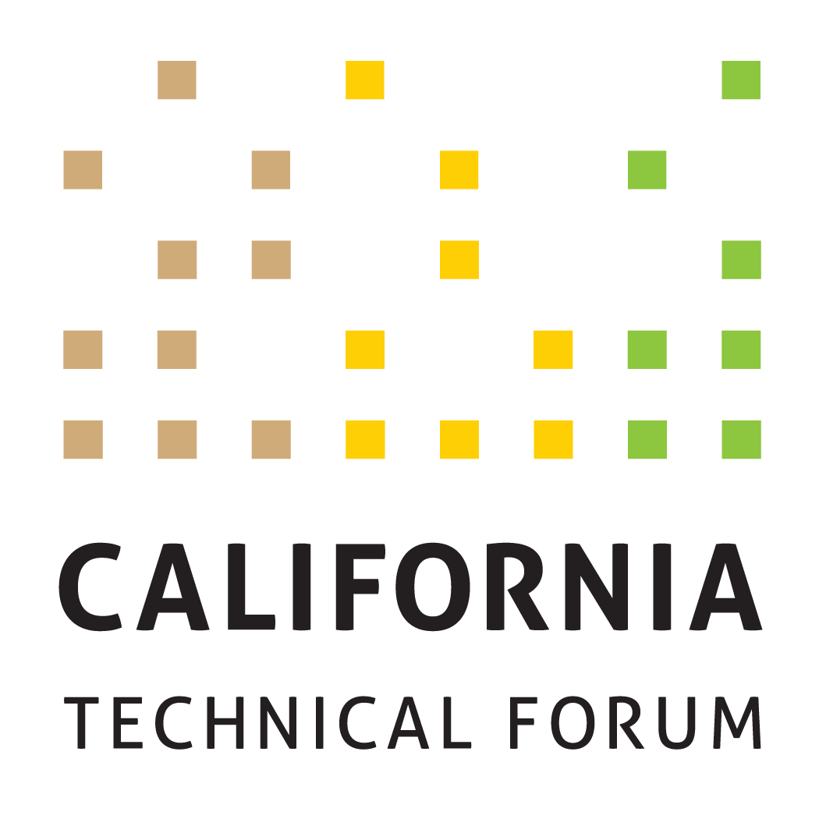

Business Plan
2020

To support the growth and success of energy efficiency and integrated demand-side management (IDSM) through a technically rigorous, independent, transparent peer review of California energy efficiency values and other related technical information.

Disclaimer: The Cal TF Policy Advisory Council (PAC) approval of this Business Plan does not constitute endorsement of ensuing technical work products by individual members or organizations.

Goal | Metrics | Tactics  (Cal TF) | Benefits | Tactics  (Others)
- Administer the eTRM ver. 1.0 | Complete 2020 eTRM training objectives, including:  - Conduct up to nine (9) two-hour webinar trainings for different user groups  - Survey participants regarding views of eTRM.  Identify and socialize Phase 3 eTRM Enhancements  - Complete by end of Q2 2020  Administer eTRM  - Ongoing | Cal TF Staff will support industry training on the eTRM through the following activities:  - Coordinate with the IOUs, POUs, CPUC, and CEC to determine their training needs and timing.  - Solicit input on eTRM training needs of 3P implementers/other stakeholders through Cal TF and other venues (such as CEDMC).  - With input from CPUC Staff, solicit input on eTRM usability and training needs by developing and administering an online questionnaire for trainees and users and prepare summary memorandum (Q3 2020).  - Solicit and memorialize feedback from users on experience with eTRM ver. 1.0 and possible enhancements.  - Solicit and document recommendations for additional features and enhancements for 2021 (Ongoing).  Cal TF Staff will administer the eTRM through the following activities:  - Maintain “issue” and “suggestion” log to track user issues and questions  - Monitor system performance  - Execute host maintenance agreement with the software developer | Cost Savings  Transparency  Standardization  eTRM User Experience  Transparency  eTRM User Experience | Key stakeholders (6 funders – PG&E, SCE, SCG, SDG&E, LADWP and SMUD – and the regulatory agencies, CPUC and CEC) will identify key internal users to receive eTRM training and support.  CPUC Staff and Ex Ante Review Consultants (EAR Consultants) will provide input on the feedback they would like from eTRM users.
- Implement the eTRM Leveraging, Transition and Launch Plan so the eTRM will be used as the “Database of Record” Effective January 1, 2021 | Finalize and implement the eTRM Leveraging, Transition and Launch Plan so that eTRM is used as the “database of record” for statewide deemed measures by CPUC Staff, IOUs, POUs, and 3Ps by January 1, 2021 | Cal TF Staff will collaborate with multiple organizations to support development of the Transition, Testing, Acceptance and Use Plans for each organization.  - Q1 and Q2 – plans developed  - Q3 and Q4 –plans implemented  Cal TF Staff will work with the CPUC Staff and Cal TF PAC to identify and implement the regulatory path to eTRM adoption as the “Database of Record” by January 1, 2021. | Cost Savings  eTRM User Experience Transparency  Statewide Consistency | The following organizations will develop transition, testing, acceptance and use plans for the eTRM  - CPUC  - IOUs
 | Develop eTRM Governance Plan  - Draft Q1, 2020  - Final Q3, 2020 | Cal TF Staff will work with eTRM funders, CEC and CPUC, with input from full PAC, on eTRM Governance document. Topics addressed will include:  - Organizations to serve on the Governance Committee  - eTRM tool ownership and licensing model  - eTRM hosting and security  - eTRM content ownership and licensing  - Annual “enhancement” process  - Funding stream  - Tool(s) or modules can connect to eTRM | Transparency  Statewide Consistency | The following organizations will review and approve the eTRM Governance Plan (eTRM funders):  - 4 IOUs (PG&E, SCE, SCG, and SDG&E)  - 2 POUs (LADWP, SMUD)  The following entities will review and comment on the eTRM Governance Plan:  - CPUC Staff  - CEC Staff  - PAC members
- Manage and Implement the 2020 Statewide New Measure Development and Measure Update Process | Track and report measure development metrics (Ongoing) | Cal TF Staff will establish a statewide Measure Review Committee for measure screening.  Cal TF Staff will create a central intake process for 3P proposed measures (new or updated) through the Cal TF website. Cal TF Staff will screen Measure Submission Form for completeness.  Cal TF Staff will memorialize measure review committee decisions and will enter “passing” measure into eTRM.  Cal TF Staff will solicit early feedback from Cal TF and EAR Consultants on proposed measures or measure updates and will monitor measure development.  Cal TF Staff will review final new measures or measure updates to ensure conformance to the Statewide Measure Development and Peer Review QA/QC Guidelines and Style Guide. Cal TF Staff will then work with measure developers to present and seek affirmation from Cal TF. Finally, Cal TF Staff will coordinate with the IOUs that will submit measures through WPA for CPUC Staff review and approval. | Cost Savings  Time Savings  Transparency  Stakeholder Engagement | The Measure Review Committee members will participate in training and follow established process.

Goal | Metrics | Tactics  (Cal TF) | Benefits | Tactics  (Others)
- Identify, Analyze, and Recommend Key Emerging Technical and Technical Policy Issues in a Statewide Consistent Way | Update, Prioritize, and Maintain Stage 2 Issues List  Track, monitor, and report on recommendations pertaining to Cal TF Stage 2 Issues List | Cal TF Staff will maintain and update the Stage 2 Issue List with input from IOUs, POUs, CPUC Staff and EAR Consultants, and CEC Staff. | Transparency  Statewide Consistency  Technical Rigor | Representatives of the following entities will provide timely input on the Stage 2 Issues List, particularly how to prioritize issues and if they would like to lead development and resolution of one or more Stage 2 issues:  - IOUs & POUs  - CPUC ED Staff & EAR team  - CEC
 | Develop at least one (1) Technical Position Paper (TPP)  - Draft TPP  - Final TPP | Cal TF Staff will develop TPP with input from a Cal TF subcommittee. Potential topics is:  - Develop framework for improving cost-effectiveness analysis in CA, including statewide consistent approach, improved CET tool development, best practice CET calculations. | Technical Rigor | The PAC will affirm the final TPP topic.  Cal TF members will provide input and contribute to the TPP via subcommittee process.  Proposed TPP topics will be discussed with regulatory staff (CPUC and CEC)
 | Develop at least one (1) white paper  - Draft white paper  - Final white paper | Cal TF Staff will develop with paper with input from a Cal TF subcommittee. Cal TF High Interest White Paper topics are:  - Fuel Substitution Measures  - EE + DR Bundled Measures  - Policy Guidance for Load Shapes  - Bundled EE Measures  - Policy Guidance for the Classification of a Measure as ET vs. Custom vs Deemed  Ongoing White Papers from 2019 are:  - Greenhouse Gas Calculation Approach and Data Sources; Recommendations for eTRM  - Deemed Measure Cost Savings  - Deemed Measure Savings Calculation Approaches  - Creating Tighter Linkage Between Deemed Savings and EM&V Studies | Technical Rigor  Statewide Consistency | The Cal TF members will provide input to determine the final white paper topic(s). Cal TF members will provide input and contribute to the white paper via subcommittee process.
- Document Deemed Modeled Measures in a Consistent and Transparent Way | Create documentation standard for a modeled measure to ensure all deemed modeled measures are well-documented, reproducible, and consistent. | Create consensus on the methodology for documenting modeled measures that could include:  - Prototype source  - Input files (weather files, thermostat settings, weighting files, etc.)  - Keyword changes with justification and documentation  - Identify areas where documentation is not available so it can be updated over time  Create a standard way to document results of a modeled measure. | Transparency Standardization  Cost Savings  Transparency Standardization | CPUC Consultants (Group A and D) and CEC Staff will provide common documentation standard for modeled measures, including hybrid measures.  SCE, the statewide lead for building energy modeling, will collaborate with Cal TF Staff.
- Develop Guidelines and Process for Hybrid Measures  (6. Develop Guidelines and Process for Hybrid Measures, cont.) | Develop guidelines for “hybrid measures” created through consensus process  - Draft – Q2  - Final – Q4  Identify and create 2 – 3 hybrid measures (Q4 2020)  Develop white paper for POUs on how their custom project development and review could be standardized and streamlined through eTRM | Define and create criteria for a hybrid measure.  Develop Hybrid Measure Characterization Template and Data Specification based on the Statewide Deemed Measure Data Specification.  Create list of potential hybrid measures and support the choice for the first 2 – 3 hybrid measures. Ensure that the first hybrid measures include both gas and electric savings measures.  Create guidance for the hybrid measure savings calculation methodology for the 2 – 3 example measures that includes:  - Allowable assumptions  - Inputs from specifications  - Inputs from spot measurements  - Inputs from logged/monitored data  Create guidance for M&V that varies based upon savings or risk or other defendable criteria for the 2 – 3 example measures.  Create guidance for the calculation methodology specifically for the 2 – 3 example measures that includes:  - Cost documentation  - References  - Project life  - Program influence | Cost Savings  Time Savings  Customer Experience Increased Savings  Standardization  Cost Savings Transparency  Customer Satisfaction  Standardization  Cost Savings Transparency  Standardization  Cost Savings  Cost Savings  Customer Satisfaction Standardization | The IOUs and POUs will provide custom project data to support this goal.  The CPUC Custom lead and CPUC Group D consultants will provide input and review.  CPUC Staff and Group A consultants will provide input to ensure alignment.  Cal TF members will help to gather the implementer perspective for this process.
- Manage, Update, and Communicate Monthly Changes to the “Statewide Deemed Measure List” | Update and post the Statewide Deemed Measure List  - Monthly | Cal TF Staff will circulate the Statewide Deemed Measure List monthly to IOUs and POUs for new measures and measure updates.  Cal TF Staff will conduct monthly teleconferences with designated IOU and POU leads to review new measures and measure updates to ensure all are aware of changes/additions and can ensure measure changes/additions reflect statewide needs.  Cal TF Staff will post monthly updated Statewide Deemed Measure List to Cal TF website. | Cost Savings  Statewide Consistency  Transparency | During monthly meetings, the IOU and POU measure development coordinators will inform their IOU counterparts and Cal TF Staff of measures under consideration, in development, and retired; as well as the status of measures in development.  IOU/POU measure development leads will ensure that new measures are developed to be applicable statewide and will reflect include input from their counterparts at other IOUs and POUs.
- Manage the Cal TF and Cal TF PAC  (8. Manage the Cal TF and Cal TF PAC, cont.) | Conduct at least ten (10) TF meetings (in-person or teleconference) and additional subcommittee meetings, as required.  Conduct four (4) PAC meetings (in person or teleconference)  Maintain Cal TF website and update and post all materials | To manage the TF the Cal TF Staff will:  - Prepare a calendar of TF meetings and locations  - Secure meeting locations and arrange other logistics  - Prepare and post meeting agendas and materials  - Manage TF meetings  - Prepare and post meeting notes  To manage the PAC the Cal TF Staff will:  - Schedule PAC meetings approximately quarterly, based on policy needs and activity  - Prepare meeting agendas and materials  - Manage meetings  - Prepare and circulate meeting notes  Cal TF Staff will maintain current data and information (including Cal TF process documents) on the Cal TF website. | Transparency  Statewide Consistency  Stakeholder Engagement | Cal TF and PAC members will attend meetings.  Cal TF members will participate in subcommittee meetings relevant to their expertise.  Cal TF and PAC members will prepare for meetings by reviewing materials in advance.
- Develop the 2021 Cal TF Business Plan | Develop Cal TF 2021 Business Plan  - Draft by October 15, 2020  - Final by the December 2020 PAC Meeting | Cal TF Staff will solicit comments on the draft Cal TF 2021 Business Plan from TF, PAC, CPUC and CEC staff, and other stakeholders.  Cal TF Staff will develop a final 2021 Business Plan that reflects stakeholder input. Cal TF Staff will submit to PAC for review and approval in the December 2020 PAC meeting. | Transparency | PAC, TF, CPUC Staff, and others will provide input on the draft 2021 Cal TF Business Plan.  PAC will affirm the 2021 Business Plan by December 2020.

Successful completion of this deliverable is subject to CPUC approval for the eTRM to serve as the database of record for statewide deemed measures.
Stage 2 issues are issues related to deemed measures that should be addressed/resolved later (after CPUC review/approval process for a new/updated measure). It is common for issues to be identified (policy or technical) that cannot be addressed/resolved at the time a measure is submitted for review due to insufficient data, need for a policy clarification/change, or other reasons.

