Methods for Estimating Measure Impacts
Quality Installation For Residential Split Systems & Packaged Units Workpaper - SCE13HC023
By: Andres Fergadiotti / SCE (DSM Engineering), REV_February 12, 2015

This report overviews communication and documentation gathered for the Western HVAC Performance Alliance (WHPA) in 2014 as well as documentation being presented to the California Technical Forum (Cal TF) on methods to be used for updating energy and demand savings estimations on measure. 2015 workpaper update is expected to incorporate parameters suggested by the CPUC’s in their WO32 - HVAC Impact Evaluation Report – See Attachment [A]

This activity is intended to encourage a transparent and collaborative process as well as alignment between deemed (Ex-Ante) energy estimating methods and Industry as well as alignment with the Cal TF undertaking rigorous processes to review energy savings estimates and technical parameters impacting the California energy efficiency portfolio.

Section 1 - Summary of Parameters Used in Building Energy Simulation (BES) for Estimating Energy Savings

Following section summarizes general methodology and parameters used for estimating measure impacts using the eQuest/DOE2.2 - Building Energy Simulation (BES) tool. These parameters are ranked as “High Impact”, “Medium Impact”, and “Low Impact” based on the severity they are expected to influence estimated impacts from measure.

Background

Methodology for estimating energy and demand savings on measure will utilize the Database for Energy Efficiency Resources (DEER) Residential Single Family (SFM) prototype. The SFM prototype describes the site configuration, including multiple building shells (total of four shells corresponding to two single-story homes and two two-story homes at different orientations). Each shell is served by a dedicated HVAC system. Prototype characteristics on mechanical, lighting, domestic hot water, envelop, occupancy, plug load, etc. correspond to an eQuest/DOE2.2 input parameter and/or performance characteristic with some of these developed specifically for the DEER analysis.

Energy and demand savings will be weighted using the DEER’s Commercial Vintage Weights documentation based on the “Single Family – Heating and Cooling” category. Building population (e.g., weight) under this criterion and throughout SCE’s territories is highest on 1975 and followed by the 1985 vintage. Contributions and/or impacts from latest vintages including 2003 and 2007 are minimal.

Residential building weights are developed from the Residential Appliance Saturation Survey (RASS) data. This supports the development of typical savings values for measures where the actual participation among the population of buildings is not known. RASS is one of the most valuable sources of information for residential Unit Energy Consumption (UEC) values. The DEER team uses these UECs to calibrate the prototypical residential simulation models so that these models yield annual energy use values for heating and cooling that are similar to RASS.

The SFM prototype will be generated using the CPUC’s Measure Analysis Software Control (MASControl) application at multiple vintages and climate zones under the SCE’s territory. The base case will be configured using the Customer Average (CAv) case as generated by MASControl. The measure case will be configured by adjusting performance parameters and/or characteristics within the base case energy model.

Weather data used in the energy simulation will be based on CZ2010 data. DEER2014 uses the new weather CZ2010 data, along with new peak period definitions based on the new weather data, in the determination of all weather sensitive energy savings. The CZ2010 weather files uses data from 1998-2009 for 86 locations in California, combined with satellite-derived solar radiation. Calculation of peak demand (kW) will similarly follow DEER2014 methods.

Proposed parameters and/or performance characteristics to be used in the energy model are generally consistent with those used in the original version of the workpaper. Table 1 compares parameters used under “base case” and “measure case” in current version of workpaper (2014) and those recommended by WO32 for new workpaper update (2015).

WO32 - HVAC Impact Evaluation Brief

WO32 HVAC Impact Evaluation (evaluation hereafter) included evaluation of SCE’s Residential Quality Installation (RQI) program. Under this study, non-participants were recruited from PG&E, SCE, and SDG&E service areas to provide a common-practice baseline. Since SCE was the only utility with a RQI program, program participants were limited to SCE’s service area. The evaluation included site visits at 50 program participant and 50 non-participant sites, all of which were located in climate zones (CZs) 8 through 16.

Energy and demand savings estimates in impact evaluation were developed through (SFM DEER Prototype) energy simulations to extrapolate and normalize observed savings to first year annual savings. Onsite data collection activities were combined with calibrated simulation modeling to estimate impacts. This approach supports the evaluation and measurement of residential HVAC systems in the current cycle and provides field data to improve ex-ante estimates used in future program cycles.

Overall gross realization rates estimated by the evaluation were 35% for energy (kWh) savings and 38% for demand (kW) savings. These realization rates were primarily driven by the finding that non-participant baselines for system sizing and duct leakage were better than those assumed in ex ante program (workpaper) calculations.

The baseline for unit efficiency was a new minimum efficiency unit, not the existing system since the program assumed a replacement upon burnout (ROB) of the existing system. The pre and post energy consumption is not equivalent to the savings from quality installation since the savings claims were not early replacements.

In summary, evaluation suggests that installations in the program exceeded Title 24 code, on average for system design attributes covered by the program, and those installations outside the program do not perform as poorly as assumed in program workpapers. Further, the program workpaper (a) does not fully capture the improved fan efficiencies present in the sampled participants and (b) does not model the impact on the program of applying sensible capacity standards via ACCA Manual S to system sizing.

Parameters to be used in building energy simulations for estimating measure impacts in 2015 workpaper will follow CPUC’s recommendations documented in evaluation. Following table (Table 1) summarizes performance parameters evaluated and documented in WO32 as well as those used in latest version of the workpaper.

Table 1. Summary of Key Parameters Utilized for Estimating Energy and Demand Savings
ID | Ranking | Description | WP  (base case) | WP (Measure Case) | WO32 Non-Participant | WO32 Participant | Remarks
1 | High Impact | Flow Performance  (kW/cfm) | 0.000510 kW/cfm | 0.000383 kW/cfm (approx. 25% reduction) | 0.000569 kW/cfm | 0.000486 kW/cfm  (Approx. 15% reduction) | WP Assumptions  KW/cfm - Design full load power of the supply fan per unit of supply air flow rate. Note that in the DEER SFM prototype this parameter is defaulted to 0.000365 kW/cfm [1][2][3].  WO32  Evaluation when possible measured fan power in cooling and either heating or fan-only modes. This difference may be partially due to the fact that QI participants also installed high efficiency units with more efficient fans. This aspect, however, was not studied as the focus was on the QI aspects not the unit efficiency and fan motor efficiency.  Additional information on static pressure, fan settings, and design airflow were not part of the analysis, but collected and documented in WO32 - Appendix C.
2 | High Impact | Duct Leakage | (24%) 0.0804 | (12%) 0.0402 | 16.6% | 11.5% | WP Assumptions  Duct Leakage (Duct Air Loss Ratio)  Fraction of the supply air that is lost from the ductwork, thereby reducing the design supply air at the zones.  DEER Assumption [4]  Baseline: 24% Leakage  Measure: 12% Leakage  Supply air leakage estimated as follow:  (% leakage/2) x 0.75 - single-story house  (% leakage/2) x 0.67 - two-story house  [9][10] Data source can be used to inform base case and/or measure case parameter  WO32  According to evaluation, almost half of the participant tested systems had leakage meeting program requirements of 15% or less.  Note that 2008 Title 24 required duct leakage less than 15% (of nominal system airflow) if a major component of the HVAC system (air handler, outdoor condensing unit, cooling or heating coil, or furnace heat exchanger) is replaced or installed.  The evaluation also measured the leakage outside the conditioned space (LTO) relative to nominal unit airflow. Per evaluation, duct leakage to outside for recent residential installations are 7.42% and 10.73% for participants and non-participants respectively. Note that total duct leakage is the sum of leakage into conditioned spaces and leakage to outside of conditioned spaces.
3 | High Impact | System Sizing (Cooling capacity, Btu/h) | Oversized by 20% | Defaulted per Prototype (0% Oversized) | 13% | 10% | WP Assumptions  See supporting documentation further in the report [5]  [8] Data source can be used to inform base case and/or measure case parameter  WO32  Data collected onsite informed the development of an ACCA Manual J-based system-sizing model for all participants and non-participants. The primary analysis compared the calculated size to the installed tonnage to determine the amount of over or under-sizing  The QI programs require the use of both Manual J [*] and Manual S [**] for equipment sizing. The evaluation used program approved Manual J software in the analysis.  Impact evaluation finding suggests oversized and undersized units in both the participant and nonparticipant samples. Both groups tended to have oversized units with a small difference in mean sizing ratio, but non-participants had a wide distribution with more cases of significant oversizing.  Further, evaluation suggests that approximately 82% of evaluated participant systems were sized within 0.5-ton of design cooling capacity.  [*]ACCA Manual J is a standard for producing air conditioning and heating load calculations for single family homes, small multi-unit residential structures, condominiums, town houses, and manufactured homes.  [**]ACCA Manual S provides sizing requirements for cooling and heating equipment, allowing the selection of equipment based on sensible and latent loads and ensuring the selected equipment will be properly matched to the local climate.
4 | High Impact | Airflow Capacity | 350 cfm/ton | 395 cfm/ton | 299.7 cfm/ton | 337.5 cfm/ton | WP Assumptions  Referenced study suggests that design flow capacity (cfm) in Measure Case may be lower than the “standard” 400 cfm/ton (e.g., in the order of 340 cfm/ton in new California homes) assumed in the analysis of the measure. [3]  [9][10] Data source can be used to inform base case and/or measure case parameter  WO32  Evaluation used nominal cooling tons established by AHRI ratings for each unit. The collected data showed that the averages were closer to 300 cfm/ton for non-participants and 338 cfm/ton for participants. These values are within the 300–350 cfm/ton range for Title 24 compliance. The 10% difference between participant and non-participant airflow was similar to workpaper assumptions.
5 | Medium Impact | Equipment Efficiency | SEER 14 (Revised per 2015 Code Updtate) | SEER 15 thru SEER 21 (Revised per DEER2015 Update) |  |  | WP Assumptions  Since the delivery mechanism on measure is Replace on Burnout (ROB), equipment efficiency (including base case efficiency) compares between the Code Case (e.g., SEER 14) and Measure Case  Updated Residential HVAC Measures - SEER ratings and tiers on equipment efficiency in 2015 version of the workpaper, including both Air Conditioners and Heat Pumps, will be consistent with that documented in 2015 DEER updates, which includes additional tier levels and size ranges as required by the code update.

References:
[1] CPUC’s MASControl software application created to generate DEER prototypical buildings (including latest building vintages (e.g., 2013) with current code updates) and to overview pre-developed DEER measures. The software application allows the use of existing prototypes to addressed non-DEER measures – www.deeresources.com.
[2] DEER SFM prototype with 1975 building vintage and California climate zone 6 (e.g., CZ06).
[3] Hidden Power Drains: Residential Heating and Cooling Fan Power Demand - John Proctor, Proctor Engineering Group, Ltd., Danny Parker, Florida Solar Energy Center.
[4] 2004-2005 Database for Energy Efficiency Resources (DEER) Update Study, Final Report, Itron, Inc.
[5] Energy Center of Wisconsin | ECW Report Number 241-1 | Central Air Conditioning in Wisconsin | A compilation of recent field research.
[6] ASHRAE Handbook – Fundamentals | Energy Estimating and Modeling Methods.
[7] Homes by Building, Vintage, and Utility Climate Zone, Source: RASS, KEMA Estimates 2002-2007
[8] Peak Demand and Energy Savings from Properly Sized and Matched Air Conditioners, Robert Mowris and Ean Jones, Verified, Inc.
[9] Laboratory Measurements and Diagnostics of Residential HVAC Installation and Maintenance Faults, Robert Mowris, Ean Jones, and Robert Eshom, Robert Mowris & Associates, Inc.
[10] NIST Technical Note 1848 - Sensitivity Analysis of Installation Faults on Heat Pump Performance, Piotr A. Domanski, Hugh I. Henderson

Section 2 – Overview and Supporting Documentation on BES Parameters

Following section overviews and details parameters (primarily those with Medium and High Impact) used in the BES for estimating energy savings on measure (e.g., current version of workpaper). Succeeding documentation additionally outlines parameters outside the BES that are part of the workpaper mechanisms that influence energy impacts on the measure: (a) Delivery Mechanism (e.g., Replace on Burnout) and (b) Best Available Data.

Static Pressure

Referenced Study: Hidden Power Drains: Residential Heating and Cooling Fan Power Demand - John Proctor, Proctor Engineering Group, Ltd., Danny Parker, Florida Solar Energy Center

The standard assumption for external static pressure, according to DOE test standards, ranges from 0.1 inches of water column (IWC) for 2-ton residential units to 0.2 IWC for units larger than 3.5 tons. As shown in table below (Table 2), the external static pressure values measured in field tests representing both new and existing construction are two to four times higher than DOE assumptions. The values for the field-tested units ranged from 0.41 IWC to 0.55 IWC. This is at least twice the value assumed for larger (3.5+ ton) units.

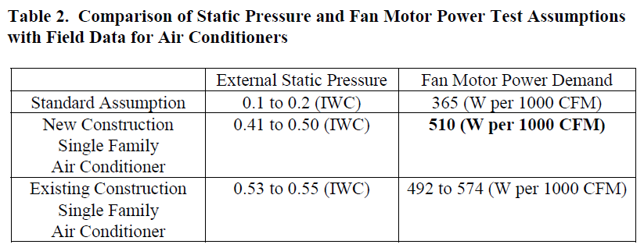

High static pressures produce reduced airflows and the need for higher horsepower fan motors to approach proper flow. Indoor fan motor power demand is a result of external static pressure, flow, fan efficiency, motor efficiency, as well as cabinet and heat exchanger design. The standard DOE assumption for indoor fan energy consumption is 365 watts per 1000 CFM. As presented in the above table (Table 2), fan motor power draw under operating conditions averages 510 watts per 1000 CFM, 40% higher than the assumed value. For a five-ton air conditioner achieving 2000 CFM of airflow, this is equivalent to a one kilowatt electric resistance heater in the air stream.

Design Flow Capacity (cfm/ton)

Referenced Study: Hidden Power Drains: Residential Heating and Cooling Fan Power Demand - John Proctor, Proctor Engineering Group, Ltd., Danny Parker, Florida Solar Energy Center.

The nine field tests reported in this study were conducted from 1994 to 1998 under the sponsorship of various Utilities and research organizations. The results are replications from three independent organizations in a wide variety of areas. The performance characteristics of these systems are presented in table (Table 1) below. Refer to referenced report for further details.

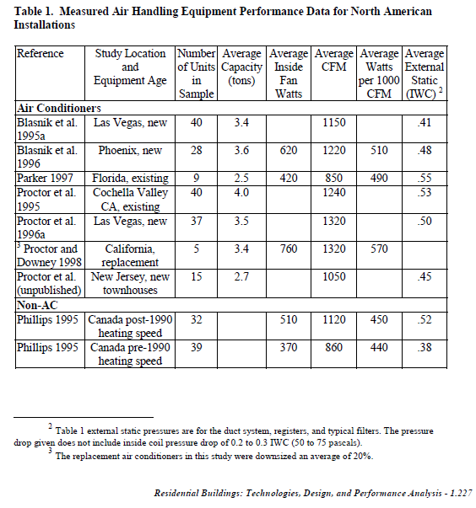
In summary, this study suggests that in new California homes, the design flow capacity per cooling capacity (e.g., cfm/ton) approximates to 350 cfm/ton opposed to 400 cfm/ton which is inconsistent with workpaper assumption on both the base case and measure case.

Duct Leakage

Referenced Study: 2004-2005 Database for Energy Efficiency Resources (DEER) Update Study, Final Report, Itron, Inc.

DEER includes two duct sealing measures under the Residential Weather Sensitive DEER Measure Descriptions: (a) Duct Sealing (28% total leakage reduction) – total leakage reduced from 40% of AHU flow to 12% and (b) Duct Sealing (12% total leakage reduction) – total leakage reduced from 24% of AHU flow to 12%. Measure analysis and assumption on energy impacts under this measure are based on the “12% total leakage reduction” DEER measure. Following table describes general parameters on Duct Sealing Measure.

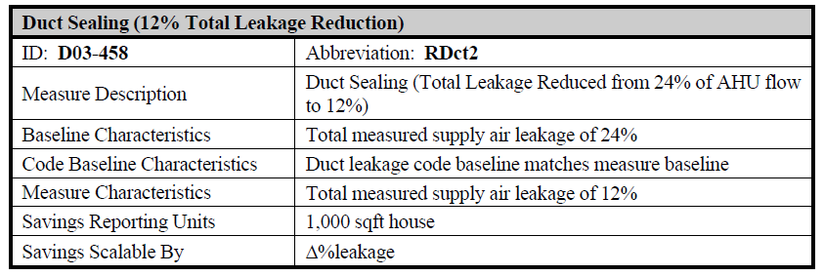

Single Family Duct Leakage Measure Description

Per DEER, the base case for their first duct leakage measure is “40% total air leakage.” Of this total, half is supply leakage. For single-story houses, 75% of the supply leakage is assumed to go to the unconditioned attic (SupLeakA), with the remainder leaking to the conditioned spaces (SupLeakH).

Duct leakage to the conditioned spaces, while typically part of most duct loss measurements, is not actually “lost” and is treated as supply CFM for the simulation. Return duct leakage in the single family house is assumed to be 80% of the volume of the supply duct leakage. This would imply that 20% of the supply duct loss is made up with outside air (RetLeakOA), but due to interactions with existing natural infiltration, it is assumed that only half of this value (10% of supply duct loss) is actually brought in from the outside. The balance of (supply air lost to attic) minus (outdoor air induced into the space) is return, or air that is sucked into the return ducts from either the attic (RetLeakA) or house(RetLeakH).

The measure case of the second duct measure documented in DEER specifies 12% total duct leakage. All of the same fractional air flows of the base case are carried through to the measure case, leading to a supply air loss of 6% times 0.75 for single-story houses and 6% times 0.67 for two-story houses.

The second duct measure, which lowers total duct leakage from 24% to 12%, has a base case supply duct leakage of 12% times 0.75 for single-story houses, and 12% times 0.67 for two-story houses. The measure case is the same as the first duct EEM.

Sizing

HVAC Equipment Sizing

The procedures of residential HVAC design (sizing) are covered in detail by a series of publications produced by the Air Conditioning Contractors of America (ACCA), which in turn references information provided by the American Society of Heating, Refrigerating and Air-Conditioning Engineers (ASHRAE). The heat loss and gain values are estimated using the procedures from the ACCA Manual J—Residential Load Calculation (Manual J) (Rutkowski 2006). Manual J applies only to single-family detached dwellings, low-rise condominiums, and townhouses.

Mechanical equipment selection is done with the aid of the ACCA Manual S—Residential Equipment Selection (Manual S) (Rutkowski 1995). Selecting equipment based on the cooling load may lead to a furnace that is oversized for the heating load. Manual S recommends that the furnace size remains within 140% of the peak heating load estimate and that cooling equipment capacity not exceed the total load by more than 15%.

It should be recognized that in energy-efficient houses, the loads may be so small that the standard manufacturer’s range of capacities exceeds these percentages (or in some cases, the capacity of the HVAC equipment stocked by the Distributor exceeds design load requirements). For example, if a house has a 19,000 Btu/h cooling load and manufacturer’s equipment is available in only 17,500 Btu/h and 23,400 Btu/h, the larger unit is more than 15% oversized. However, the larger unit should be the equipment selected to ensure the peak load will be met. Designers may want to consider multispeed equipment in these cases, where the system runs more frequently at a lower capacity to more closely meet the load for more times of the year.

Referenced Study 1: Energy Center of Wisconsin, Report Number 241-1 | Central Air Conditioning in Wisconsin | A compilation of recent field research | May 2008

Per referenced study, while Manual J calculations indicate that most systems are appropriately sized to within ½ ton, monitoring data suggest that most systems are in fact oversized: empirically-based sizing estimates indicate that about a quarter of systems are appropriately sized, a third are oversized by ½ ton, and 40 percent are oversized by a ton or more. Only one of 39 systems evaluated appeared to be undersized. Following figure (Figure 5) depicts empirical estimates of relative sizing per referenced study.
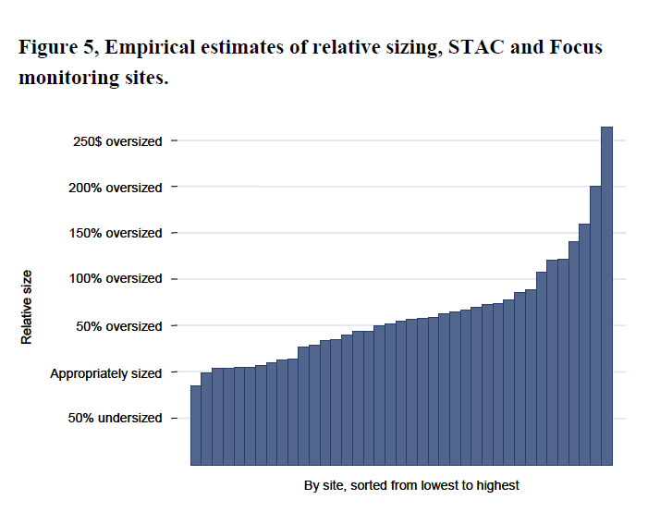
Referenced Study 2: Peak Demand and Energy Savings from Properly Sized and Matched Air Conditioners - Robert Mowris and Ean Jones, Verified, Inc.

This study indicates that research studies have shown that 50 to 70 percent (%) of residential and commercial air conditioning systems are oversized by 120% or more (James, et al 1997; Sonne, et al 2006; Mowris, 2006; Nadel 1998; Parker 1993; Jacobs 2003; Felts 1998; ACCA 2006). Air conditioners are typically oversized to compensate for installation design flaws and defects, such as cooling equipment installed in hot attics, leaky ducts, improper refrigerant charge and airflow (RCA), improper maintenance, or mismatched evaporator and condenser coils (Mowris et al 2007).

This study further suggests that most air conditioning contractors in the United States do not know how to use the Air Conditioner Contractors of America (ACCA) Manual J sizing guidelines to specify and install properly sized air conditioners (Vieira, et al 1996; Mowris 2006).

Sizing Methods in Building Energy Simulation Tools

Sizing methods in most Building Energy Simulation tools are per ASHRAE Standard 90.1, Appendix G, Performance Rating Method, Building Performance Calculation, Equipment Capacities, “The equipment capacities (i.e., system coil capacities) for the baseline building design shall be based on sizing runs for each orientation and shall be oversized by 15% for cooling and 25% for heating, i.e., the ratio between the capacities used in the annual simulations and the capacities determined by the sizing runs shall be 1.15 for cooling and 1.25 for heating.

Note that eQuest/DOE2.2 includes an “auto-size” flow input parameter defaulted to 1.15. The same can be override to “0” for excluding “auto-size”

eQuest/DOE2.2 additionally includes a “cooling” SIZING-RATIO input parameter. A multiplier on the capacity of the cooling coil that allows you to modify the capacity of the cooling coil without changing the system air flow rates. See SIZING-RATIO, above, which multiplies both coil capacities and air flow rates. If SIZING-RATIO is also specified, the net multiplier on the capacity of the cooling coil is [COOL-SIZING-RATI] x [SIZING-RATIO]. This parameter is defaulted to 1.0.

DOE2 based building simulation software (including eQuest) use the Weighting Factor method. The Weighting Factor method of calculating instantaneous space sensible load is a compromise between simpler methods (e.g., steady-state calculation) that ignore the ability of building mass to store energy, and more complex methods (e.g., complete energy balance calculation). With this method, space heat gains at constant space temperature are determined from a physical description of the building, ambient weather conditions, and internal load profiles.

WHPA Committee comment(s) related to this Section are documented below:

“I think doing Manual J’s and D’s for the 16 CZs could be useful and would take care of a number of the comments above. Set the sizes in DOE2 with those procedures instead of using DOE2 autosizing. The calcs would be the same for the prototypes in each CZ except the design days. Using J & D sizes and static pressures could go a long ways towards proving the effectiveness of QI because you could get up to the 500 cfm/ton range and down to the 0.6 in H20 static. For the QI runs, you could use J & D. Then for the non-QI runs, instead of guessing at typical oversize maybe see what oversizing you end up with if you employ common mistakes in your sizing like sizing at a 70% SHR, or if you’re daring, sizing with “rules of thumb””

Thermostat Setpoint (DEER / Residential Appliance Saturation Survey)

Temperature setpoints in the energy model (eQuest) for HVAC equipment control were programmed as 78.0 degree F for cooling and 68.0 degree F for heating. Temperature setpoints used for estimating energy impacts on measure (e.g., 78 degree F cooling and 68 degree F heating) are consistent with those reported and summarized in SCE’s study directed by J. Hirsch & Associates under “Summary of RASS reported Thermostat Set Points” (derived from RASS database by house type, geographic region, and thermostat type for households with central air conditioning) with standard temperature setpoints averaging 75.1 degree F for cooling and 66.6 degree F for heating.

Further, temperature setpoints used for evaluating energy impacts in this referenced study match those used in the workpaper measure (e.g., 78 degree F cooling and 68 degree F heating) under “medium” occurrence (e.g., 77 to 80 F cooling and 66 to 70 F heating RASS bin).

Specific direction from Energy Division’s on Temperature Setpoints to be used in the energy model (eQuest) when estimating non-DEER impact is such that “The residential thermostats schedules were developed as part of the calibration process so that baseline residential results in DEER reasonably matched heating and cooling end uses published in RASS (Residential Appliance Saturation Survey). Therefore, these schedules must be used in the development of any non-DEER measures. Residential results must be determined by simulating all five residential thermostat schedules, then weighting together the results using the weights for each climate zone and vintage. Climate zone and vintage weights are included with the DEER documentation available from www.deeresources.com.”

Suggested direction from the Energy Division on using multiple temperature setpoint schedules to address RASS increases the building simulation time and resources in addition to the added complexity to the energy building simulation and data analysis process. The suggested approach can be somehow optimized by the implementation of a batch process using a single building simulation model.

Delivery Mechanism

The delivery mechanism used for this measure is Replacement on burnout (ROB). ROB measures replace existing equipment with more energy efficient equipment on failure of the existing equipment.
The delivery mechanism on the measure is different than that from a Retrofit (RET) in which, the measure replaces existing equipment that is working and has remaining useful life (RUL) with new, energy efficient equipment. RET can also apply to situations where the customer would have not taken action to replace their current inefficient equipment without program involvement such as direct install program measures. RET measures have two savings periods, one for the RUL period of the existing equipment noted as the first baseline period and one for the EUL-RUL of the new equipment noted as the second baseline period.

WHPA Committee comment(s) related to this Section are documented below:

- “I think the group comments were clear. Rather than Replace on Burnout representing a large majority of the baseline systems being assumed by CPUC/ED, several members commented on the majority of RQI program participants replacements were a result of voluntary retrofit rather than a failed system. HUGE shift. What's the impact of that shift?”

- “If 80% were retrofit rather than ROB, what effect would that have on NTG or other program evaluation measures?”

- “Regarding Customer Average (1st Baseline), what % of baseline installations does the CPUC/ED assume was code compliant? 100%? If Jarred Metoyer, KEMA, was correct in his May presentation that Title 24 code compliant systems seemed hardly any or no better in performance than non-compliant installations, then RQI Installations should be compared to older, poorly installed, almost entirely non-code compliant existing home installation performance levels.”

Best Available Data

WHPA Committee comment(s) related to this Section are documented below:

  - “"Best available data" comment where outside sources are sought when there is no estimated savings within DEER. This is a really big and important item. See the April ACTION item at the end of the May meeting minutes. Jarred Metoyer committed to working with Nils Strindberg, now Pete Jacobs for an interim, on the specific test-in/test-out data requirements necessary to assess 1) HVAC equipment actual performance output to compare to manufacturer's rating and 2) HVAC system performance delivered to the space, not just equipment output. This is at the CORE, in my opinion, of moving from DEER formulas based on modeling and laboratory testing to real in-field performance testing and system evaluation.”

  - “Are there ANY newer and reliable sources of existing home system performance evaluation? The data used for the SCE RQI Work Paper was from research conducted about 10 years ago. Is there any new, really reliable data which the CPUC/ED has conducted?”

Attachments

[A]

Programmable Thermostats Installed into Residential Buildings: Predicting Energy Saving Using Occupant Behavior & Simulation, Southern California Edison - Design & Engineering Services
California Residential Appliance Saturation Study, Prepared for the California Energy Commission by KEMA, Inc.

