2023 BP METRIC 4A: Enhanced eTRM Measure Ideation Process

To help meet California’s ambitious energy savings and decarbonization goals, the 2023 Cal TF Business Plan (BP) includes a greater focus on identifying and rapidly screening new measure opportunities for the eTRM. BP Metric 4A seeks to “Develop and Implement a Measure Identification Strategy.” This workpaper outlines a two-step approach to meet this goal by increasing the outreach activities and stakeholders involved with new measure ideation, along with a method for quickly and effectively prioritizing the increased volume of new opportunities.

Problem Statement
Cal TF’s current New Measure Review process, implemented in 2020, relies on a “push” model to identify new measure opportunities where a measure proponent must be aware of Cal TF’s process and take the initiative to submit an idea. Participants in the current process are largely already part of Cal TF: IOUs, POUs, and implementers. Since most new measures originate from the pool of stakeholders regularly involved with Cal TF, there are almost certainly potential measures that are not being identified and pursued, which means new energy savings opportunities that Cal TF can evaluate and shepherd through to new measures are being lost.

Goals, Metrics, and Objectives
The graphs below show the number of ideas that have been submitted to Cal TF’s New Measure Screening process and approved as new measures since 2020.
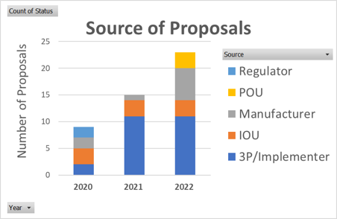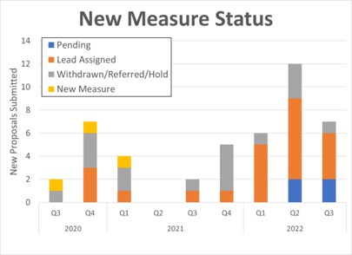
Though measure throughput has increased each year, augmenting the existing approach with the proposed new intake model outlined in this workplan should accelerate this growth in the future. The proposed new intake model consists of two key strategies:
- Strategy 1: Expand the Cal TF measure identification process to include a “pull” approach in addition to the current approach of new measure identification where Cal TF stakeholders “push” measures to the Cal TF.
- Strategy 2: Develop and deploy a rapid scoring process for measures identified through the new “pull” strategy to quickly and cost-efficiently assess which measures may be good candidates for the California energy efficiency portfolio and eTRM.
Strategy 1, the “pull” model, will expand the potential pool of new measures with Cal TF staff conducting outreach to entities that are likely unaware of Cal TF’s New Measure Review Process, as well as undertaking more proactive outreach to existing Cal TF stakeholders to encourage additional measure idea submission. Because this “pull” approach will yield a greater number of measure ideas, Cal TF proposes Strategy 2, which seeks to rapidly and cost-effectively assess the larger new measure candidate pool so that resources aren’t unnecessarily expended pursuing non-viable measures.

Stakeholder Benefits
- Time and Cost Savings, by more rapidly and cost-effectively identifying and assessing new measure opportunities for the EE portfolios.
- Stakeholder Engagement, by increasing collaboration with early-stage technology developers and other sources of potential new measures for the EE portfolios.
- Customer Experience, by increasing the eTRM measures available to customers.

Scope

Strategy 1: “Pull” Strategy with Proactive Outreach
Cal TF proposes regular collaboration with early-stage technology developers who have not previously been engaged with California's measure development process. This collaboration will involve regular check-ins with leading cleantech, academic, and research organizations that can provide “leads” for new measure opportunities in the form of a technology maker who is entering the marketplace with a new product that has the potential to reliably deliver energy savings.
Additionally, Cal TF will “pull” new measure ideas from other industry resources, including:
- Existing Cal TF stakeholders (IOUs, POUs, implementers)
- Prior emerging technology projects that were not developed
- EPIC projects
- Measures in other jurisdictions
- Measures under review by utility emerging technology programs outside California

Strategy 2: Rapid Scoring Process
Cal TF Staff will use a rapid-scoring method on technologies and new measure ideas brought in through the “pull” strategy to more formally determine viability for inclusion in the eTRM and EE portfolios. This new rapid-scoring process will efficiently and cost-effectively assess each measure idea across the following categories:
- Portfolio impact (energy savings, cost-effectiveness, measure life)
- Customer appeal (affordability, ease of adoption, non-energy benefits)
- Measure viability (appropriateness for eTRM, ease of implementation, size of market)
High-scoring concepts will enter the current New Measure Process at the Measure Screening stage, just like any other measure that is currently identified through the existing “push” approach. Concepts that do not score well may be referred to other stakeholders, such as CalNext, EPIC, or others for follow-up, or they may be eliminated for consideration as an eTRM measure (though any eliminated concept can be brought back into consideration as new information becomes available, the marketplace changes, or the technology evolves).
Combined, Strategies 1 and 2 will enhance the new measure pipeline, which will translate to a more robust statewide portfolio of eTRM measures and associated increased energy savings.

Deliverables
- Presentation on Rapid Scoring Tool/Method – by March 2023
- Project update, including list of new measures and scoring outcomes – July 2023

Potential Obstacles and Preliminary Solutions
Cal TF does not anticipate significant challenges with this activity.

Schedule
Cal TF will commence “pull” outreach efforts upon affirmation of the workplan and anticipates implementing the new model by mid 2023.
Key Milestones:
- Present 4A workplan for TF affirmation – February 2023
- Initiate Strategy 1 – March 2023
- Present Rapid Scoring Methods to New Measure Screening Committee – March 2023
- Project update to TF and PAC – July 2023

Stakeholders and Team Members
Cal TF Staff member Spencer Sator will lead this initiative with input from TF Members and the Measure Screening Committee.

Budget
Cal TF Staff will conduct this activity within the approved Cal TF budget.

Affirmation
This workplan requires TF affirmation.
The TF affirmed this workplan on February 23, 2023.
Attachment 1: Proposed Resources and Collaboration Approach
There is a rich startup ecosystem from which Cal TF can seek new measure ideas. Potential organizations with whom Cal TF may collaborate with regularly in these efforts includes government and university labs, trade organizations, incubators and accelerators, and venture capital organizations. For example:
- CA Research Entities
  - Western Cooling Efficiency Center (WCEC)
  - California Plug Load Research Center (CalPlug)
  - California Lighting Technology Center (CLTC)
- Government Labs
  - ARPA-E
  - National labs
- Incubators and accelerators
  - IN2 Innovation Incubator
  - Incubatenergy Network
  - LA Cleantech Incubator (LACI)
  - CleanTech Open
  - Build Edison
- ET Leaders Outside CA
  - Con Edison
  - ComEd
  - Xcel Energy
  - Duke Energy
- Other key industry groups
  - GSA Green Proving Ground
  - Pecan Street
  - NYSERDA
  - Energy Trust
The anticipated cadence of interacting with relevant organizations is subject to adjustment as this process is refined in the coming months but will be primarily based on the volume of new technologies each organization typically interacts with. Those organizations who are involved with a large number of startups/technologies warrant more frequent meetings, while those who only have a throughput of new technologies in the range of single digits per year will be contacted perhaps only once a year.
It is important to note that while this effort will significantly broaden the number and variety of new technologies entering the new measure development pipeline, there will always be gaps. The gaps that will still exist in this “pull” approach to pipeline development include:
- New startups with significant VC funding who are in ‘stealth mode’ and are unwilling to publicly share information, lest they lose a competitive advantage. Technologies from large and established companies (e.g., GE, Trane, Johnson Controls). While not universal, many of these companies also tend to share less about products in development and typically have no use for the ecosystem of accelerators and incubators that are more focused on smaller entrepreneurs and startups. Products that are developed overseas and are expanding into the US without interacting with the ecosystem of accelerators, incubators, and other stakeholders identified in this workplan.

