Work Paper SCE13WP008
Water Pumping
Revision # 0

Southern California Edison

Commercial Variable Speed Swimming Pool Pump

At-a-Glance Summary

 | Measure 1
Measure description | A Variable Speed (VS) Pool Pump ≤ 3 horsepower (HP) in a commercial setting
Program delivery method | Direct install, Downstream
Measure application type | ER, ROB
Base case description | Source: Customer existing (ER) or Title 20 code baseline (ROB)  A Single-speed Pool Pump ≤ 3 HP in a commercial setting
Energy and demand impact common units | Per pump
Peak Demand Reduction  (kW/unit) | ER: 0.59 kW  ROB: 0.36 kW
Energy savings  (Base case – Measure)  (kWh/unit) | ER: 7,441 kWh  ROB: 5,586 kWh
Gas savings  (Base case – Measure)  (therms/unit) | 0
Full measure cost  ($/unit) | Source: Contractor bids  $1,650
Incremental measure cost  ($/unit) | Source: Contractor bids  $950
Effective useful life  (years) | Source: DEER 2014 (OutD-PoolPump)  10 years
Net-to-gross ratio(s) | Source: DEER 2014 (ET-Default)  0.85
Important comments

Document Revision History

Revision # | Revision Date | Section-by-Section Description of Revisions | Author (Name, PA)
0 | 10/06/2014 | New work paper | Jason Wang, SCE

Commission Staff Review and Comment History

Revision # | Date Submitted to Commission Staff | Date Comments Received | Commission Staff Comments

Table of Contents
At-a-Glance Summary
Document Revision History
Table of Contents
Section 1. General Measure & Baseline Data
  - Product Measures
  - Program Implementation Overview
  - Product Parameter Data
Section 2. Calculation Methods
2.1 Program Implementation Analysis
2.2 Electric Energy Savings Estimation Methodologies
2.3 Demand Reduction Estimation Methodologies
2.4 Gas Energy Savings Estimation Methodologies
Section 3. Load Shapes
Section 4. Base Case, Measure, and Installation Costs
4.1 Base Case(s) Costs
4.2 Measure Case Costs
4.3 Installation/Labor Costs
4.4 Incremental & Full Measure Costs
Appendix 1 – Supplemental Files
Appendix 2 – Commission Staff Comments/Review
Appendix 3 – Measure Application Type Definitions
Appendix 4 – CPUC Quality Metrics
Appendix 5 – DEER Resources Flow Chart
References

General Measure & Baseline Data
  - Product Measures
General Description
The measure is a Variable Speed (VS) Pool Pump ≤ 3 horsepower (HP) in a commercial setting. The base case is a Single-speed Pool Pump ≤ 3 HP in a commercial setting.

Technical Description
Pool pumps are used to circulate swimming pool water through a filtration system in order to keep it clear and remove debris and disease-causing agents. Pumps are also used for pool cleaning sweeps, heating, and water features such as fountains and waterfalls. A pool pump motor in California is typically 0.5 to 3 horsepower (hp), single phase, alternating current (AC), and either a permanent split capacitor (PSC) or capacitor-start capacitor-run (CSCR) design [467]. Most run at a fixed single-speed of 3450 revolutions per minute (rpm) [468].

A VS pool pump uses a motor controller that can be programmed to modulate motor speed and flow rate. For VS pool pumps ≤ 3 HP, the controller and pump are integrated into a single unit as shown in Figure 1. Larger pumps typically use a VS control unit housed in a separate enclosure; these are not included in the scope of this work paper. VS pool pumps typically use electronically-commutated motors (ECMs), which offer higher efficiencies that PSC motors.

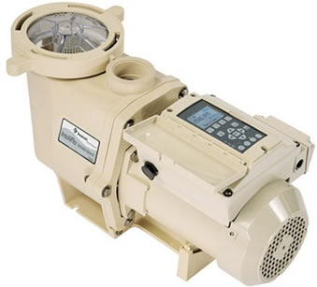
Figure 1 Variable Speed Pool Pump

Significant energy savings can be achieved by reducing flow rate when it is not necessary to operate at full flow. This is indicated by the Pump Affinity Law, which expresses the relationship between power (P), speed (n), and flow (Q):
$$\frac{P_{2}}{P_{1}}={\left(\frac{n_{2}}{n_{1}}\right)}^{3}={\left(\frac{Q_{2}}{Q_{1}}\right)}^{3}$$

Running the pump at half speed will theoretically reduce power draw to 1/8 of full power, but actual power draw will likely be higher due to lower motor efficiencies at part load. For this work paper, savings are derived from test data and not the Affinity Law.

Benefits of VS pool pumps are not limited to energy savings. They are quieter and need less maintenance than single-speed pumps. Lower flow rates allow the filter to more effectively remove debris, which improves water clarity. Reduced strain on the pump, filters, and plumbing prolong the useful life of the equipment [466].
  - Program Implementation Overview
Implementation Methods
The Delivery Mechanisms and Program Types are:
- Direct Install (Early Retirement, ER)
Qualified contractors will install VS pool pumps at customer facilities.
- Downstream (Replace-on-Burnout, ROB)
Customers will apply for an incentive after installing qualifying VS pool pumps.

Program Restrictions and Guidelines

Eligibility Requirements
- Both base and measure case pool pumps must be ≤ 3 HP, but the VS pump does not have to have the same horsepower rating as the base case single-speed pump. For example, replacing a 1 HP single-speed pump with a 3 HP VS pump is acceptable. Some counties offer guidance on what size or model of pump to install based on site data.
- For this work paper, horsepower rating refers to the nameplate horsepower before service factor is applied.
- Only 1-for-1 pump replacements are eligible.

Implementation Requirements
- All climate zones are eligible.
- Assembly, Hotel, and Motel building types are eligible.

Documentation Requirements
- Applications must include proof that the existing pool pump flow rate meets the 6-hour turnover rate required by Title 24.

Measure Application Type
See Implementation Methods above.
  - Product Parameter Data
- DEER Data
DEER does not have a measure for variable speed pool pumps. DEER did have a measure for two speed swimming pool pumps (2005: D03-967). This measure used an inefficient single speed pool pump as the base case and an efficient 1.5 hp two speed pool pump as the measure case. The savings were based on an average 25,000 gallon residential single family swimming pool, and the measure was limited to pool pumps used for filtration. These savings are not applicable to this measure because greater energy savings result from using a variable speed pump compared to a two-speed pump.

Measure ID | Measure  Description | Base  Description | Energy Savings (kWh/yr) | Demand Savings (Watts/yr) | EUL (yr) | Measure  Equipment Cost  ($) | Base Equipment Cost ($) | Labor Cost ($)
D03-967 | Efficient Two Speed Pool Pump, 1.5 hp | Inefficient Single Speed Pool Pump | 1400 | 540 | 10 | 527.21 | 345.04 | 357.12

The most recent version of DEER (2014 Code Update) does not include pool pump measures.

Table 1. DEER Difference Summary
DEER | Used in Workpaper Approach?
Modified DEER methodology | No
Scaled DEER measure | No
DEER base case used | No
DEER measure case used | No
DEER building types Used | No
DEER operating hours used | No
Reason for Deviation from DEER | DEER does not contain this type of measure.
DEER Version | N/A
DEER ID and Measure Name (Sample) | N/A

Net-to-Gross
Table 2. DEER Net-to-Gross Ratios
From DEER Tables
NTGR_ID | Description | Sector | Building Type | NTG | Program Delivery
ET-Default | Emerging Technologies approved by ED through work paper review | All | Any | 0.85 | Any

Effective Useful Life / Remaining Useful Life

Table 3. DEER EUL Values/Methodology
READi EUL ID | Market | End Use | Measure | EUL (Years) | RUL (Years)
OutD-PoolPump | Residential | Recreation | High Efficiency Pool Pump | 10 | 3.3

In-Service Rate / First Year Installation Rate:

Table 4. Installation Rate
From DEER Tables
GSIA_ID | Description | Sector | Building Type | GSIA Value | Program Delivery
Def-GSIA | Default GSIA values | Any | Any | 1.0 | Any

READi Technology Fields

Table 5. READi Tech IDs
READi Field Name | Values included in this workpaper
Measue Case UseCategory | Recreation
Measure Case UseSubCats | Pool
Measure Case TechGroups | Pump System
Measure Case TechTypes | Pool Pump
Base Case TechGroups | Pump System
Base Case TechTypes | Pool Pump
- Codes & Standards Requirements Base Case and Measure Information

California Code of Regulations, Title 20, Public Utilities and Energy (2014) [422]: Section 1605.3(g)(5) requires two-speed control for residential pool pumps ≥ 1 HP. This does not apply to commercial pool pumps.

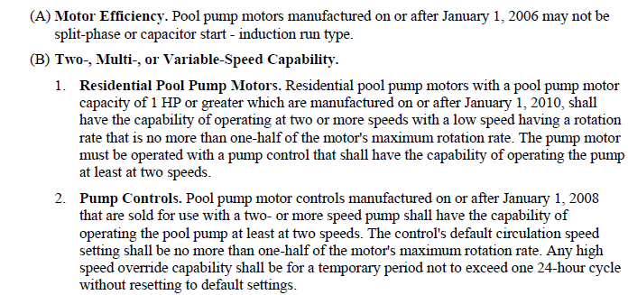

Codes and Standards Enhancement (CASE) Initiative for Title 20, Pools and Spas [467]: The CASE report recommendations, which have been accepted by Title 20, requires specific efficiency levels for single-speed, two-speed, and VS pool pumps ≤ 5 HP. This applies to both residential and commercial pool pumps.

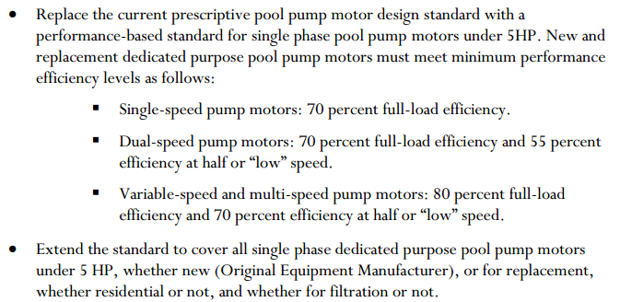

California Code of Regulations, Title 24, Building Standards Code (2013) [462]: Chapter 31B “Public Swimming Pools,” Section 3124B provides capacity requirements for several types of pools. The pools eligible for this work paper fall under item 5, “other types of public pools.” The Title 24 language does not explicitly state that pool water must be turned over in 6 hours during pool open hours; it only states that the pump system must have the capability to do so. However, based on discussions with health inspectors and pool operators, the flow rate corresponding with a six hour turnover time is treated as the minimum flow rate during pool open hours. This minimum flow rate is site-specific and calculated from pool volume.
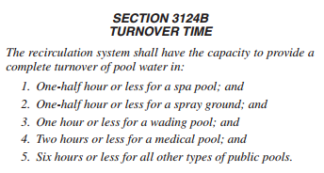

California Code of Regulations, Title 22, Social Security (2014) [473]: Chapter 20 “Public Swimming Pool,” Section 65525 states that during filtration, the flow rateshall not be lowered below 65% of that required by Title 24. This does not impact the work paper because this work paper assumes that the measure case VS pool pump will operate at 100% of the Title 24-required flow rate during filtration during pool open hours.

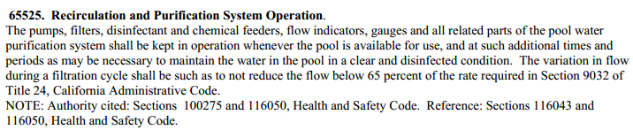

Local Health Codes: Health departments at the city, county, or other level may provide regulations and guidelines for public swimming pools. Most counties will cite the Title 24 turnover time requirements.
- Relevant EM&V Studies

Commercial Pool Pump Market Characterization Study: Intermediate Report [468]: This study was done to support this work paper. The study results were directly used to develop the savings estimates.

- Relevant Workpaper Dispositions
There have been no dispositions on this work paper.
- Other Sources for non-DEER Methods

Codes and Standards Enhancement Initiative (CASE) report for Pools and Spas [467]: The proposed code requirements in this report were used to develop the code baseline.
Measure Guideline: Replacing Single-Speed Pool Pumps with Variable Speed Pumps for Energy Savings [466]: This DOE document served as a general source of information about the benefits and potential of VS pool pumps over single-speed pumps.

California Energy Commission (CEC) Appliance Efficiency Database, for Residential Pool Pumps: This database was used to determine the measure case power consumption; a regression analysis was performed.
- Calculation Methods
  - Program Implementation Analysis
Table 6. Baseline by Measure Application Type
Measure Application Type | Baseline | Baseline Technology | Duration
ER | First | Existing technology | 3.3 years
 | Second | Code/standard | 6.7 years
ROB | First | Code/standard | 10 years
 | Second | ROB N/A | ROB N/A

For ER, the Direct Install program will work with qualified contractors to perform retrofits for existing inefficient single speed pumps. Contractors will examine the condition and age of the existing equipment to verify that ER is occurring.
  - Electric Energy Savings Estimation Methodologies

2.2.1 Emerging Technologies Assessment
This work paper was developed in conjuction with an SCE Emerging Technologies assessment [468], which included a market characterization study and field monitoring.

2.2.1.1 Market Characterization Study
The three commercial market segments identified as having the potential for the VS pool pump measure were:
- Lodging (hotels, motels)
- Schools (high schools, colleges, universities)
- Assemblies (fitness centers, sports clubs, recreational areas, other public pools)

For each market segment, an attempt was made to survey 50 randomly selected sites (in SCE service territory) for equipment and operational characteristics, including:
- Pool and pump operating schedule
- Pool system: Volume, filtration medium, pressure drop,
- Pool pump and motor: Size, service factor, age, efficiency, controls, nameplate, flow rate, speed, etc.
- Spot measurement of voltage, current, power factor (using a True RMS meter)
- Health code requirements, turnover rates

Key findings from the study:
- Lodging: Study results indicated that hotels and motels should be the primary target market for the VS pool pump measure. Most of the lodgings (33 of 50) use single-speed pool pumps ≤ 3 HP which operate 24/7. Lodging data were used in the savings calculations.
- Schools: Most pool pumps (37 of 42) are greater than 3 HP because they serve large, competitive-sized lap pools. Therefore the VS pool pump measure would not cover those pumps. Survey data from schools were used to inform the development of this work paper but not used in savings calculations.
- Assemblies: Operating schedules are similar to that of the lodging market segment, but more pumps are > 3 HP because fitness centers often have Olympic-sized lap pools. Only 31 sites were successfully surveyed because irregular staffing schedules made it difficult to gain access to the site. Assembly data were used in the savings calculations.
- Flow Requirements: Several sites have pumps that are undersized and therefore cannot meet the required 6 hours/turnover flow rate. In addition, many of the pools are too large to be served by a single pump ≤ 3 HP. Many pool operators surveyed did not know their local turnover requirements.

2.2.1.2 Field Monitoring
Pending field results.

2.2.2 Energy Savings and Demand Reduction Estimation Methodology

Example Site
This site will be used in all following examples:
Building type: Motel
Pool hours: 7:00am‒7:00pm
Pump run hours: 24/7
Pump: Single-speed, 1.5 HP
Pool: 26,393 gallons
Electrical: 1-phase, 8.8 amps, 230 V, no power factor measured

2.2.2.1 Base Case Energy Usage
ER Baseline
The base case power consumption is calculated using voltage (V), current (I) and power factor (pf) measurements taken during the surveys. Due to issues with the meters, in most cases only voltage and current readings were obtained. Therefore, if power factor is not available, a value of 0.8 (from the Handbook of Pumps and Pumping [472], full load for 0.75‒7.5 kW; see Figure 2) is assumed.

$$P_{1-phase}\left[kW\right]=V_{RMS}\left[V\right]*I_{RMS}\left[amps\right]*pf*\frac{1 kW}{1,000 W}$$
$$P_{3-phase}\left[kW\right]=V_{RMS}\left[V\right]*I_{RMS}\left[amps\right]*pf*\sqrt{3}*\frac{1 kW}{1,000 W}$$

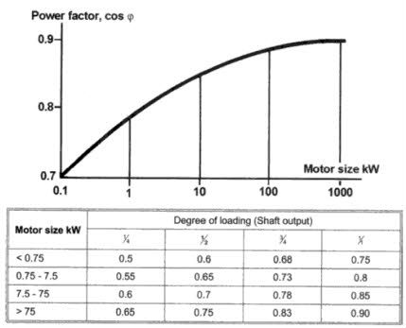
Figure 2 Typical Power Factors by Motor Size

The annual energy usage (E) is calculated as shown:
$$E_{base}\left[kWh\right]=P_{base}\left[kW\right]*PumpHours\left[\frac{hours}{day}\right]*AnnualSchedule\left[\frac{days}{year}\right]$$

Motel Example (ER)
$$P_{base}=230 V*8.8 amps*0.8*\frac{1 kW}{1,000 W}=1.62 kW$$

$$E_{base}=1.62 kW*24\frac{hours}{day}*365\frac{days}{year}=14,184 kWh$$

ROB Baseline
Upcoming Title 20 standards require single speed pool pump motors to be at least 70% efficient at full load. To develop the ROB code baseline, the watt draw from the ER baseline (P_{base}) is multiplied by an adjustment factor. This adjustment factor is the ratio between the average efficiencies of a Title 20-qualifying and non-qualifying pool pump motor. These efficiencies are from the Codes and Standards Enhancement Initiative (CASE) report for Pools and Spas [467]; see Table 7.

Table 7 Average Pool Pump Motor Efficiencies and Power Consumption Adjusment Factors
HP | Non Qualifying | Title 20 Qualifying | Adjustment Factor
0.5 | 62% | 77% | 81%
0.75 | 63% | 76% | 83%
1 | 66% | 76% | 87%
1.5 | 65% | 76% | 86%
2 | 67% | 79% | 85%
2.5 | 70% | 77% | 91%
3 | 70% | 79% | 89%

Motel Example (ROB)

$$P_{base}=1.62 kW*\frac{65\%}{76\%}=1.38 kW$$

$$E_{base}=1.38 kW*24\frac{hours}{day}*365\frac{days}{year}=12,132 kWh$$

Note that the ROB baseline does not consider whether the existing pump is appropriately sized for the pool. It is a theoretical case where the efficiency of the customer’s existing pump (from survey data) has been improved to Title 20 levels.

2.2.2.2 Measure Case Energy Usage
The measure case power consumption is determined from a regression analysis of data from the California Energy Commission (CEC) Appliance Efficiency Database, for Residential Pool Pumps. Since there is no significant distinction between residential and commercial pool pumps (upcoming Title 20 standards will apply the same requirements to both) [467], the use of residential data is considered acceptable.

CEC System Curves
For each pool pump in the CEC database, flow rates and watt draws at each of the three CEC system curves (A, B, C) are provided. Each VS pump has several entries because they are tested at multiple speed (rpm) settings. See Figure 3 for a sample pump curve and the CEC curves and equations.

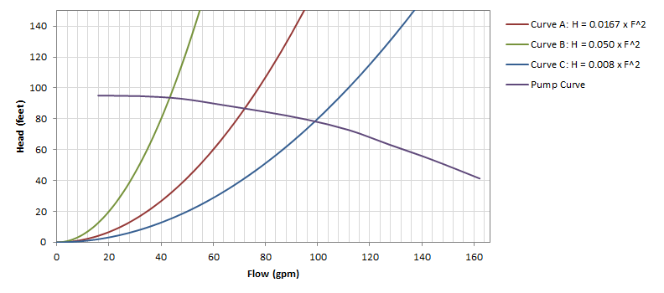
Figure 3 Sample Pump Performance Curve and CEC System Curves

Since pool plumbing head losses are site-specific, the CEC curves are used to represent three typical plumbing scenarios:
- Curve A corresponds to a system with high head losses. This is typical of a new pool with 2” PVC pipe [469, 470].
- Curve B corresponds to an older system with very high head losses. This is typical of a pool with 1 ½” copper pipe [469, 470].
- Curve C corresponds to a system with medium head losses. This is typical of a new pool with 2 ½” PVC pipe [469].

For the VS pool pump measure, Curve C is used because it is assumed to be the most representative of VS pump installations. The Los Angeles County Department of Public Health has issued guidelines for the installation of VS pumps, which state:

“For existing pools, installation will be allowed only when plumbing and equipment is sized to accommodate the maximum flow of the pump at 60 feet of head at the highest rpm.”

The guidelines also include specific requirements for a particular VS pump model:

“Installation of this pump will only be allowed when the plumbing size of the suction line is at least 3” and the plumbing size of the return line is at least 2 ½“. These are the pipe sizes needed to accommodate the maximum flowrate of this pump.”

While these guidelines may not be standard for other counties, and while many other variables such as filters and piping configuration will influence head losses, for this work paper it is assumed that during installation some system improvements will be performed so that the post-retrofit system curve resembles Curve C.

See Figure 4 below for a plot of the polynomial regression:
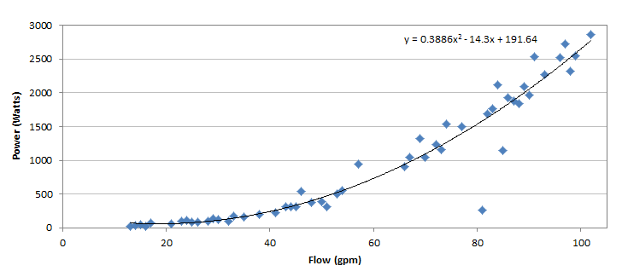
Figure 4 CEC Curve C Flow vs Power for Variable Speed Pool Pumps

Pool Open Hours
The Title 24 6-hour turnover requirement for public pools is used to determine the minimum flow rate (Q_{open}) during pool open hours:

$$Q_{open}\left[gpm\right]=\frac{PoolVolume[gal]}{TurnoverRate\left[\frac{hours}{turnover}\right]*60\frac{min}{hour}}$$

Motel Example

$$Q_{open}=\frac{26,393 gal}{6 \frac{hours}{turnover}*60 \frac{min}{hour}}=73.31 gpm$$

Pool skimmers require a minimum of 25 gpm to function adequately [466], so a value of 25 is used if flow is calculated to be below 25. It is noted that not all VS pool pump models will be able to lower flow rate to 25 gpm or below, so in those cases the energy savings may be reduced.

Using the regression results shown in Figure 4, the expected watt draw of a VS pump providing 73.31 gpm is:
$$P_{measure,open}=\left(0.3886*{73.31}^{2}-14.3*73.31+191.64\right)*\frac{1 kW}{1,000 W}=1.23 kW$$

Note that some counties may require a turnover rate greater than Title 24’s 6 hours/turnover, so the watt draw may be greater in those cases.

Pool Closed Hours
There are no regulations that specify minimum flow rates for public pools during closed hours, but it is recommended that the water be filtered two hours before and two hours after open hours [471]. Therefore pool pumps can be run at any speed during closed hours as long as the water passes health code water quality criteria (including pH, disinfectant concentration, and clarity/turbidity). Since residential pools have a suggested turnover rate of 24 hours/turnover [466], this work paper uses that turnover rate for commercial pools during closed hours.

Motel Example
$$Q_{closed}\left[gpm\right]=\frac{26,393 gal}{24 \frac{hours}{turnover}*60 \frac{min}{hour}}=18.33 gpm$$

Since skimmers require 25 gpm to function adequately, and since some VS pool pumps have a limit on how low speed can be reduced:

$$Q_{closed}=25 gpm$$

At 25 gpm, the expected watt draw of a VS pump is 0.077 kW.

$$P_{measure,closed}=\left(0.3886*{25}^{2}-14.3*25+191.64\right)*\frac{1 kW}{1,000 W}=0.077 kW$$

However, as a conservative assumption, the minimum watt draw is set at 120 W, which is the lowest possible watt draw from the Pentair Commercial Pool Pump Savings Calculator [469].

$$P_{measure,closed}=0.12 kW$$

Annual Energy Usage
The following assumptions are used in the annual energy usage calculations:
- Non-filtration tasks such as pool cleaning, backwashing filters, and water features may require a pool pump to run at high speed. Typically when a residential VS pool pump is programmed, a high speed serves these non-filtration tasks, and a low speed is used for filtration. However, the Title 24 6-hour turnover time for public pools requires that, in many cases, commercial VS pool pumps operate at high speed for filtration during open hours. Therefore, it is assumed that the open hours flow rate Q_{open} is sufficient to perform non-filtration tasks as well.
- Approximately 10% of a pool pump’s operation time is used for non-filtration tasks [466]. Therefore, the open hours are extended by applying a factor of 1.1:

$$AdjustedOpenHours\left[\frac{hours}{day}\right]=OpenHours\left[\frac{hours}{day}\right]*1.1$$

$$ClosedHours\left[\frac{hours}{day}\right]=24-AdjustedOpenHours\left[\frac{hours}{day}\right]$$

The annual energy usage (E) is calculated as shown:

$$E_{measure}\left[kWh\right]=\left(P_{measure,open}\left[kW\right]*AdjustedOpenHours\left[\frac{hours}{day}\right]+P_{measure,closed}\left[kW\right]*ClosedHours\left[\frac{hours}{day}\right]\right)*AnnualSchedule\left[\frac{days}{year}\right]$$

Motel Example
$$E_{measure}=\left(1.23 kW*\left(12*1.1\right) \frac{hours}{day}+0.12kW*(24-12*1.1) \frac{hours}{day}\right)*365=6,409 kWh$$

2.2.2.3 Energy Savings and Demand Reduction
Per-site Energy Savings
The annual energy savings for the Motel Example are:

Motel Example (ER)

$${ΔE}_{measure}[kWh]=E_{base}[kWh]-E_{measure}[kWh]$$

$${ΔE}_{measure}=14,184 kWh-6,409 kWh=7,776 kWh$$

Motel Example (ROB)

$${ΔE}_{measure}=12,132 kWh-6,409 kWh=5,723 kWh$$

Per-site Demand Reduction
Most lodging and assembly sites are open year-round, but several only open during summer or winter. Nearly all sites operate their pools between 2pm and 5pm. The coincident diversity factors (CDFs) are calculated by averaging the number of open hours during 2‒5pm and dividing by 3:

Table 8 Coincident Diversity Factors
Building Type | CDF
Lodging (Hotel and Motel) | 0.98
Assembly | 0.86

Motel Example (ER)

$${ΔP}_{measure}\left[kW\right]=\left(P_{base}\left[kW\right]-P_{measure,open}\left[kW\right]\right)*CDF$$

$${ΔP}_{measure}=\left(1.62 kW-1.23 kWh\right)*0.98=0.38 kW$$

Motel Example (ROB)

$${ΔP}_{measure}=\left(1.38 kW-1.23 kWh\right)*0.98=0.15 kW$$

Work Paper Energy Savings and Demand Reduction
As a deemed measure, the VS pool pump measure requires savings to be consolidated to one value per permutation of building type, climate zone, and program type. This was done using the following methodology:

- Assemble initial data set
As mentioned in Section 2.1.1, the Schools data were removed from consideration. This left 81 sites total for Lodging (50) and Assembly (31).

- Remove ineligible sites
Fifty of the 81 sites were removed from consideration for one or more of the following reasons:
- Existing pump is not single speed and therefore ineligible for this measure.
- Existing pump is greater than 3 HP and therefore not within the scope of the measure.
- Pool requires a larger pump or multiple pumps:
The highest Curve C flow recorded in the CEC database, for any type of pool pump, is 102 gpm (except for 1 outlier at 170 gpm). Assuming a 6-hour turnover, this corresponds to a pool size of approximately 36,000 gallons. This implies that sites with a pool > 36,000 gallons need a pump greater than 3 HP or multiple pumps in parallel. All sites meeting this criterion were removed from consideration. There will be cases where the plumbing system has less head than specified by Curve C and allows flows > 102 gpm, but those are not considered in this analysis.

Of the remaining eligible sites, 26 were Lodging, and 5 were Assembly; many of the Assembly sites had large pools > 36,000 gal. Due to the low representation of Assembly sites, all 31 remaining sites were treated as a single group for analysis.

- Average Energy Savings
A straight average of the 31 per-site energy savings values yielded:
- ER: 7,441 kWh
- ROB: 5,586 kWh

- Average Demand Reduction
A straight average of the 31 per-site demand reduction values yielded:
- ER: 0.59 kW
- ROB: 0.36 kW

- Climate Zone
This measure is assumed to be unaffected by climate zone, so no further adjustments were made.

First Baseline
- ER: 7,441 kWh
- ROB: 5,586 kWh

Second Baseline
- ER: 5,586 kWh

  - Demand Reduction Estimation Methodologies
See Section 2.2 above.

First Baseline
- ER: 0.59 kW
- ROB: 0.36 kW

Second Baseline
- ER: 0.36 kW
  - Gas Energy Savings Estimation Methodologies
No gas energy savings are claimed for this work paper.

First Baseline
N/A

Second Baseline
N/A
- Load Shapes
The difference between the base case load shape and the measure load shape would be the most appropriate load shape; however, only end-use profiles are available. Therefore, the closest load shape chosen for this measure is the Residential Pool Pumps load shape. See table below for a list of all Building Types and Load Shapes. See the KEMA report [31] for a more thorough discussion regarding the load shapes for this measure.

Table 9. Building Types and Load Shapes
Building Type | E3 Alternate Building Type | Load Shape
Assembly | Residential | Residential Pool Pumps
Lodging - Hotel | Residential | Residential Pool Pumps
Lodging - Motel | Residential | Residential Pool Pumps

- Base Case, Measure, and Installation Costs
Table 10. Measure cost summary by application type
Measure Application Type | Base Case  Equipment Cost  ($/unit) | Measure  Equipment Cost  ($/unit) | Installation Cost  ($/Unit) | Incremental Measure Cost  ($/unit) | Full Measure Cost  (1st Baseline period)  ($/unit) | Full Base Cost  (2nd baseline period)  ($/unit)
ROB | $700 | $1,650 | N/A | $950 | N/A | N/A
NC |  |  | N/A |  | N/A | N/A
ER | $700 | $1,650 | N/A | N/A* | $1,650 | $950
REA |  |  |  | N/A*
* IMC may be useful for determining program incentive.
  - Base Case(s) Costs
For SCE’s residential VS pool pump work paper, the SCE evaluation team solicited bids (material and labor) for single-speed and VS residential pool pumps to ascertain costs. The bid to replace a single-speed pump with a single-speed pump is $687.24. A DOE Measure Guideline document on VS pool pumps estimated single-speed pool pump costs as $400 to $700 [466].

Based on these sources, the base case cost used for this work paper is $700.
  - Measure Case Costs

For SCE’s residential VS pool pump work paper, the bid to replace a single-speed pump, remove the mechanical timer, and install and program a VS pump is $1,705.77. A DOE Measure Guideline document on VS pool pumps estimated measure costs as $1,400 to $1,800 [466]. The preliminary bids for phase 2 of the Emerging Technologies assessment are, on average, $1,600. The average cost for material and labor in SCE’s multifamily VS pool pump program is $1,600.

Based on these sources, the measure case cost used for this work paper is $1,650.

In some cases, auxiliary equipment such as flow meters and valves need to be replaced. These are not included in the measure cost. Permit fees are not included in the measure cost.

  - Installation/Labor Costs
The installation and labor costs are included in the costs presented in Sections 4.1 and 4.2.
  - Incremental & Full Measure Costs
For ER, the full measure cost (FMC) is:

FMC = Measure Equipment Cost + Measure Labor Cost
FMC = $1,650

For ER and ROB, the incremental measure cost (IMC) is:

IMC = (Measure Equipment Cost + Measure Labor Cost) –
(Base Case Equipment Cost + Base Case Labor Cost)
IMC = $1,650 – $700 = $950

Table 11. Incremental and full measure cost calculations
Measure Application Type | Incremental Measure Cost  ($/unit) | Full Measure Cost  (1st Baseline period)  ($/unit) | Full Base Cost  (2nd baseline period)  ($/unit)
ROB/NEW | Incremental Measure Cost =  (Measure Equipment Cost + Measure Labor Cost) –  (Base Case Equipment Cost + Base Case Labor Cost) | N/A | N/A
ER | N/A | Full Measure Cost =  Measure Equipment Cost + Labor Cost | Full Base Cost =  (-1)*(Second Base Case Equipment Cost + Labor Cost)
REA | N/A | Full Measure Cost =  Measure Equipment Cost + Labor Cost | N/A

Table 12. Incremental and full measure cost values
Measure Application Type | Incremental Measure Cost  ($/unit) | Full Measure Cost  ($/unit) | Full Base Cost  (2nd Baseline)  ($/unit)
ROB/NEW | $950 | N/A | N/A
ER | N/A | $1,650 | $950
REA | N/A |  | N/A

Appendix 1 - Supplemental Files

Appendix 2 – Commission Staff Comments / Review

Include embedded file(s) with Commission staff feedback.

Appendix 3 - Measure Application Type Definitions

The DEER Measure Cost Data Users Guide found on www.deeresources.com under DEER2011 Database Format hyperlink, DEER2011 for 13-14, spreadsheet SPTdata_format-V0.97.xls, defines the measure application type terms as follows:

Measure Application Type
Code | Description | Comment
ER | Early retirement | Measure applied while existing equipment still viable, or retrofit of existing equipment
EAR | Retrofit Add-on | Retrofit to existing equipment without replacement
ROB | Replace on Burnout | Measure applied when existing equipment fails or maintenance requires replacement
NC | New Construction | Measure applied during construction design phase as an alternative to a code-compliant standard design

Baseline Technologies for UES and Cost calculations
Measure Application Type | Baseline | Baseline Technology | Measure Cost Calculation | Duration
ER | First | Existing technology | Measure equipment cost + labor cost | RUL = 1/3*EUL
 | Second | Code or standard | (-1)*(Code/standard equipment cost + labor cost) | EUL - RUL
REA | First | Existing technology | Measure equipment cost + labor cost | EUL
 | Second | N/A | N/A | N/A
ROB | First | Code or standard | (Measure equipment cost + labor cost) – (Code/standard cost + labor cost) | Full EUL
 | Second | N/A | N/A | N/A
NC | First | Code or standard | (Measure equipment cost + labor cost) – (Code/standard cost + labor cost) | Full EUL
 | Second | N/A | N/A | N/A

Measure cost overview developed by SCE:

Appendix 4 – CPUC Quality Metrics
CPUC workpaper development actions to ensure quality are listed below, adapted from ex ante implementation scoring metrics described in Attachment 7 of Decision (D).13-09-023. The corresponding scoring metrics are shown below.
Metric | Workpaper Development Action to Ensure Quality
2 | Address all aspects of the Uniform Workpaper Template
3a | Include appropriate program implementation background
3b | Include analysis of how implementation approach influences development of ex ante values
3c | Include all applicable supporting materials
3d | Include an adequate description of assumptions or calculation methods
4 | Pursue up-front collaboration on high impact measures with Commission staff prior to formal submission for review
7 | Include analysis of recent and relevant existing data and projects that are applicable to workpaper technologies for parameter development that reflects professional care, expertise, and experience
9 | Appropriately incorporate DEER assumptions, methods, and values for new or modified existing measures using professional care and expertise
10 | Incorporate cumulative experience into workpaper through inclusion of an analysis of previous activities, reviews, and direction. (ED expects IOUs to immediately incorporate disposition guidance into workpapers to be submitted for formal review)

Appendix 5 – DEER Resources Flow Chart

References
[31] | KEMA Inc, JJ Hirsch and Associates, Itron Inc. (2006). Load Shape Update Initiative-Final Report.
[351] | California Public Utilities Commission. (2013). Energy Efficiency Policy Manual-Version 5
[422] | California Energy Commission. "2014 Appliance Efficiency Regulations (Title 20)." CEC-400-2014-009-CMF (2014).
[436] | 2014 Database for Energy Efficient Resources (DEER). 2014 DEER EUL Table - Update (DEER2014-EUL-table-update_2014-02-05.xlsx).
[462] | California Building Standards Commission, Based on the 2012 International Building Code. California Building Code 2013. 1 Jan. 2014. California Code of Regulations, Title 24, Part 2.
[466] | Hunt, A., and S. Easley. Measure Guideline: Replacing Single-Speed Pool Pumps with Variable Speed Pumps for Energy Savings. U.S. Department of Energy, May 2012. Web. 25 Aug. 2014.
[467] | Worth, Chad, Eric Ludovici, Elizabeth Joyce, and Gary Fernstrom. Analysis of Standards Proposal for Residential Swimming Pool & Portable Spa Equipment. 29 July 2013. Codes and Standards Enhancement (CASE) Initiative.
[468] | Hillis, Ryan, and Dennis Rowan. Commercial Pool Pump Market Characterization Study: Intermediate Report. ASWB Engineering, 22 July 2014.
[469] | Pentair. "COMMERCIAL POOL PUMP SAVINGS CALCULATOR." Web. 25 Aug. 2014. <http://www.pentairpool.com/dealer-resources/calculators/commercial-pump-calc/standard.html>.
[470] | NSF International. "NSF/ANSI 50: Equipment for Swimming Pools, Spas, Hot Tubs, and Other Recreational Water Facilities." Issue 57. Web. 25 Aug. 2014. <http://standards.nsf.org/apps/group_public/download.php?document_id=8332>.
[471] | Information & Energy Services, Inc. Multi-Family Residential Variable Speed Swimming Pool/Spa Pump Retrofit. 2012.
[472] | Nesbitt, Brian. "10.1.3.1 Power Factor." Handbook of Pumps and Pumping: Pumping Manual International. 1st ed. Burlington: Elsevier, 2006. 263. Web. 25 Aug. 2014.
[473] | California Office of Administrative Law. "California Code of Regulations, Title 22, Social Security." Web. 24 July. 2014.

Full measure cost = measure equipment cost + measure labor cost
Incremental measure cost = Measure equipment cost – Baseline equipment cost
Full measure cost = measure equipment cost + installation cost, for first baseline period
Full base cost = 2nd baseline equipment cost + installation cost, for the second baseline period
The E3 calculator determines the net present value of the second baseline cost and subtracts it from the first baseline cost to determine the measure cost for the early retirement measure. According to the Energy Efficiency Policy Manual v.5 at page 32, the measure cost for an early-retirement case is “the full cost incurred to install the new high-efficiency measure or project, reduced by the net present value of the full cost that would have been incurred to install the standard efficiency second baseline equipment at the end of the [RUL] period”.
According to the Energy Efficiency Policy Manual v.5 at page 32, the measure cost for an early-retirement case is “the full cost incurred to install the new high-efficiency measure or project, reduced by the net present value of the full cost that would have been incurred to install the standard efficiency second baseline equipment at the end of the [RUL] period”. Page 33 elaborates that “the period between the RUL and EUL defines the second baseline calculation period…the measure cost for this period is the full cost of equipment, including installation, for the second baseline equipment measure”.
The Energy Efficiency Policy Manual v.5 at page 33 states “the remaining useful life (RUL)…[is established by DEER] as one-third of the expected useful life (EUL) for the equipment type”.
The Uniform Workpaper Template is not posted on the DEER website as of 4/21/14, and is currently in Microsoft Access Database format.
Metric 3 is not split among a – d in Attachment 7, however metric 3 was separated into four subcategories in this document for the purposes of identifying individual workpaper development actions to address quality.
“Adequate” is defined in Attachment 7 such that derivations of underlying assumptions of workpaper are easy to understand by the CPUC reviewer.

