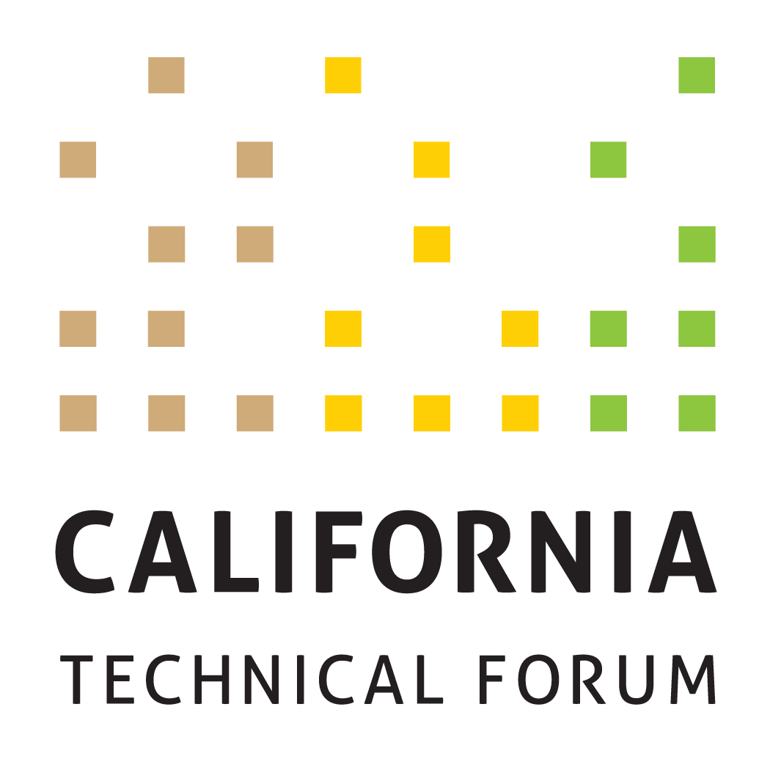

DRAFT v5.0
Business Plan
2024

To support the growth and success of energy efficiency and integrated demand-side management (IDSM) through a technically rigorous, independent, transparent peer review of California energy efficiency values and other related technical information.

Disclaimer: The Cal TF Policy Advisory Council (PAC) approval of this Business Plan does not constitute endorsement of ensuing technical work products by individual members or organizations.

Metrics | Workplan Required | Tactics (Cal TF Staff) | Benefits | Tactics (Others)

GOAL 1. eTRM Management and Measurement
1A. Create eTRM Development Roadmap  - eTRM Development Roadmap Work Plan (Q1)  - Q1, Q2 Broad stakeholder engagement and input  - Q3 Draft eTRM Development Roadmap  - Q4 Final eTRM Development Roadmap | Yes | Cal TF Staff will:  - Lead planning process in Q1 and Q2 to develop eTRM Development Roadmap. Issues to be addressed will include but not be limited to:  - Developing Business and Technical Requirements for Custom Module  - Status, standards and requirements of system security, performance and stability  - Coordination, integration, automation with other systems and governing bodies, including CEDARS, CET, PA, POU and implementer systems  - Common technical/software development standards  - Data analytics opportunities, either within eTRM or in combination with other systems and/or databases  - Governance Principles, in coordination with CEDARs and CET  - Desired Service Level Agreement standards  - Standardized eTRM Planning and Development schedule  - Training and Support needs  - Required documentation for users, administrators, others  - Additional eTRM modules or features to support smaller and/or less sophisticated users  - Addition of other measure types, such as low-income or equity measures, C&S measures, small business, NMEC measures, other IDSM resources | eTRM User Experience  Collaboration  Stakeholder Engagement | Cal TF Staff will seek input from broad range of eTRM users/potential users, including CPUC, CEC, PAs, POUs, Implementers, Customers/Trade Allies, MTA, EM&V, RENS, CalNEXT, GET, TECH, Equity stakeholders  PAs, select 3P implementers, EM&V, MTA Administrator provide input on how EE/DR data flows through eTRM, CEDARs, CET, EDCS, etc.
1B. Implement selected enhancements for eTRM v2.x  - Complete by end of Q4 2024  - Enhancements may be altered during year based on eTRM core stakeholder input and affirmation | Yes (after the eTRM Roadmap is complete) | Cal TF Staff will:  - Implement a limited set of enhancements in 2024, as discussed during the Q1 and Q2 eTRM Development Roadmap Planning Process, during Q3 and Q4  - Work Plan will describe enhancements to be completed, including cost, scope and sequence plus explanation and value of each enhancement.  - Track and prioritize reported bugs and minor “ad hoc” features, and work with software developers to schedule fixes and associated regression testing (ongoing)  - Update eTRM documentation after each release  - Retain SOC-2 Certification and keep compliant with SOC-2 requirements.  - If appropriate, undergo an annual security audit and additional regular pen testing | Regulatory Compliance  Statewide Consistency  Quality Control  eTRM User Experience  Collaboration  Stakeholder Engagement | eTRM Core Stakeholders will designate at least one primary and one backup representative who will participate in eTRM v2.x development as noted below. Representatives (or their designees) will participate in:  - Meetings  - Planning  - Sprint testing/client acceptance testing  - Project documentation.  eTRM Core Stakeholders will provide input on the technical guidance document.
 | No | Cal TF Staff will:  - Provide customer support to eTRM users that could originate through the eTRM@FutEE.biz account, Cal TF, trainings, or other channels  - Create and implement eTRM training based upon eTRM Core Stakeholder and eTRM User feedback  - Track Google Analytics quarterly to document eTRM usage. | Statewide Consistency  Quality Control  eTRM User Experience  Stakeholder Engagement | Each eTRM Core Stakeholder organization will identify their respective internal users to receive eTRM training and support.

GOAL 2. Measure Management
2A. Solicit stakeholder input on current deemed measure development and updating process, then track/report on relevant metrics  - Survey and/or talk with stakeholders (Q1)  - Develop draft and final Metrics for deemed measure development and updating process (Q2)  - Track and report on agreed-upon metrics (Q3 – Q4) | No | Cal TF Staff will:  - Survey and/or interview stakeholders to assess their current experience and satisfaction with deemed measure development process, including measure developers, PAs, implementers, CPUC Staff and Consultants (Q1)  - Develop proposed metrics to track key parameters that relate to quality and stakeholder satisfaction with measure development process. (Q2)  - Develop final metrics (Q2)  - Track and report on agreed-upon metrics | Cost Savings  Time Savings  Quality  Stakeholder Satisfaction | Input/engagement from Measure Developers, PAs, CPUC Staff and Consultants.
2B. Establish, Implement and Monitor Measure Development and Updating QA/QC Standards for eTRM  - Written Measure Development Accountability Plan (Q1)  - Quarterly Reports on Measure Development QA/QC (Q2 – Q4) | No | Cal TF Staff will:  - Develop and maintain training materials and tools for Measure Developers, including “basic training” for new measure developers and associated pre-requisites and training requirements to be a measure developer (ongoing)  - Develop and train on written accountability standards, requirements and consequences for failure to adhere to eTRM and measure development standards and requirements  - Manage measure developer list of qualified and active measure developers, and control measure developer list  - Train a Measure Manager within the IOUs and LADWP to be “single point of contact”; CCAs and RENs will have the training made accessible  - Sample QA/QC final measure updates to ensure statewide conformance  - Document, communicate, and track QA/QC issues identified by Cal TF Staff and CPUC ex ante consultants; provide feedback to IOU Measure Managers  - After select measures submitted for CPUC Staff review, seek and track feedback on QA/QC issues identified after CPUC review  - Coordinate and facilitate statewide processes | Statewide Coordination  Statewide Consistency  Quality Control  Cost Savings  Quality Control | Measure Developers and Measure Reviewers (including PAs, POUs, CPUC consultants, CPUC Staff, and 3Ps) will take the appropriate eTRM measure training.  PAs and LADWP will designate “single point of contact” to submit measures to Cal TF for QA/QC.  PAs will submit yearly cost for new/updated measures and number of measures and measure updates.
2C. Establish consistent statewide processes and approaches for deemed measures | No | Cal TF Staff will:  - Coordinate regular PA meetings to identify, discuss and agree-upon and document needed deemed measure conventions and processes | Statewide consistency  Quality | PAs identify issues, attend regular meetings, provide subject matter experts as needed, work to forge consensus on approaches and processes and review final documentation memorializing approaches.

GOAL 3. New Measure Rapid Screening, Evaluation and Development
3A. Identify and facilitate Measure Screening Committee (MSC) evaluation at least twenty (20) New Measures | No | Cal TF Staff will continue to lead a process to identify and evaluate potential new measures (custom, deemed, hybrid, other)  Cal TF Staff will track and report metrics for all measures coming through the Cal TF New Measure Process:  - Number of proposed measures submitted  - Number of proposed measures affirmed by MSC  - Number of measures not affirmed by MSC and the reason why; identify alternate path for measure  - Number of proposed measures affirmed by the TF  - Number of proposed measures published in the eTRM  - Time from Measure Initiation to Measure Submission  - Number of decarbonization/CO2/GHG/Low income measures developed through Cal TF/Other | Customer Experience  Stakeholder Engagement | Cal TF stakeholders, energy program stakeholders, and other innovators will engage with Cal TF Staff on new measure identification strategies.
3B. Support development of New Measures, budget permitting. | No | Track metrics as described above | Cost Savings  Time Savings  Quality/ Accuracy | Cal TF stakeholders, energy program stakeholders, and other innovators will engage with Cal TF Staff on new measure development activities.

GOAL 4. Data Integration and Data Analytics
4A. Organize and Lead Data Charette #3; Prepare Summary Report | No | Cal TF Staff will:  - Organize meeting on how EE data could be analyzed to facilitate improved program design, implementation and evaluation once EE data is better organized and streamlined through different systems  - Draft Final Report on Cal TF-led Data Charettes | Improve Analysis of EE Data  Reduce Costs  Increase Quality | Cal TF and non-Cal TF participants who are using EE/IDSM data to improve program/portfolio design, implementation and evaluation agree to present to Cal TF and review/comment on final report.

GOAL 5. Custom Initiative
5A. Centralize and Summarize Commission Policy; Streamline and Clarify Custom Policy, Guidance, and Resources (Q1) | No | Cal TF Staff will:  - Develop an approach to centralize, clarify, consolidate, update, and maintain key custom resources to improve access and understanding across statewide stakeholders  - Facilitate stakeholder discussions, including collaboration with CPUC, to clarify areas of confusion, inconsistent interpretation, or disagreement on existing policy and guidance  - Develop and maintain resources based on stakeholder input, including: 1) Library of Custom Resources, 2) Library of Custom Measures and Tools, 3) Baseline Database  - Work with custom stakeholders to develop a communication and training approach to help stakeholders learn, understand, and be aware of policy, resources, and other critical/valuable information  - Establish maintenance and ownership plan to ensure resources are maintained up-to-date and ownership/ update approach and responsibilities are clear | Collaboration  Stakeholder Engagement  Standardization  Transparency  Time Savings  Cost savings | Custom Stakeholders will provide input on Cal TF to determine priority and approach and requirements for implementation.  Cal TF stakeholders will collaborate with Cal TF Staff to implement select recommendations and provide feedback on outcomes.
5B. Establish Streamlined, Organized, Structured Statewide Custom Templates and Codes (Q2, unless otherwise noted.) | No | Cal TF Staff will:  - Develop and socialize statewide custom measure codes (Q1)  - Identify the package of statewide templates needed to support custom measures and projects (Q1)  - Review regulatory policy and guidance to determine and confirm data and reporting requirements  - Review data requirements to identify efficiency and streamlining opportunities, data fields that must be protected from public view, and any inconsistencies across templates and/or stakeholder materials to be reconciled  - Facilitate stakeholder engagement to develop streamlined, structured statewide templates that meet data requirements  - Socialize updated templates among stakeholders to encourage use of new templates for custom measures  - Assess opportunity to incorporate templates into the eTRM  Examples of templates include Project Feasibility Template, Installation Report Template, Review Checklist, and Measure Codes. | Collaboration  Standardization  Transparency  Time Savings  Cost savings  Increased Measure Uptake | Custom Stakeholders will:  - Provide input on data requirements and proposed new/updated statewide templates for custom measures and programs  - Incorporate updated templates into program activities
5C. Develop SW Custom Measure Packages (CMP) for at least ten (10) measures and at least ten (10) SW Custom Tools (ongoing) | No | Cal TF Staff will:  - Prioritize custom measures and tools based on the 2023 measure lists and stakeholder input (Q1)  - Develop guidelines for statewide tools to support consistent formats, data structures, ownership, and ongoing maintenance (Q1)  - Develop draft statewide CMPs with stakeholder input following established Cal TF workflow  - Develop and/or update selected tools with stakeholder input following established Cal TF workflow  - Facilitate the technical review and affirmation of the CMP and tools by the Custom Subcommittee and TF following established Cal TF workflow  - Solicit input from CPUC Ex Ante and Ex Post reviewers  - Incorporate the affirmed CMP and tools into the public Custom Library and provide notifications to custom stakeholders of updates and available resources  - Finalize proposal for TF affirmation regarding responsibility for ongoing maintenance of CMP resources | Standardization  Transparency  Cost Savings  Time Savings  Stakeholder Engagement | PAs, POUs, TF members, implementers, CPUC, and other stakeholders will provide input throughout the process.  The CPUC Custom lead and CPUC Group D consultants will provide input and review. CPUC Group A consultants will review to ensure alignment with Deemed.  TF members will affirm Custom Measure Packages. for each selected measure.  PAs and CPUC will support the use of affirmed Custom Measure Packages.
5D. Custom Policy Initiative (ongoing) | No | Cal TF Staff will:  - Facilitate stakeholder discussions to develop proposals that solve key barriers to custom measures, projects, and programs  - Develop materials and facilitate discussions to socialize and build consensus around proposals and solutions.  - Working with PAC members, coordinate stakeholder engagement as appropriate to gain support for proposals among key decision-makers  - Identify and research through documents and interviews custom best practices in up to ten (10) jurisdictions (may include CA POUs) | Customer Experience  Collaboration  Stakeholder Engagement  Transparency  Time Savings  Cost savings  Increased Measure Uptake | Custom Stakeholders will:  - Provide input on proposed policy solutions and associated stakeholder challenges/benefits  - Provide data as needed to demonstrate the challenges, need, and benefits of proposals  - Support broad stakeholder engagement to develop, socialize, and build consensus around the policy proposals  PAC Members will affirm and secure internal organizational support for policy proposals  PAC members will participate as needed in policy advocacy strategy and activities.

GOAL 6. Technical Issue and Technical Policy Analysis
6A. Develop at least one (1) Technical Position Paper (TPP) | No | Cal TF Staff will develop a TPP that describes the current challenges facing EE in California and proposed solutions. | Technical Rigor | The PAC will affirm the selected TPP topic(s).
6B. Develop at least one (1) White Paper | No | Cal TF Staff will develop a White Paper that identifies other proceedings/activities related to Cal TF work and how Cal TF will track and/or engage.  Cal TF will solicit additional TPP and White Paper topics from Cal TF members and keep running list of topics that may be further developed depending on available interests and resources in 2024.  Additional topics of interest include:  - Load shape development and use beyond DEER measures  - Role of NMEC measures in eTRM, custom and deemed measures  - Measure lifecycle integration into eTRM (potential and goals, ETP, EM&V, and C&S)  Integrated data flow for energy efficiency | Technical Rigor  Statewide Consistency  Stakeholder Engagement | The Cal TF members will provide input to select the white paper topic(s).  Cal TF members will provide input and contribute to the white paper via subcommittee process.

GOAL 7. Cal TF, PAC and Stakeholder Engagement and Management
7A. Conduct at least ten (10) TF meetings (may be in-person or via teleconference); organize lead subcommittee and ad hoc meetings | No | Cal TF Staff will:  - Organize and lead Cal TF and PAC  - Maintain Cal TF Website and internal/external Cal TF documentation as relevant and up-to-date | Transparency  Stakeholder Engagement  Statewide Consistency | Cal TF members will:  - Review materials in advance of all meetings  - Attend Cal TF meetings
7B. Conduct four (4) PAC meetings (in person with teleconference options); ad hoc meetings as needed | No | Cal TF Staff will:  - Schedule and facilitate quarterly PAC meetings and ad hoc PAC meetings based on policy needs and activity  - Provide updates on BP during quarterly meetings | Statewide Policy Consistency  Oversight and Governance | PAC members will:  - Review materials in advance of all meetings  - Attend PAC meetings
7C. Develop and finalize the 2025 Cal TF Business Plan (BP) | No | Cal TF Staff will:  - Prepare a Draft 2025 BP in collaboration with Cal TF members by end of Q3 2024  - Solicit comments on the draft 2025 Cal TF BP from PAC and TF members, CPUC and CEC Staff, and other stakeholders  - Seek PAC affirmation of 2025 Cal TF BP by December 2024. | Transparency  Stakeholder Engagement  Oversight and Governance | PAC, TF, CPUC Staff, and others will provide input on the Draft 2025 Cal TF BP.  PAC will affirm the 2025 BP by December 2024.
7D. Update 5-year Roadmap in conjunction with the Business Plan update process. | No | Cal TF Staff will:  - Prepare Draft Roadmap Updates in collaboration with Cal TF members by end of Q3 2024  - Solicit comments on the draft Roadmap Updates from PAC and TF members, CPUC and CEC Staff, and other stakeholders  - Seek PAC affirmation of Draft Roadmap Updates by December 2024. | Transparency  Stakeholder Engagement  Oversight and Governance | PAC, TF, CPUC Staff, and others will provide input on any updates to the 5-year Cal TF Roadmap.  PAC will affirm the Cal TF Roadmap by December 2024.

NOTE: Cal TF’s ability to achieve all goals and tactics contained in the 2024 Business Plan are contingent on being able to shift unspent eTRM funds from 2023, as well as shift funds between eTRM and Cal TF as needed in 2024.

