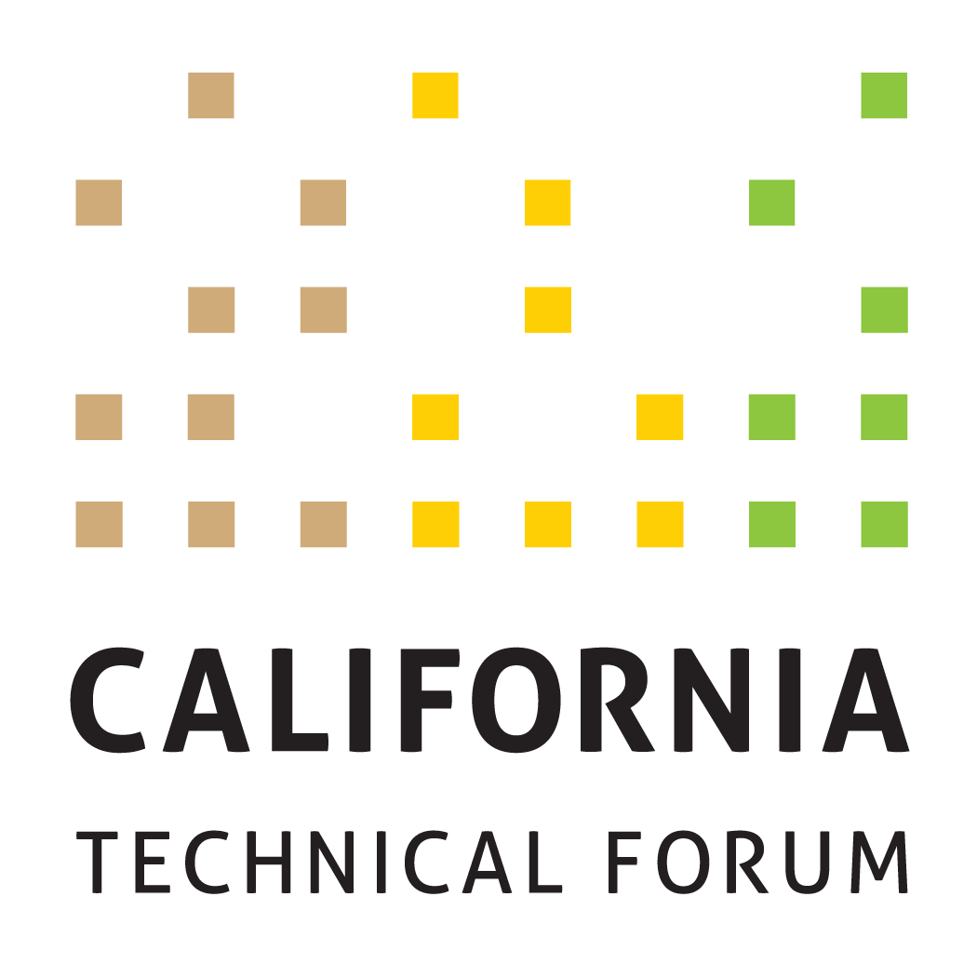

DRAFT ver. 1.0
Business Plan
2024

To support the growth and success of energy efficiency and integrated demand-side management (IDSM) through a technically rigorous, independent, transparent peer review of California energy efficiency values and other related technical information.

Disclaimer: The Cal TF Policy Advisory Council (PAC) approval of this Business Plan does not constitute endorsement of ensuing technical work products by individual members or organizations. Testing

Metrics | Workplan Required | Tactics (Cal TF Staff) | Benefits | Tactics (Others)

GOAL 1. Manage and Develop the eTRM (CORE)
1A. Complete and socialize eTRM enhancement prioritization in 2024 Q1 | No | Cal TF Staff will:  - Track enhancements proposed by eTRM Core Stakeholders, through the eTRM mailbox, or from other interested stakeholders  - Socialize enhancements with eTRM Core Stakeholders, through Cal TF meetings and through ongoing stakeholder meetings  - In Q4, host in-person meeting to prioritize and select enhancements for 2025  - Brief PAC on final list of selected enhancements by end of 2024 | eTRM User Experience  Collaboration  Stakeholder Engagement | eTRM Core Stakeholders and eTRM Users will provide input on enhancements to existing features and possible new features.  eTRM Core Stakeholders will approve final list of enhancements for 2024 and participate in selection of enhancements for 2025
1B. Implement selected enhancements for eTRM v2.x  - Complete by end of Q4 2024  - Enhancements may be altered during year based on eTRM core stakeholder input and affirmation | No | Cal TF Staff will:  - Track and prioritize reported bugs, and work with software developers to schedule fixes and associated regression testing  - Update eTRM documentation after each release  - Keep compliant with SOC-2 requirements | Regulatory Compliance  Statewide Consistency  Quality Control  eTRM User Experience  Collaboration  Stakeholder Engagement | eTRM Core Stakeholders will designate at least one primary and one backup representative who will participate in eTRM v2.x development as noted below. Representatives (or their designees) will participate in:  - Meetings  - Planning  - Sprint testing/client acceptance testing  - Project documentation.  eTRM Core Stakeholders will provide input on the technical guidance document.
 | No | Cal TF Staff will:  - Provide customer support to eTRM users that could originate through the eTRM@FutEE.biz account, Cal TF, trainings, or other channels  - Create and implement eTRM training based upon eTRM Core Stakeholder and eTRM User feedback  - Track Google Analytics quarterly to document eTRM usage. | Statewide Consistency  Quality Control  eTRM User Experience  Stakeholder Engagement | Each eTRM Core Stakeholder organization will identify their respective internal users to receive eTRM training and support.

GOAL 2. Manage Existing Measure Updates (CORE)
2A. Track and report metrics for existing measure updates:  - Number of measures in 2023  - New  - Updated  - Time from Start to CPUC Submission  - New  - Updated  - Year Average Cost for:  - New Measures  - Measure Updates  - Completeness & Accuracy  - Nature of Updates | No | Cal TF Staff will:  - Develop and maintain training materials and tools for Measure Developers  - Train a Measure Manager within the IOUs and LADWP to be “single point of contact”  - QA/QC final measure updates to ensure statewide conformance  - Document, communicate, and track QA/QC issues identified during Cal TF Review  - After each measure submitted for CPUC Staff review, seek and track feedback on QA/QC issues identified after CPUC review  - Manage submittal of new/updated measures to CPUC | Statewide Coordination  Statewide Consistency  Quality Control  Cost Savings  Quality Control | Measure Developers and Measure Reviewers (including IOUs, POUs, CPUC consultants, CPUC Staff, and 3Ps) will take the appropriate eTRM measure training.  PAs and LADWP will designate “single point of contact” to submit measures to Cal TF for QA/QC.  PAs will submit yearly cost for new/updated measures and number of measures and measure updates.

GOAL 3. Lead New Measure Identification and Development (CORE)
3A. Identify and facilitate Measure Screening Committee (MSC) evaluation at least twenty (20) New Measures | No | Cal TF Staff will lead a process to identify and evaluate potential new measures (custom, deemed, other).  Cal TF Staff will track and report metrics for all measures coming through the Cal TF New Measure Process:  - Number of proposed measures submitted  - Number of proposed measures affirmed by MSC  - Number of measures not affirmed by MSC and the reason why; identify alternate path for measure  - Number of proposed measures affirmed by the Cal TF  - Number of proposed measures published in the eTRM  - Time from Measure Initiation to Measure Submission  - Number of decarbonization/CO2/GHG/Low income measures developed through Cal TF/Other | Customer Experience  Stakeholder Engagement | Cal TF stakeholders, energy program stakeholders, and other innovators will engage with Cal TF Staff on new measure identification strategies.
3B. Develop at least five (5) or more New Measures approved by Measure Screening Committee. | No | Track metrics as described above. | Cost Savings  Time Savings  Quality/Accuracy | Measure updates funded through utility measure development budget.
3C. Develop at least five (5) or more Low Income approved by Measure Screening Committee. | No | Track metrics as described above. | Cost Savings  Time Savings  Quality/Accuracy | Low-income measures funded through low-income budget.
3D. Accelerate measure uptake of at least five (5) new measures or new offerings | Yes | Cal TF Staff will:  - Engage implementers to understand needs missing from current programs  - Engage implementers during the measure development process  - Develop training tools and presentations that can be delivered through Cal TF meetings or focused group meetings | Increased measure uptake | Cal TF stakeholders, energy program stakeholders, and other innovators will engage with Cal TF Staff on new measure uptake strategies.

Goal 4. Data Integration and Data Analytics
4A. Create map of EE/DR data flow from customer site to measure maturity | Yes | Cal TF Staff will:  - Interview PAs, select 3P implementers, EM&V, MTA Administrator, others to understand how EE/DR data “flows through eTRM, CEDARs, CET, EDCS, etc.  - Create map of data flow from customer site through measure maturity  - Identify in map where data flow could be streamlined, automated, etc. | Transparency  Cost savings  Time savings | Cal TF stakeholders will respond to requests for information and review and comment on draft map and recommendations.
4B. Prepare White Paper on role of NMEC in deemed and custom measures/projects | Yes | Cal TF Staff will:  - Summarize current regulatory framework for deemed measures, custom measures, and NMEC projects.  - Interview PAs, regulators, evaluators and implementers on how NMEC data can be used with deemed measure packages and custom data.  - Prepare draft White Paper on role of NMEC data in deemed measure packages and custom measures/projects. | Transparency  Cost savings  Time savings | Cal TF stakeholders will respond to requests for information and review and comment on draft white paper and recommendations.
4C. Prepare Data Analytics White Paper on how EE/DR Data can be combined with other state/federal data to improve EE/DR program design, implementation, evaluation | Yes | Cal TF Staff will:  - Summarize EE/DR data that can be extracted at customer site and based on Commissions “15/15” rule to protect PII.  - Identify and characterize other sources of state and federal data that could be combined with EE/DR data through ArcGIS, PowerBI, Tableau and/or other data analytics packages  - Interview PAs, 3P implementers, EM&V, MTA Administrator, others to understand how EE/DR data combined with other state and federal data at customer site level and/or 15/15 aggregated level could be used to improve program design, implementation and evaluation  - Draft White Paper that describes value of using EE and DR data contained in EE/DR IT “Ecosystem” at 15/15 and customer site data combined with other data sources to improve program design, implementation and evaluation, better leverage other related efforts (Potential and Goals, Mkt Tx, etc.) and grid management/optimization with other customer-side efforts | Transparency  Cost savings  Time savings | Cal TF stakeholders will respond to requests for information and review and comment on draft white paper and recommendations.

GOAL 5. Custom Initiative
5A. Prioritize, socialize, and incorporate program and policy recommendations to support statewide standardization and streamlining in the development and delivery of custom measures, projects, and programs | Yes | Cal TF Staff will:  - Develop a workplan to incorporate selected program and policy improvements.  - Work with core custom stakeholders to implement workplan. | Stakeholder Engagement  Standardization  Transparency  Time Savings  Cost savings | Custom Stakeholders will review Cal TF recommendations and provide input to determine which recommendation can be incorporated directed by stakeholders and to help select and prioritize which policy recommendations to pursue.
5B. Implement the eTRM Custom Library | No | Cal TF Staff will:  - Develop the Custom Library in the eTRM according to eTRM Custom Phase 1 Functional Specifications developed in 2023  - Populate the Custom Library with tools and resources vetted through the Custom Subcommittee and TF (when appropriate)  - Coordinate resource locations with CPUC, CEC, PAs, and other custom stakeholders to avoid duplication and ensure the eTRM Custom Library is maintained up to date.  - Socialize the Custom Library with stakeholders to ensure awareness of the centralized, statewide, up-to-date resource for custom stakeholders | Standardization  Transparency  Time Savings  Stakeholder Engagement  Customer Experience | Custom Stakeholders will:  - Provide input on the final Functional Specifications, testing, and potential future improvements  - Support socializing the eTRM Custom Library among stakeholders
5C. Develop SW Custom Measure Packages (CMP) for at least five (5) measures and at least five (5) SW Custom Tools | Yes | Cal TF Staff will:  - Facilitate the selection of custom measures and tools based on the prioritized measure lists developed in 2023  - Develop guidelines for statewide tools to support consistent formats, data structures, and ongoing maintenance  - Develop draft SW CMPs with stakeholder input  - Develop and/or update selected tools with stakeholder input  - Facilitate the technical review and affirmation of the CMP and tools by the Custom Subcommittee and TF  - Incorporate the affirmed CMP and tools into the Custom Library and provide notifications to custom stakeholders | Standardization  Transparency  Cost Savings  Time Savings  Stakeholder Engagement | POUs, IOUs, TF members, CPUC, and other stakeholders will provide input throughout the process.  The CPUC Custom lead and CPUC Group D consultants will provide input and review. CPUC Group A consultants will review to ensure alignment with Deemed.  TF members will affirm Custom Measure Packages. for each selected measure.  PAs and CPUC will support the use of affirmed Custom Measure Packages.
5D. Begin Implementation of eTRM Custom Modules | Yes | Cal TF Staff will:  - Socialize eTRM Custom Modules among stakeholders to support awareness and buy-in of integrated, transparent, and statewide custom measure and project platform (continued from 2023 BP)  - Develop business requirements and functional specifications for eTRM Modules with stakeholder input (continued from 2023 BP)  - Facilitate stakeholder input process to prioritize and schedule eTRM module implementation  - Implement selected eTRM module(s)  - Develop appropriate documentation to support implemented eTRM modules and tools  - Socialize eTRM modules and provide training and user support as needed to ensure awareness and effective use among stakeholders  eTRM Custom Modules may include:  - eTRM Statewide Custom Measure Packages with SW Custom Measure Codes  - eTRM Custom-Calculated Measures (i.e., “Hybrid Measures”)  - Custom Project Development  - Custom Project Library and Technical Review (i.e., replacement of CMPA)  - Custom Project Disposition Library (i.e., replacement of Disposition Database) | Customer Experience  Cost Savings  Standardization Time Savings  Transparency | POU, IOU, and CPUC custom project staff, will review and comment on Cal TF Staff analysis of how existing eTRM tools can be used to standardize and streamline custom projects.

GOAL 6. Identify, Analyze, and Recommend Key Emerging Technical and Technical Policy Issues in a Statewide Consistent Way
6A. Develop at least one (1) Technical Position Paper (TPP) | Yes | Cal TF Staff will:  - Solicit topics and priorities from the PAC, TF members, and stakeholders  - Propose and confirm final TPP topic with PAC  - Develop TPP with input from a Cal TF subcommittee | Technical Rigor | The PAC will affirm the selected TPP topic(s).
6B. Develop at least one (1) White Paper | No | Cal TF Staff will develop white paper with input from a Cal TF subcommittee, in addition to White Papers otherwise listed on this BP.  Topics of interest include:  - Analysis controller integration  - Load shape development and use beyond DEER measures  - Measure lifecycle integration into eTRM (potential and goals, ETP, EM&V, and C&S)  - Integrated data flow for energy efficiency | Technical Rigor  Statewide Consistency  Stakeholder Engagement | The Cal TF members will provide input to select the white paper topic(s).  Cal TF members will provide input and contribute to the white paper via subcommittee process.

GOAL 7. Manage the Cal TF and Cal TF PAC (CORE)
7A. Conduct at least ten (10) TF meetings (may be in-person or via teleconference); organize lead subcommittee and ad hoc meetings | No | Cal TF Staff will:  - Organize and lead Cal TF and PAC per Cal TF Process Rules  - Maintain Cal TF Website and internal/external Cal TF documentation as relevant and up-to-date | Transparency  Stakeholder Engagement  Statewide Consistency | Cal TF members will:  - Review materials in advance of all meetings  - Attend Cal TF meetings
7B. Conduct four (4) PAC meetings (in person with teleconference options); ad hoc meetings as needed | No | Cal TF Staff will:  - Schedule and facilitate quarterly PAC meetings and ad hoc PAC meetings based on policy needs and activity  - Provide updates on BP during quarterly meetings | Statewide Policy Consistency  Oversight and Governance | PAC members will:  - Review materials in advance of all meetings  - Attend PAC meetings
7C. Develop and finalize the 2025 Cal TF Business Plan (BP) | No | Cal TF Staff will:  - Prepare a Draft 2025 BP in collaboration with Cal TF members by end of Q2 2024  - Solicit comments on the draft 2025 Cal TF BP from PAC and TF members, CPUC and CEC Staff, and other stakeholders  - Seek PAC affirmation of 2025 Cal TF BP by end of November 2024. | Transparency  Stakeholder Engagement  Oversight and Governance | PAC, TF, CPUC Staff, and others will provide input on the Draft 2025 Cal TF BP.  PAC will affirm the 2025 BP by end of November 2024.
7D. Update 5-year Roadmap in conjunction with the Business Plan update process. | No | Cal TF Staff will:  - Prepare Draft Roadmap Updates in collaboration with Cal TF members by end of Q2 2024  - Solicit comments on the draft Roadmap Updates from PAC and TF members, CPUC and CEC Staff, and other stakeholders  - Seek PAC affirmation of Draft Roadmap Updates by end of November 2024. | Transparency  Stakeholder Engagement  Oversight and Governance | PAC, TF, CPUC Staff, and others will provide input on any updates to the 5-year Cal TF Roadmap.  PAC will affirm the Cal TF Roadmap by end of November 2024.

One Work Plan will be prepared for all “Data Analytics” goals
When required, Cal TF Staff will develop a more detailed workplan for the Business Plan Metric, including: the content described in Metric 8C. Cal TF Staff should scale the level of detail in the Workplan to the scope.
The “Tactics (Others)” column indicates the requirements and expectations of Cal TF stakeholders to achieve each Business Plan metric. When possible, the referenced Cal TF Stakeholder representative should contribute to the tactic; when necessary, the stakeholder representative may assign a designee for participation and/or input.
eTRM Core Stakeholders include the funding utilities (PG&E, SCE, SDG&E, SCG, and LADWP), regulatory agencies (CPUC and CEC), and the CPUC ex ante review (EAR) consultants.
Custom Measure Packages are the comparable to Deemed Measure Packages, but applied to custom measures. A Custom Measure Package includes the Custom Measure Characterization (a description of the measure, eligibility requirements, recommended savings calculation and M&V methods, and required data collect) and associated tools and resources to support the inclusion of the custom measure in a custom project.
Cal TF develops Technical Position Papers (TPPs) on topics related to technical policy issues of general interest to Cal TF participants. TPPs lead to project work and hence are approved by the PAC. Examples of TPPs can be found on the Cal TF website (http://www.caltf.org/tools).
Cal TF develops White Papers (WPs), analogous to scoping memos, to define issues that Cal TF members are interested in considering. Examples of Cal TF White Papers can be found on the Cal TF website (http://www.caltf.org/tools).

