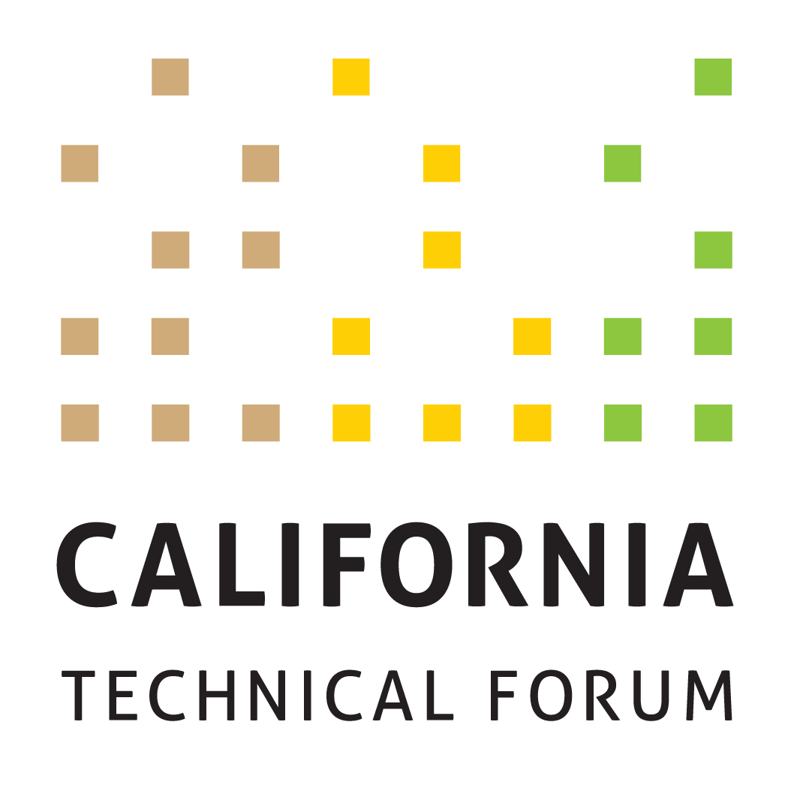

DRAFT v4
Business Plan
2023

To support the growth and success of energy efficiency and integrated demand-side management (IDSM) through a technically rigorous, independent, transparent peer review of California energy efficiency values and other related technical information.

Disclaimer: The Cal TF Policy Advisory Council (PAC) approval of this Business Plan does not constitute endorsement of ensuing technical work products by individual members or organizations.

Metrics | Workplan Required | Tactics (Cal TF Staff) | Benefits | Tactics (Others)
GOAL 1. Administer software development of eTRM v2.x (CORE)
1A. Implement enhancements for eTRM v2.x  - Complete by end of Q4 2023  - All enhancements will be deployed according to eTRM Core Stakeholder needs  - All enhancements will be completed within budget | No | Cal TF Staff will administer the eTRM v2.x software development contract and meet contract deliverables and timelines, including the development of requirements | Regulatory Compliance  Statewide Consistency  Quality Control  eTRM User Experience  Collaboration  Stakeholder Engagement | eTRM Core Stakeholders will designate at least one primary and one backup representative who will participate in eTRM v2.x development as noted below. Representatives (or their designees) will:  - Meetings: Attend version kick-off and weekly meetings.  - Planning: For each enhancement, provide review/comment on Functional Requirements and Testing and Acceptance (T&A) criteria (for both sprint testing and client acceptance testing).  - Sprint Testing/Client Acceptance Testing: During each sprint, comment on wireframes, view user interfaces, and test all features/enhancements developed during the sprint. Document and submit testing results according to established T&A criteria and within project timelines.  - Project Documentation: As requested, review and comment on project documentation.
1B. Update eTRM technical guidance | No | Cal TF Staff will keep current the guidelines on technical considerations for updating and maintaining the eTRM that could include:  - Ensuring eTRM updates do not adversely impact existing systems  - Meeting eTRM performance standards  - Updating software development/release practices | Quality Control  eTRM User Experience | eTRM Core Stakeholders will provide input on the technical guidance document.
1C. Complete eTRM enhancement prioritization in 2023 Q2  1D. Socialize and implement eTRM 2023 Enhancements | No | Cal TF Staff will:  - Track and prioritize reported bugs and work with developer to schedule fixes and associated regression testing, separately or as a part of a scheduled sprint, depending on severity/impact  - Track enhancements proposed by eTRM Core Stakeholders during development of eTRM v2.x  - Solicit and memorialize feedback from users on experience with eTRM v2.x and possible enhancements  - Document unsolicited recommendations for additional features and enhancements received via the eTRM@FutEE.biz account for 2023 | eTRM User Experience  Collaboration  Stakeholder Engagement | eTRM Core Stakeholders and eTRM Users will provide input on enhancements to existing features and possible new features.
GOAL 2. Ongoing Implementation of Current eTRM Version (CORE)
Complete 2023 eTRM training objectives, including:  2A. Conduct up to six (6) webinar trainings for various stakeholder user groups  2B. Conduct post-training survey | No | Cal TF Staff will implement eTRM training through the following activities:  - Coordinate with IOUs, POUs, CPUC, and CEC to determine training needs and timing  - Solicit input on eTRM training needs of 3P implementers/other stakeholders through the eTRM user account email notification feature, Cal TF members, and other venues (such as CEDMC)  - Record trainings to allow on-demand access for new users or as a refresher  Cal TF Staff will provide customer support to eTRM users that could originate through the eTRM@FutEE.biz account, Cal TF, trainings, and other channels.  Cal TF Staff will track Google Analytics monthly to understand and track eTRM usage. | Statewide Consistency  Quality Control  eTRM User Experience | Each eTRM Core Stakeholder organization (defined above) will identify their respective internal users to receive eTRM training and support.  CPUC Staff, CEC Staff and EAR consultants will provide input on the survey feedback they would like from eTRM users.
2C. Governance: Finalize eTRM Governance Plan with eTRM key stakeholders | No | Cal TF Staff will:  - Finalize the eTRM Governance Plan with input from eTRM key stakeholders including CPUC, CEC, IOUs, POUs, and others  - Develop eTRM governance in coordination with CEDARS/CET governance plan | Regulatory Compliance  Statewide Policy  Governance and Oversight | eTRM Core Stakeholders will provide input on the eTRM Governance Plan.  CPUC Staff will collaborate with Cal TF Staff regarding CEDARS and CET governance.  PAC will affirm the final eTRM Governance Plan.
GOAL 3. Manage Existing Measure Updates (CORE)
3A. Track and report metrics for existing measure updates:  - Number of measures updated in the eTRM  - Time (Start to Submission, then Published as Approved) - Time from start of updated measure loaded into eTRM to CPUC submission for each measure developed in eTRM  - Time – (Time spent updating measure – internal and consultant)  - Completeness & Accuracy – Use QC Checklist for measure development to ensure quality updates and to support continuous improvement  - Nature of Updates – for each update, track and report on nature of measure updates | No | Cal TF Staff will:  - Manage the measure update workflow within the eTRM to support updates within the eTRM, while IOUs will perform the majority of measure development within the eTRM  - Conduct training for Measure Developers regarding the measure update process in the eTRM and associated measure requirements  - Update the Statewide Measure Development and Peer Review QA/QC Guidelines to incorporate a summary checklist to facilitate constructive feedback to Measure Developers  - QA/QC final measure updates to ensure conformance to the Statewide Measure Development and Peer Review QA/QC Guidelines and the Style Guide and alignment with CPUC policy and guidance  - Use QA/QC findings to identify corrective actions (e.g., additional training or new enhancements) to support continuous improvement  - Implement the updates for the existing measures to incorporate features from the eTRM v2.x. Updates could include deemed measure property data, load shape input, or measure lifecycle management data  - Begin tracking measure metrics (e.g., time and cost) when automated workflow features are available in the eTRM and if Measure Developers enter time spent accordingly | Statewide Coordination  Statewide Consistency  Quality Control  Cost Savings | Measure Developers and Measure Reviewers (including IOUs, POUs, CPUC consultants, CPUC Staff, and 3Ps) will take the appropriate eTRM measure training.  Measure Developers will review the Statewide Measure Development and QA/QC Guidelines and participate in periodic feedback sessions as part of the continuous improvement process.  Stakeholder input is required to define which updates are needed for existing measures.
3B. Coordinate monthly statewide meetings on new/updated measures for the Statewide Deemed Measure List | No | Cal TF Staff will:  - Circulate the Statewide Deemed Measure List monthly to IOUs and POUs for new measures and measure updates  - Track CPUC measure update requirements such as the DEER resolution and facilitate statewide coordination (including with CPUC) to comply with these guidelines and update schedules  - Conduct monthly teleconferences with designated IOU and POU leads to review planned new measures and planned measure updates to ensure all parties are aware of changes/additions and can ensure measure changes/additions reflect statewide needs  - Post monthly updated Statewide Deemed Measure List to Cal TF website  - Distribute updated Statewide Deemed Measure List to designated IOU lead for submission to EAR Consultants  - Identify ways to integrate the Statewide Deemed Measure List with the eTRM and automate updates  - (Time permitting) Solicit input from Cal TF membership on select updates to existing measures | Statewide Coordination  Statewide Consistency  Transparency | IOU and POU measure development leads will inform their IOU/POU counterparts and Cal TF Staff of new measures and measure updates under consideration, in development, and retired, as well as the status of measures in development.  IOU and POU measure development leads will ensure that new measures are developed to be applicable statewide and will reflect input from their counterparts at other IOUs and POUs.
3C. Develop a Stakeholder Communication Plan and Versioning Rules for Measure Package Updates | Yes | Cal TF Staff will:  - Solicit input from Cal TF stakeholders (IOUs, POUs, CCAs RENs and implementers) on communication needs, including content, format, and timing and to understand goals/challenges with existing update information and notifications  - Identify and/or develop appropriate communication channels and schedule to notify statewide stakeholders of measure additions, updates, and retirements  - Develop versioning rules for consistency in tracking Measure Package updates  - Determine approach to implement proposed versioning and update plan  Update notifications will include effective dates and relative impacts of changes. | Transparency  Stakeholder Engagement  Statewide Policy Consistency | Cal TF stakeholders (including IOUs, POUs, CCAs RENs and implementers) will participate in discussions regarding notification needs and will provide input on the versioning and notification proposal.
GOAL 4. Manage and Implement the Statewide New Measure Development Process (CORE)
4A. Develop and Implement Measure Identification Strategy | Yes | Cal TF Staff will work with stakeholders as a trusted, impartial partner to identify potential new and updated measures, including:  - POUs and CEC to identify measures they would like developed/added to the eTRM so the eTRM contains all POU and CEC measures (market-based, utility-funded, and EPIC projects)  - 3P implementers and innovators/measure developers including proposed measures from ETP and EPIC  - IOUs and CPUC to included additional measures in the eTRM such as:  - Cold water measures  - Low GWP measures  - Fuel substitution measures | Customer Experience  Stakeholder Engagement | Cal TF stakeholders, energy program stakeholders, and other innovators will engage with Cal TF Staff on new measure identification strategies.
4B. Track and report metrics for all measures coming through the Cal TF New Measure Process:  - Number of proposed measures submitted  - Number of proposed measures affirmed by Measure Screening Committee (MSC)  - Number of measures not affirmed by MSC and the reason why; identify alternate path for measure  - Number of proposed measures affirmed by the Cal TF  - Number of proposed measures published in the eTRM  - Time from Measure Initiation to Measure Submission | No | Measure Screening Committee (MSC): Cal TF Staff will manage and lead the MSC to screen all proposed new measures/measure updates as noted below:  - Screen proposal form for completeness  - Document Terms and Conditions  - Track action items  - Maintain transparency of the proposal list  - Memorialize MSC decisions  - Document the recommendations in the form of Measure Package Plan  - Upload “passing” measures into eTRM if draft measure capability is available  For new measure types, Cal TF Staff will document in a White Paper and socialize key issues with MSC, Cal TF Subcommittee, IOU/POU, and CPUC/CEC Staff prior to making a decision.  Procedural, electrification, and GHG and refrigerant reduction measures should be prioritized to evaluate how they can be included in the intake, screening, and review process  Statewide Coordination of Measure Development and QA/QC: Cal TF Staff will:  - Manage the statewide coordination process for all new and updated measures, consistent with the process and guidelines posted on the Cal TF website, which may change from time to time  - QA/QC all measures prior to submission to CPUC and/or publishing in eTRM to ensure measures conform to the statewide measure QA/QC Guidelines and align with CPUC policy/guidance  - Solicit input from Cal TF membership on select new and updated measures | Compliance  Cost Savings  Time Savings  Quality Control  Transparency  Stakeholder Engagement  Statewide Consistency  Standardization  Transparency  Stakeholder Engagement | The Measure Screening Committee members will:  - Review materials in advance of each meeting  - Participate in each monthly meeting  - Follow the established process and protocols  All interested IOUs and POUs and all IOU statewide Measure Leads will participate in the measure development/update oversight process, beginning when each measure is assigned to a Measure Developer (internal or external).  Assigned statewide Measure Leads will submit measures to CPUC/EAR Team for review, in accordance with the measure development schedule provided to the CPUC Staff.  POU staff will support the identification and development of POU measures for the eTRM.  POUs will engage in monthly meetings to share information and collaborate on statewide approaches.
GOAL 5. Develop POU and Statewide Custom Measures
5A. Gather, organize, and prioritize existing custom guidelines, tools, and resources being used by POUs, IOUs, and implementers. | Yes | Cal TF Staff will:  - Compile and organize the guidelines, tools, and resources used by custom program stakeholders  - Identify which materials are used and useful and potentially overlapping  - Compare collected resources to custom program activity, claims, and other data to assess the value of statewide standardization for the POU and IOU custom portfolios  - Develop proposal to improve approach to summarizing and providing clear CPUC guidance on custom projects  - Facilitate stakeholder input (e.g., via Custom Subcommittee) to identify and prioritize custom standardization efforts  - Update list of potential measures that could be uploaded and managed in eTRM | Stakeholder Engagement  Standardization | POUs, IOUs, CPUC, CEC, implementers, and other stakeholders will:  - Provide input on relevant materials useful for standardizing and streamlining custom measures, projects, and programs.  - Provide input to help identify which custom resources are most relevant and valuable for custom program activity and claims potential.  - Provide feedback, via committees, regarding custom standardization and other related custom stakeholder efforts.
5B. Finalize High-Level Custom Roadmap by 2023 Q2 | Yes | Cal TF Staff will:  - Solicit and organize feedback on Cal TF Staff analysis of how existing CalTF frameworks and eTRM tools can be used to standardize and streamline custom projects.  - Prepare high-level draft Cal TF Custom Roadmap  - Prepare final Cal TF Custom Roadmap with input from TF and Custom Subcommittee  - Present final roadmap to PAC | Stakeholder Engagement  Standardization  Cost Savings  Time Savings  Customer Experience | POUs, IOUs, TF members, CPUC, and other stakeholders will provide input throughout the process.
5C. Develop and implement statewide methods for at least three (3) custom measures | Yes | Cal TF Staff will:  - Facilitate the selection of custom measures  - Facilitate the custom measure development process for statewide standard methods  - Present developed methods to the TF members for review and approval/affirmation  - Complete the custom measure template (measure characterization and data) for selected measures | Standardization  Transparency  Cost Savings  Time Savings  Stakeholder Engagement | POUs, IOUs, TF members, CPUC, and other stakeholders will provide input throughout the process.  POUs, IOUs, CPUC, and implementers will provide custom project data to support this goal.  TF members will approve/affirm statewide methods for each selected measure.
5D. Update eTRM documentation (ongoing, as needed) | Yes | Cal TF Staff will update eTRM documentation as needed to include POU and statewide custom measures in the eTRM. Updates may include:  - eTRM Measure Characterization template  - eTRM Measure and Permutation Data Spec templates  - Measure Naming Convention  - Measure Development and QA/QC Guidelines  - eTRM Reference Library  - New Measure Development & Review process  Cal TF Staff will document required eTRM enhancements to develop Custom Measures within the eTRM. | Cost Savings  Time Savings  Customer Experience  Standardization  Transparency  Stakeholder Engagement | POU, IOU, and CPUC custom project staff, will review and comment on Cal TF Staff analysis of how existing eTRM tools can be used to standardize and streamline custom projects.
5E. Implement select POU and statewide tools/calculators in the eTRM | Yes | Cal TF Staff will:  - Work with software developer to determine how custom tools could be moved into eTRM so they can be executed rather than just uploaded as a flat file  - Work with the software developer to implement selected custom solutions | Customer Experience  Cost Savings  Time Savings  Standardization | POUs, IOUs, and TF members, will work with Cal TF Staff to determine which tools/calculators are still “used and useful.”  The CPUC Custom lead and CPUC Group D consultants will provide input and review.  CPUC Staff and Group A consultants will provide input to ensure alignment.  Cal TF members will help to provide the implementer perspective for this process.
GOAL 6. Identify, Analyze, and Recommend Key Emerging Technical and Technical Policy Issues in a Statewide Consistent Way
6A. Develop at least one (1) Technical Position Paper (TPP)  - Draft TPP  - Final TPP | Yes | Cal TF Staff will:  - Solicit topics and priorities from the PAC, TF members, and stakeholders  - Propose and confirm final TPP topic with PAC  - Develop TPP with input from a Cal TF subcommittee | Technical Rigor | The PAC will affirm the selected TPP topic(s).  Cal TF members will provide input and contribute to the TPP via subcommittee process.  Proposed TPP topics will be discussed with regulatory staff (CPUC and CEC).
6B. Develop at least one (1) white paper  - Draft white paper  - Final white paper | No | Cal TF Staff will develop white paper with input from a Cal TF subcommittee.  Topics of interest include:  - Analysis controller integration  - Load shape development and use beyond DEER measures  - Measure lifecycle integration into eTRM (potential and goals, ETP, EM&V, and C&S)  - Integrated data flow for energy efficiency  - Regulatory review for custom measures/projects  - Dual fuel gas and electric measures  Existing white papers that may be expanded include:  - New measure types  - Greenhouse gas calculation approach and data sources; recommendations for eTRM  - Creating tighter linkage between deemed savings and EM&V studies | Technical Rigor  Statewide Consistency  Stakeholder Engagement | The Cal TF members will provide input to select the white paper topic(s).  Cal TF members will provide input and contribute to the white paper via subcommittee process.
6C. Review and update existing Cal TF documentation (TPPs, white papers, templates), as needed. | Yes (for updates) | Cal TF Staff will:  - Review existing TPPs, white papers, and templates to identify needed updates  - Recommend/implement updates  - Summarize updates for Cal TF members | Transparency  Accuracy | Cal TF members will review updated documents.
6D. Provide relevant regulatory updates to support Cal TF membership in staying in compliance with regulatory requirements | No | Cal TF Staff will:  - Work with stakeholders to define the scope, format, and frequency for regulatory updates  - Collect and summarize regulatory information or updates (e.g., guidance, decisions, resolutions) that impact Cal TF processes or work products  - Recommend updates to Cal TF processes or work products to remain in compliance | Time Savings  Statewide Consistency  Accuracy | Cal TF members will provide input on relevant regulatory updates (including guidance, decisions, and resolutions) that may impact existing or proposed measures or otherwise be of interest to Cal TF Stakeholders.
GOAL 7. Manage the Cal TF and Cal TF PAC (CORE)
7A. Conduct at least ten (10) TF meetings (in-person with teleconference options) and regular technical and measure screening meetings | No | Cal TF Staff will:  - Prepare a calendar of TF meetings and locations  - Secure meeting locations and arrange logistics  - Prepare/circulate meeting agendas and materials  - Manage TF meetings  - Post meeting schedule, agendas, and notes on the Cal TF website  - Provide ad hoc updates and information as requested by Cal TF technical members  - Maintain flow of new measures through the New Measure Review Process | Transparency  Stakeholder Engagement  Statewide Consistency | Cal TF members will:  - Review materials in advance of all meetings  - Attend Cal TF meetings
7B. Conduct additional subcommittee meetings | No | Cal TF Staff will:  - Recruit subcommittee members  - Prepare/circulate meeting agendas and materials  - Facilitate subcommittee meetings  - Prepare and track subcommittee action items  - Post meeting materials and resultant work products on the Cal TF website  Continuing subcommittees include New Measure, Deemed Measure Property Data, and Custom. New subcommittee topics may include GHG calculations and data visualization. | Transparency  Stakeholder Engagement  Statewide Consistency | Cal TF members and other interested industry stakeholders/subject matter experts will:  - Participate in subcommittees that align with interests and expertise  - Review materials in advance all subcommittee meetings  - Attend subcommittee meetings
7C. Review and Discuss Cal TF Governance Model, current practice. | No | Cal TF Staff will:  - Solicit input from a broad range of stakeholders including Funders, PAC, TF Members, CPUC and CEC Staff/Commissioners, and 3P implementers  - Facilitate discussions with PAC on current Cal TF governance documents and practice, and how governance has evolved | Transparency  Clear Governance | Cal TF Stakeholders will provide input on governance needs and considerations and will review/comment on proposed governance model.  PAC will affirm the final governance model.
7D. Conduct four (4) PAC meetings (in person with teleconference options); ad hoc meetings as needed | No | Cal TF Staff will:  - Schedule quarterly PAC meetings and ad hoc PAC meetings based on policy needs and activity  - Prepare meeting agendas and materials  - Facilitate PAC meetings  - Prepare and circulate meeting action items  - Provide ad hoc updates and information as requested by PAC members | Statewide Policy Consistency  Oversight and Governance | PAC members will:  - Review materials in advance of all meetings  - Attend PAC meetings
7E. Maintain Cal TF website and update and post all materials | No | Cal TF Staff will maintain current data and information (including Cal TF process documents) on the Cal TF website. | Transparency  Stakeholder Engagement | n/a
GOAL 8. Develop and Manage the Cal TF Roadmap, Business Plan, and Budget (CORE)
8A. Develop 5-year Roadmap that identifies core Cal TF/eTRM activities, new strategic initiatives, and desired success factors. Roadmap will identify coordination needs and leveraging opportunities to achieve desired outcomes.  Update the Roadmap annually in conjunction with the Business Plan update process. | No | Cal TF Staff will:  - Solicit input from Cal TF members and other stakeholders and market actors to prepare a draft 5-year Cal TF Roadmap by end of Q2 2023  - Solicit feedback from Cal TF members and other stakeholders and market actors, and update the Roadmap based on stakeholder feedback  - Submit the final Cal TF Roadmap to the PAC for affirmation by end of Q3 2023  - Solicit input to update the Roadmap during the annual Business Plan review/approval process | Transparency  Stakeholder Engagement  Oversight and Governance | PAC, TF, CPUC Staff, and others will provide input on the 5-year Cal TF Roadmap.  PAC will affirm the Cal TF Roadmap by end of Q3 2023.
8B. Develop and finalize the 2024 Cal TF Business Plan (BP) and budget  - Draft by June 2023  - Final by November 2023 | No | Cal TF Staff will:  - Prepare a Draft 2024 BP in collaboration with Cal TF members by end of Q2 2023  - Solicit comments on the draft 2024 Cal TF BP from PAC and TF members, CPUC and CEC Staff, and other stakeholders  - Submit a final 2024 BP that reflects stakeholder input for PAC affirmation by November 2023  Annual BP development, review, and approval process will include updates to the Cal TF Roadmap.  All PAC members will have equal opportunity to provide input on budget/BP | Transparency  Stakeholder Engagement  Oversight and Governance | PAC, TF, CPUC Staff, and others will provide input on the Draft 2024 Cal TF BP.  PAC will affirm the 2024 BP by end of November 2023.
8C. Develop workplans for non-core projects or initiatives or where required in the Business Plan | No | Cal TF Staff will:  - Prepare workplans for non-core projects/initiatives, incorporating stakeholder input and feedback  - Establish a governance process to approve workplans prior to launching the key activities  Each workplan will include:  - a problem statement  - project goals and objectives  - scope of the initiative  - list of deliverables  - expected benefits to stakeholders  - potential obstacles and preliminary solutions  - proposed schedule and budget  - stakeholders and team members, and effort expected from Cal TF membership | Transparency  Stakeholder Engagement  Oversight and Governance | TF and PAC members will provide input on the workplan governance and approval process.  TF members will provide input on and affirm the workplans.  PAC will affirm workplans if the activity requires adjustments to the approved annual Business Plan or budget.
8D. Provide quarterly status updates to the PAC on business plan and budgets | No | Cal TF Staff will:  - Provide status updates on BP progress and budget for PAC review  - Identify emerging issues or challenges that may require adjustments to the BP, and facilitate discussions as needed | Transparency  Stakeholder Engagement  Oversight and Governance | PAC members will:  - Review quarterly business plan and budget updates  - Provide input as needed to address emerging issues or constraints

When required, Cal TF Staff will develop a more detailed workplan for the Business Plan Metric, including: the content described in Metric 8C. Cal TF Staff should scale the level of detail in the Workplan to the scope.
The “Tactics (Others)” column indicates the requirements and expectations of Cal TF stakeholders to achieve each Business Plan metric. When possible, the referenced Cal TF Stakeholder representative should contribute to the tactic; when necessary, the stakeholder representative may assign a designee for participation and/or input.
eTRM Core Stakeholders include the funding utilities (PG&E, SCE, SDG&E, SCG, and LADWP), regulatory agencies (CPUC and CEC), and the CPUC ex ante review (EAR) consultants.
Cal TF develops Technical Position Papers (TPPs) on topics related to technical policy issues of general interest to Cal TF participants. TPPs lead to project work and hence are approved by the PAC. Examples of TPPs can be found on the Cal TF website (http://www.caltf.org/tools).
Cal TF develops White Papers (WPs), analogous to scoping memos, to define issues that Cal TF members are interested in considering. Examples of Cal TF White Papers can be found on the Cal TF website (http://www.caltf.org/tools).

