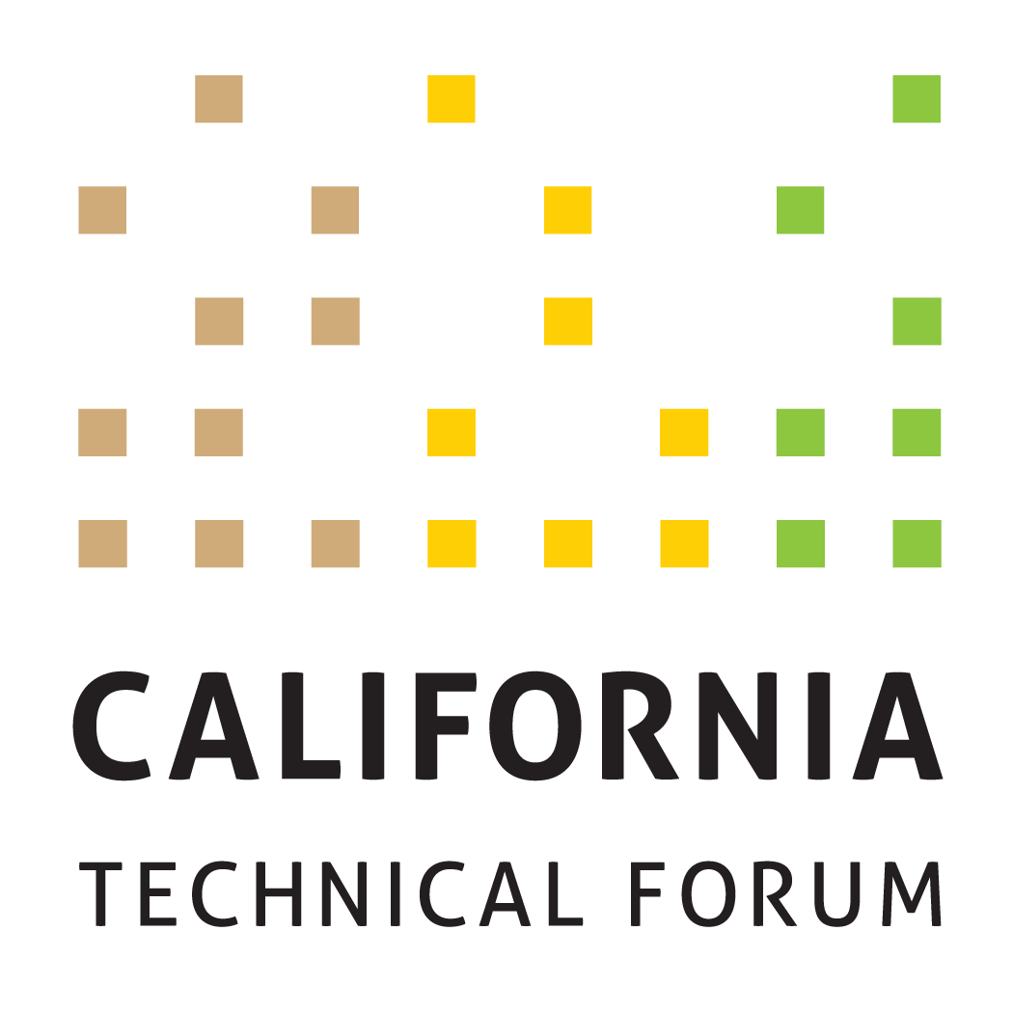

DRAFT v2
Business Plan
2023

To support the growth and success of energy efficiency and integrated demand-side management (IDSM) through a technically rigorous, independent, transparent peer review of California energy efficiency values and other related technical information.

Disclaimer: The Cal TF Policy Advisory Council (PAC) approval of this Business Plan does not constitute endorsement of ensuing technical work products by individual members or organizations.

Metrics | Tactics (Cal TF) | Benefits | Tactics (Others)
GOAL 1. Administer software development of eTRM v2.x
Implement enhancements for eTRM v2.x  - Complete by end of Q4 2023  - All enhancements will be deployed on time, or modified by CPUC Staff as needed  - All enhancements will be completed within budget | Cal TF Staff will administer the eTRM v2.x software development contract and meet contract deliverables and timelines | Regulatory Compliance  Statewide Consistency  Quality Control  eTRM User Experience  Collaboration  Stakeholder Engagement | eTRM Core Stakeholders include the funding utilities (PG&E, SCE, SDG&E, SCG, and LADWP) and regulatory agencies (CPUC and CEC) and the CPUC ex ante review (EAR) consultants. eTRM Core Stakeholders will designate at least one primary and one backup representative who will participate in eTRM v2.x development as noted below. Representatives will:  - Meetings: Attend version kick-off and weekly meetings.  - Planning: For each enhancement, provide review/comment on Functional Requirements and Testing and Acceptance (T&A) criteria (for both sprint testing and client acceptance testing).  - Sprint Testing/Client Acceptance Testing: During each sprint, comment on wireframes, when applicable, view user interfaces, and test all features (enhancements) developed during the sprint. Document and submit results of all testing according to established T & A criteria and within project timelines.  - Project Documentation: As requested, review and comment on project documentation.
Update eTRM technical guidance | Cal TF Staff will keep current the guidelines on technical considerations for updating and maintaining the eTRM that could include:  - eTRM updates do not adversely impact existing systems  - eTRM performance standards  - Software development and release practices | Quality Control  eTRM User Experience | eTRM Core Stakeholders will provide input on the technical guidance document.
Complete eTRM enhancement prioritization in 2023 Q2  Socialize and implement eTRM 2023 Enhancements | Cal TF Staff will:  - Track enhancements proposed by eTRM Core Stakeholders during development of eTRM v2.x.  - Solicit and memorialize feedback from users on experience with eTRM v2.x and possible enhancements.  - Document unsolicited recommendations for additional features and enhancements received via the eTRM@FutEE.biz account for 2023 (Ongoing, via Contact Us feature). | eTRM User Experience  Collaboration  Stakeholder Engagement | eTRM Core Stakeholders and eTRM Users will provide input on enhancements to existing features and possible new features.
GOAL 2. Ongoing Implementation of Current eTRM Version
Complete 2023 eTRM training objectives, including:  - Conduct up to six (6) webinar trainings for various stakeholder user groups  - Conduct post-training survey | Cal TF Staff will implement eTRM training through the following activities:  - Coordinate with the IOUs, POUs, CPUC, and CEC to determine their training needs and timing.  - Solicit input on eTRM training needs of 3P implementers/other stakeholders through the eTRM user account email notification feature, Cal TF members, and other venues (such as CEDMC).  Cal TF Staff will provide customer support to eTRM users that could originate through the eTRM@FutEE.biz account, Cal TF, trainings, and other channels.  Cal TF Staff will track Google Analytics on a monthly basis to understand and track eTRM usage. | Regulatory Compliance  Statewide Consistency  Quality Control  eTRM User Experience | Each eTRM Core Stakeholder organization (defined above) will identify their respective internal users to receive eTRM training and support.  CPUC Staff, CEC Staff and EAR consultants will provide input on the survey feedback they would like from eTRM users.
Governance: Finalize eTRM Governance Plan with eTRM key stakeholders | Cal TF Staff will finalize eTRM Governance Plan with input from eTRM key stakeholders including CPUC, CEC, IOUs, POUs, and others.  Cal TF Staff will develop eTRM governance in coordination with CEDARS/CET governance plan. | Compliance
GOAL 3. Manage Existing Measure Updates
Track and report metrics for existing measure updates:  - Number of measures updated in the eTRM  - Time (Start to Submission, then Published as Approved) - Time from start of updated measure loaded into eTRM to CPUC submission for each measure developed in eTRM  - Time – (Time spent updating measure – internal and consultant)  - Completeness & Accuracy – Use QC Checklist for measure development to ensure quality updates and to support continuous improvement  - Nature of Updates – for each update, track and report on nature of measure updates | Cal TF Staff will manage the measure update workflow within the eTRM to support updates within the eTRM, while IOUs will perform the majority of measure development within the eTRM.  Cal TF Staff will conduct training for measure developers regarding the measure update process in the eTRM and associated measure requirements.  Cal TF Staff will update the Statewide Measure Development and Peer Review QA/QC Guidelines to incorporate a summary checklist to facilitate constructive feedback to measure developers.  Cal TF Staff will QA/QC final measure updates to ensure conformance to the Statewide Measure Development and Peer Review QA/QC Guidelines and the Style Guide.  - Results from QA/QC check will track causes for variation so that corrective actions (i.e., additional training or new enhancements can be identified) to support continuous improvement.  Cal TF Staff will implement the updates for the existing measures to incorporate features from the eTRM v2.x. Updates may not be extended beyond the existing published version of each measure, which could include:  - Deemed measure property data  - Load shape input  - Measure lifecycle management data  Cal TF Staff will begin tracking measure metrics when automated workflow features are available in the eTRM and if measure developers enter time spent accordingly.  - Time and Cost | Statewide Coordination Statewide Consistency  Quality Control  Cost Savings | Measure developers and measure reviewers (including IOUs, POUs, CPUC consultants, CPUC Staff, and 3Ps) will be required to take the appropriate eTRM measure training.  Measure developers will review the Statewide Measure Development and QA/QC Guidelines and will participate in periodic feedback sessions as part of the continuous improvement process.  Stakeholder input required to define which updates are needed for existing measures.
Coordinate monthly statewide meetings on new/updated measures for the Statewide Deemed Measure List | Cal TF Staff will:  - Circulate the Statewide Deemed Measure List monthly to IOUs and POUs for new measures and measure updates.  - Conduct monthly teleconferences with designated IOU and POU leads to review planned new measures and planned measure updates to ensure all parties are aware of changes/additions and can ensure measure changes/additions reflect statewide needs.  - Post monthly updated Statewide Deemed Measure List to Cal TF website.  - Distribute updated Statewide Deemed Measure List to designated IOU lead for submission to EAR Consultants.  - Identify ways to integrate the Statewide Deemed Measure List with the eTRM so Statewide Deemed Measure list can be updated automatically rather than manually.  - Cal TF meeting time available, solicit input from Cal TF membership on select updates to existing measures. | Statewide Coordination Statewide Consistency  Transparency | IOU and POU measure development leads will inform their IOU counterparts and Cal TF Staff of new measures and measure updates under consideration, in development, and retired, as well as the status of measures in development.  IOU and POU measure development leads will ensure that new measures are developed to be applicable statewide and will reflect input from their counterparts at other IOUs and POUs.
GOAL 4. Manage and Implement the Statewide New Measure Development Process
Track and report metrics for all measures coming through the Cal TF New Measure Process  - Number of proposed measures submitted  - Number of proposed measures affirmed by Measure Screening Committee  - Number of measures not affirmed by Measure Screening Committee and the reason why; identify alternate path for measure  - Number of proposed measures affirmed by the Cal TF  - Number of proposed measures published in the eTRM  - Time from Measure Initiation to Measure Submission | Measure Identification: Cal TF Staff will work with various stakeholders as a trusted, impartial partner to identify potential new and updated measures, including:  - POUs and CEC to identify measures they would like developed/added to the eTRM so the eTRM contains all POU and CEC measures (market-based, utility-funded, and EPIC projects).  - 3P implementers and innovators/measure developers including proposed measures from ETP and EPIC.  - IOUs, as they choose.  - CPUC to included additional measures in the eTRM such as:  - Cold water measures  - Low income measures  Measure Screening Committee: Cal TF Staff will manage and lead the statewide Measure Screening Committee to screen all proposed new measures/measure updates:  - Cal TF Staff screens Proposal form for completeness.  - Document Terms and Conditions.  - Track action items.  - Maintain transparency of the proposal list.  - Memorialize Screening Committee decisions.  - Document the recommendations in the form of Measure Package Plan.  - Upload “passing” measures into eTRM if draft measure capability is available.  - For new measure types, document in a White Paper and socialize key issues with Measure Screening Committee, Cal TF Subcommittee, IOU/POU, and CPUC/CEC Staff prior to making a decision.  - Procedural measures should be prioritized to evaluate how they can be included in the intake, screening, and review process  Statewide Coordination of Measure Development and QA/QC: Cal TF Staff will:  - Manage statewide coordination process for all new and updated measures, consistent with the process and guidelines posted on the Cal TF website, which may change from time-to-time.  - QA/QC all measures prior to submission to CPUC and/or publishing in eTRM to ensure measures conform to the statewide measure QA/QC Guidelines.  - Solicit input from Cal TF membership on select new and updated measures. | Compliance  Cost Savings  Time Savings  Quality Control  Transparency  Stakeholder Engagement  Statewide Consistency  Standardization  Transparency  Stakeholder Engagement | The Measure Screening Committee members will:  - Review materials in advance of each Committee meeting  - Participate in each monthly meeting  - Follow the established process and protocols.  All interested IOUs and POUs and all IOU statewide measure Leads will participate in measure development/ update oversight process, beginning when each measure is assigned to a measure developer (internal or external).  Assigned statewide measure Lead will submit measures to CPUC/EAR Team for review, in accordance with the measure development schedule provided to the CPUC Staff.  POU staff will support the identification and development of POU measures for the eTRM.  POUs will engage in monthly meetings to share information and collaborate on statewide approaches.
GOAL 5. Continue Development of POU and statewide Custom Measures
Gather, organize, and prioritize existing custom guidelines, tools, and resources being used by POUs, IOUs, and implementers. | Cal TF Staff will:  - Compile and organize the guidelines, tools, and resources used by custom program stakeholders  - Identify which materials are used and useful and potentially overlapping  - Compare collected resources to custom program activity, claims, and other data to assess the value of statewide standardization for the POU and IOU custom portfolios.  - Work through committee to identify and prioritize custom standardization efforts.  - Update list of potential measures that could be uploaded and managed in eTRM. | Stakeholder Engagement  Standardization | POUs, IOUs, CPUC, CEC, implementers, and other stakeholders will:  - provide input on relevant materials useful for standardizing and streamlining custom measures, projects, and programs.  - provide input to help identify which custom resources are most relevant and valuable for custom program activity and claims potential.
Finalize High-Level Custom Roadmap by 2023 Q2 | Cal TF Staff will:  - Solicit and organize feedback on Cal TF Staff analysis of how existing eTRM tools can be used to standardize and streamline custom projects.  - Prepare high-level draft Cal TF Custom Roadmap  - Prepare final Cal TF Custom Roadmap with input from TF and Custom Subcommittee.  - Present final roadmap to PAC | Stakeholder Engagement Standardization  Cost Savings  Time Savings  Customer Experience | POUs, IOUs, TF members, CPUC, and other stakeholders will provide input throughout the process.
Develop and implement statewide methods for at least three (3) custom measures | Cal TF Staff will:  - Facilitate the selection of custom measures  - Facilitate the custom measure development process for statewide standard methods and clarity, consistency  - Present developed methods to the TF members for review and approval/affirmation  - Complete the custom measure template (measure characterization and data) for newly identified measures. | Standardization  Transparency  Cost Savings  Time Savings  Stakeholder Engagement | POUs, IOUs, TF members, CPUC, and other stakeholders will provide input throughout the process.  POUs, IOUs, CPUC, and implementers will provide custom project data to support this goal.  TF members will approve/affirm statewide methods for each selected measure.
Update eTRM documentation (ongoing, as needed) | Cal TF Staff will update eTRM documentation as needed to include POU and statewide custom measures in the eTRM. Updates may include:  - eTRM Measure Characterization template  - eTRM Measure and Permutation Data Spec templates  - Measure Naming Convention  - Measure Development and QA/QC Guidelines  - eTRM Reference Library  - New Measure Development & Review process  Cal TF Staff will document required eTRM enhancements to develop Custom Measures within the eTRM using. | Cost Savings  Time Savings  Customer Experience  Standardization  Transparency  Stakeholder Engagement | POU, IOU, and CPUC custom project staff, will review and comment on Cal TF Staff analysis of how existing eTRM tools can be used to standardize and streamline custom projects.
Implement select POU and statewide tools/calculators in the eTRM | Cal TF Staff will:  - Work with software developer to determine how custom tools could be moved into eTRM so they can be executed rather than just uploaded as a flat file.  - Work with the software developer to implement selected custom solutions. | Customer Experience  Cost Savings  Time Savings  Standardization | POUs, IOUs, and TF members, will work with Cal TF Staff to determine which are still “used and useful”.  The CPUC Custom lead and CPUC Group D consultants will provide input and review.  CPUC Staff and Group A consultants will provide input to ensure alignment.  Cal TF members will help to provide the implementer perspective for this process.
GOAL 6. Identify, Analyze, and Recommend Key Emerging Technical and Technical Policy Issues in a Statewide Consistent Way
Develop at least one (1) Technical Position Paper (TPP)  - Draft TPP  - Final TPP | Cal TF Staff will:  - Solicit topics and priorities from PAC, TF members, and stakeholders  - Propose and confirm final TPP topic with PAC  - Develop TPP with input from a Cal TF subcommittee. | Technical Rigor | The PAC will affirm the final TPP topic.  Cal TF members will provide input and contribute to the TPP via subcommittee process.  Proposed TPP topics will be discussed with regulatory staff (CPUC and CEC)
Develop at least one (1) white paper  - Draft white paper  - Final white paper | Cal TF Staff will develop white paper with input from a Cal TF subcommittee. Topics of interest are:  - Analysis Controller integration  - Load Shape development and use beyond DEER measures  - Measure lifecycle integration into eTRM (Potential and Goals, ETP, EM&V, and C&S)  - Integrated Data Flow for Energy Efficiency  - Regulatory Review for Custom Measures and Projects  Ongoing white papers from 2019/2020 are:  - New Measure Types  - Greenhouse Gas Calculation Approach and Data Sources; Recommendations for eTRM  - Creating Tighter Linkage Between Deemed Savings and EM&V Studies | Technical Rigor  Statewide Consistency | The Cal TF members will provide input to determine the final white paper topic(s).  Cal TF members will provide input and contribute to the white paper via subcommittee process.
Review and update existing Cal TF documentation (TPPs, white papers, templates), as needed. | Cal TF Staff will:  - Review existing TPPs, white papers, and templates to identify whether any should be updated  - Recommend and implement updates as needed  - Summarize updates for Cal TF members | Transparency  Accuracy | Cal TF members will review updated documents.
Provide quarterly summaries of relevant regulatory updates to support Cal TF membership in staying in compliance with regulatory requirements | Cal TF Staff will:  - Collect relevant regulatory updates or information (e.g., guidance, decisions, resolutions, etc.) that impact Cal TF processes or work products  - Summarize relevant regulatory information on quarterly basis, including recommendations for updates to Cal TF processes or work products to remain in compliance. | Time Savings  Statewide Consistency Accuracy | Cal TF members will provide input on relevant regulatory updates, guidance, decisions, resolutions, that may
GOAL 7. Manage the Cal TF and Cal TF PAC
Conduct at least ten (10) TF meetings (in-person with teleconference options) and regular technical and measure screening meetings | To manage Cal TF Meetings, Cal TF Staff will:  - Prepare a calendar of TF meetings and locations and post on Cal TF website  - Secure meeting locations and arrange other logistics  - Prepare meeting agendas and materials and post on Cal TF website  - Manage TF meetings  - Prepare meeting notes and post on Cal TF website  - Provide ad hoc updates and information as requested by Cal TF technical members  - Add meetings as needed to keep flow of new measures through the New Measure Review Process | Transparency  Stakeholder Engagement  Statewide Consistency | Cal TF members will:  - Review materials in advance of all meetings  - Attend Cal TF meetings
Conduct additional subcommittee meetings | To manage the Cal TF Subcommittees, the Cal TF Staff will:  - Recruit TF subcommittee members and outside experts  - Arrange subcommittee teleconferences  - Prepare meeting agendas (as needed) and circulate meeting materials  - Facilitate Cal TF subcommittee meetings  - Prepare and track subcommittee action items  - Post meeting materials and resultant work products on Cal TF website  2023 Subcommittees continuing from 2022 include:  - Custom Subcommittee  - New Measure Subcommittee  - Deemed Measure Property Data Subcommittee  Additional Topics may include:  - GHG calculations  - Data visualization needs | Transparency  Stakeholder Engagement  Statewide Consistency | Cal TF members and other interested industry stakeholders/subject matter experts will:  - Participate in subcommittees that align with interests and expertise  - Review materials in advance all subcommittee meetings  - Attend subcommittee meetings
Review and Discuss Cal TF Governance Model, current practice. | Cal TF Staff will:  - Facilitate discussions with PAC on current Cal TF governance documents and practice, and how governance has evolved. | Transparency  Clear Governance | Review/comment from a broad range of stakeholders, including: Funders, PAC, Cal TF Members, CPUC and CEC Staff/Commissioners, CA 3P Stakeholders
Conduct four (4) PAC meetings (in person with teleconference options); ad hoc meetings as needed | Cal TF Staff will:  - Schedule quarterly PAC meetings  - Schedule additional ad hoc PAC meetings based on policy needs and activity  - Prepare meeting agendas and materials  - Facilitate PAC meetings  - Prepare and circulate meeting action items  - Provide ad hoc updates and information as requested by PAC members | Statewide Policy Consistency  Oversight and Governance | PAC members will:  - Review materials in advance of all meetings  - Attend PAC meetings
Maintain Cal TF website and update and post all materials | Cal TF Staff will maintain current data and information (including Cal TF process documents) on the Cal TF website. | Transparency  Stakeholder Engagement
GOAL 8. Develop and Manage the Cal TF Roadmap, Business Plan, and Budget
Develop 5-year Roadmap that identifies core Cal TF/eTRM activities, new strategic initiatives, and desired success factors. Roadmap will identify coordination needs and leveraging opportunities to achieve desired outcomes.  Update the Roadmap annually in conjunction with the Business Plan update process. | Cal TF Staff will:  - Prepare a draft 5-year Cal TF Roadmap by end of Q2 2023  - Solicit feedback from Cal TF members and other stakeholders and market actors  - Update the Roadmap based on stakeholder feedback  - Submit the Final Cal TF Roadmap to PAC for review and approval by end of Q3 2023.  - Solicit input and recommend updates to the Roadmap during the annual Business Plan review and approval process. | Transparency  Stakeholder Engagement Oversight and Governance | PAC, TF, CPUC Staff, and others will provide input on the Draft 5-year Cal TF Roadmap.  PAC will affirm the Cal TF Roadmap by end of Q3 2023.
Develop and finalize the 2024 Cal TF Business Plan and budget  - Draft by June 2023  - Final by November 2023 | Cal TF Staff will:  - Prepare a Draft 2024 Business Plan in collaboration with Cal TF members by end of Q3 2023  - Solicit comments on the Draft 2024 Cal TF Business Plan from Cal TF members, PAC members, CPUC Staff, CEC Staff, and other stakeholders.  - Develop a Final 2024 Business Plan that reflects stakeholder input.  - Submit the Final 2024 Business Plan to PAC for review and approval by end of November 2023.  Annual Business Plan development, review, and approval process will include any updates to the Cal TF Roadmap.  All PAC members will have equal opportunity to provide input on budget/BP. | Transparency  Stakeholder Engagement  Oversight and Governance | PAC, TF, CPUC Staff, and others will provide input on the Draft 2024 Cal TF Business Plan.  PAC will affirm the 2024 Business Plan by end of November 2023.
Establish workplans for projects or initiatives approved in the Business Plan | Cal TF Staff will:  - Prepare workplan for projects/initiatives approved in the Business Plan for approval by the Cal TF membership.  - Provide for a governance process to approve project workplans prior to launching the key activities  Workplan will include the following for each project/initiative:  - a problem statement,  - project goals and objectives, scope of the initiative,  - list of deliverables,  - expected benefits to stakeholders,  - potential obstacles and preliminary solutions,  - proposed schedule and budget,  - stakeholders and team members, and effort expected from Cal TF membership. | Transparency  Stakeholder Engagement Oversight and Governance | TF Members will provide input on the workplans.
Provide quarterly status updates to the PAC on business plan and budgets | Cal TF Staff will:  - Provide status updates on business plan progress and budget status for PAC review.  - Identify any emerging issues or challenges that may require adjustments to the annual business plan and facilitate discussions as needed | Transparency  Stakeholder Engagement Oversight and Governance | PAC members will:  - Review quarterly business plan and budget updates  - Provide input as needed to address emerging issues or constraints

