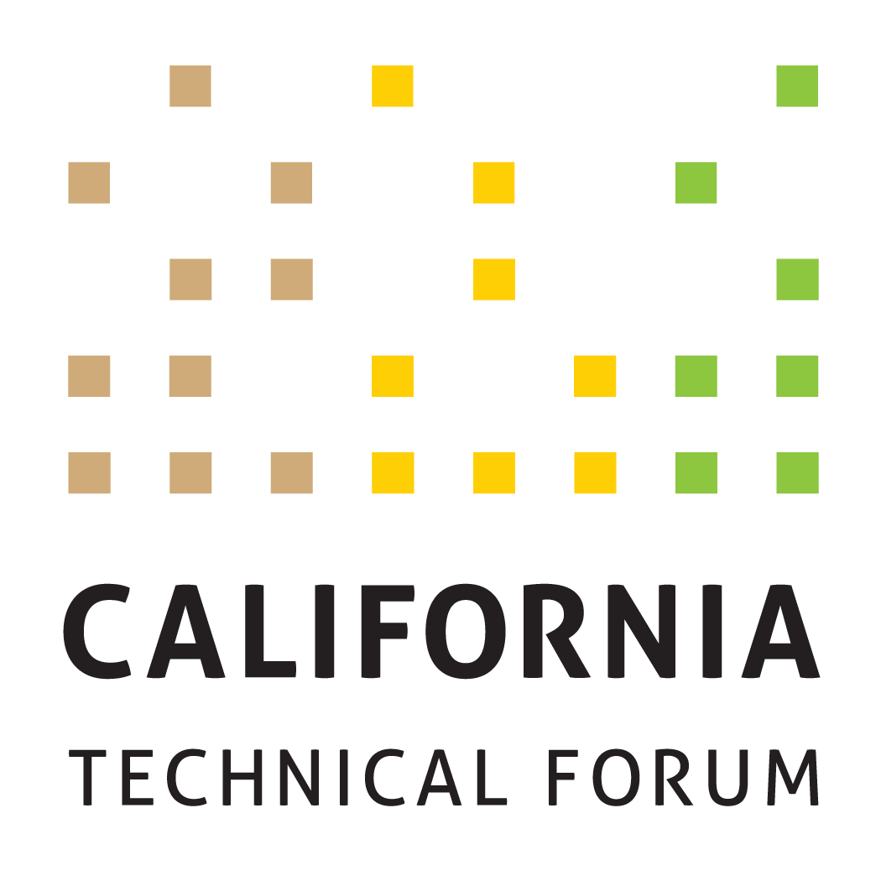

Business Plan
2021

To support the growth and success of energy efficiency and integrated demand-side management (IDSM) through a technically rigorous, independent, transparent peer review of California energy efficiency values and other related technical information.

Disclaimer: The Cal TF Policy Advisory Council (PAC) approval of this Business Plan does not constitute endorsement of ensuing technical work products by individual members or organizations.

Goal | Metrics | Tactics  (Cal TF) | Benefits | Tactics  (Others)
- Administer software development of eTRM ver. 2.0 | Implement enhancements for eTRM v2.0  Complete by end of Q4 2021  - All enhancements will be deployed on time, pursuant to the eTRM Software Development contract schedule, which shall be based on date of contract execution  - All enhancements will be completed within budget | Cal TF Staff will administer the eTRM v2.0 software development contract and meet contract deliverables and timelines for the following task:  - Task 1: Project initiation  - Task 2: Implement Phase 1 and Phase 2 Enhancements  - Task 3: Update eTRM documentation to reflect Phase 1 and Phase 2 Enhancements  - Task 4: Limited Release for Testing and Acceptance Process  - Task 5: Track and report on schedule and budget  - Task 6: Provide eTRM website hosting monitoring and maintenance  - Task 7: Fix “bugs” and/or develop minor features  - Task 8: Refine and provide prices for future enhancements in collaboration with Cal TF Staff and Core Stakeholders | Regulatory Compliance  Statewide Consistency  Quality Control  eTRM User Experience  Collaboration  Stakeholder Engagement | eTRM Core Stakeholders include the funding utilities (PG&E, SCE, SDG&E, SCG, and LADWP) and regulatory agencies (CPUC and CEC) and the CPUC ex ante review (EAR) consultants. Each eTRM Core Stakeholder will:  - Designate at least one primary and one backup representative who will participate in eTRM v2.0 development as noted below.  Representatives of each eTRM Core Stakeholder organization will:  - Meetings: Attend project kick-off and weekly meetings.  - Planning: For each enhancement, provide review/comment on 1. Functional Requirements and 2. Testing and Acceptance (T&A) criteria (for both sprint testing and integration testing).  - Sprint Testing/Integration Testing: During each sprint, comment on wireframes, where applicable, view site interfaces, use and test all features (enhancements) developed during the sprint. Document and submit results of all T & A according to established T & A criteria and within project timelines.  - Project Documentation: As requested, review and comment on project documentation.
 | Identify and socialize eTRM v3.0 (2022) Enhancements in two groups:  - Within one (1) week of eTRM Release. 2.2 sprints completed (expected May 2021)  - Within one (1) week of eTRM Release. 2.3 sprints completed (expected October 2021) | Cal TF Staff will:  - Track enhancements proposed by eTRM Core Stakeholders during development of eTRM ver. 2.0.  - With input from CPUC and CEC staff, solicit input on eTRM usability and training needs by developing and administering an online questionnaire to trainees and all eTRM User accounts and prepare summary memorandum (Q3 2021).  - Solicit and memorialize feedback from users on experience with eTRM ver. 2.x and possible enhancements.  - Document unsolicited recommendations for additional features and enhancements received via the eTRM@FutEE.email account for 2022 (Ongoing, via Contact Us feature). | eTRM User Experience  Collaboration  Stakeholder Engagement | eTRM Core Stakeholders and eTRM Users will provide input on enhancements to existing features and possible new features.
- Ongoing Implementation of Current eTRM Version | Complete 2021 eTRM training objectives, including:  - Conduct up to six (6) webinar trainings for various stakeholder user groups  - Conduct post-training survey | Cal TF Staff will implement eTRM training through the following activities:  - Coordinate with the IOUs, POUs, CPUC, and CEC to determine their training needs and timing.  - Solicit input on eTRM training needs of 3P implementers/other stakeholders through the eTRM user account email notification feature, Cal TF members, and other venues (such as CEDMC).  Cal TF Staff will provide customer support to eTRM users that could originate through the eTRM@FutEE.email account, Cal TF, trainings, and other channels  Cal TF Staff will track Google Analytics on a monthly basis to understand and track eTRM usage. | Regulatory Compliance  Statewide Consistency  Quality Control  eTRM User Experience | Each eTRM Core Stakeholder organization (defined above) will identify their respective internal users to receive eTRM training and support.  CPUC Staff, CEC Staff and EAR consultants will provide input on the survey feedback they would like from eTRM users.
 | Update Transition and Launch Plan per CPUC Resolution E-5082; implement the eTRM Leveraging, Transition and Launch Plan so that eTRM achieves full “Data Source of Record” for statewide deemed measures by CPUC Staff, IOUs, POUs; and IOU ownership portion can be transitioned to CPUC through 2023 DEER Resolution | Cal TF Staff will collaborate with multiple organizations to support development of the Transition, Testing, Acceptance and Use Plans for each organization.  - Q1 and Q2 – plans developed  - Q3 and Q4 – plans implemented  Cal TF Staff will work with the CPUC Staff and Cal TF PAC to identify and implement the regulatory path to eTRM adoption as the “Database of Record” by January 1, 2022. | Cost Savings  eTRM User Experience Transparency  Statewide Consistency | The following organizations will develop transition, testing, acceptance and use plans for the eTRM  - CPUC  - IOUs
 | Governance: Finalize eTRM Governance Plan with Expected eTRM 2022 owners | Cal TF Staff will:  - Finalize eTRM Governance Plan with input from expected 2022 eTRM owners (LADWP, SMUD, CPUC) | Compliance
3. Measure Management: Manage Existing Measure Updates | Track and report metrics for existing measure updates:  - Number of measures updated in the eTRM  - Time (Start to Submission, then Published as Approved) - Time from start of new or updated measure loaded into eTRM to CPUC submission for each measure developed in eTRM  - Time – (Time spent updating measure – internal and consultant)  - Completeness & Accuracy – Use QC Checklist for measure development to ensure quality updates and to support continuous improvement  - Nature of Updates – for each update, track and report on nature of measure updates | Cal TF Staff will manage the measure update workflow within the eTRM before automated enhancements are available, which includes Shared Data support.  Cal TF Staff will conduct training to measure developers regarding the measure update process in the eTRM and associated measure requirements.  Cal TF Staff will update the Statewide Measure Development and Peer Review QA/QC Guidelines to incorporate a summary checklist to facilitate constructive feedback to measure developers.  Cal TF Staff will conduct QA/QC of measure updates and support preparation of measure submission package for updated measures.  Cal TF Staff will QA/QC final measure updates to ensure conformance to the Statewide Measure Development and Peer Review QA/QC Guidelines and the Style Guide.  - Results from QA/QC check will track causes for variation so that corrective actions (ie, additional training or new enhancements can be identified) to support continuous improvement.  - Cal TF Staff will coordinate with the assigned lead IOU to prepare final measure package to submit to CPUC.  Cal TF Staff will implement the updates for the existing measures to incorporate features from the eTRM v2.0 Phase 1 and Phase 2 enhancements.  Cal TF Staff will begin tracking measure metrics when automated workflow features are available in the eTRM.  - Time and Cost | Statewide Coordination Statewide Consistency  Quality Control  Cost Savings | Measure developers and measure reviewers (including IOUs, POUs, CPUC consultants, CPUC Staff, and 3Ps) will be required to take the appropriate eTRM measure training.  Measure developers will review the Statewide Measure Development and QA/QC Guidelines and will participate in periodic feedback sessions as part of the continuous improvement process.  IOUs will need to track their hours and consultant hours; Cal TF will track cost with a blended rate. The measure start would be defined once the decision to create a new measure has been made (ie, a Measure ID created).
 | Coordinate monthly statewide meetings on new/updated measures for the Statewide Deemed Measure List  - Monthly | Cal TF Staff will:  - Circulate the Statewide Deemed Measure List monthly to IOUs and POUs for new measures and measure updates.  - Conduct monthly teleconferences with designated IOU and POU leads to review planned new measures and planned measure updates to ensure all parties are aware of changes/additions and can ensure measure changes/additions reflect statewide needs.  - Post monthly updated Statewide Deemed Measure List to Cal TF website.  - Distribute updated Statewide Deemed Measure List to designated IOU lead for submission to EAR Consultants.  - Identify ways to integrate the Statewide Deemed Measure List with the eTRM so Statewide Deemed Measure list can be updated automatically rather than manually. | Statewide Coordination Statewide Consistency  Transparency | IOU and POU measure development leads will inform their IOU counterparts and Cal TF Staff of new measures and measure updates under consideration, in development, and retired, as well as the status of measures in development.  IOU and POU measure development leads will ensure that new measures are developed to be applicable statewide and will reflect input from their counterparts at other IOUs and POUs.
- Measure Management: Manage and Implement the Ongoing Statewide New Measure Development Process | Track and report metrics for all measures coming through the Cal TF New Measure Process  - Number of proposed measures submitted  - Number of proposed measures affirmed by Measure Screening Committee  - Number of measures not affirmed by Measure Screening Committee and the reason why; identify alternate path for measure  - Number of proposed measures affirmed by the Cal TF  - Number of proposed measures published in the eTRM  - Time – Time from Measure Initiation to Measure Submission | Measure Identification: Cal TF Staff will work with various stakeholders to identify potential new and updated measures, including: (Cal TF Staff will support until funding for Cal TF Implementation runs out.)  - POUs and CEC to identify measures they would like developed/added to the eTRM so the eTRM contains all POU and CEC measures (market-based, utility-funded, and EPIC projects).  - 3P implementers and innovators/measure developers.  - IOUs, as they choose.  Measure Screening Committee: Cal TF Staff will manage and lead the statewide Measure Screening Committee to screen all proposed new measures/measure updates:  - Cal TF Staff screens Proposal form for completeness.  - Memorialize Screening Committee decisions.  - Upload “passing” measures into eTRM. IOU support will be needed to upload measures into the eTRM due to budget constraints.  - For new measure types, document in a White Paper and socialize key issues with Measure Screening Committee, Cal TF Subcommittee, IOU/POU, and CPUC/CEC Staff prior to making a decision. Limit on the number of new measure types must be confined based upon the level of effort for each.  Statewide Coordination of Measure Development and QA/QC: Cal TF Staff will, budget permitting:  - Manage statewide coordination process for all new and updated measures, consistent with the process and guidelines posted on the Cal TF website, which may change from time-to-time.  - Provide QA/QC on all measures prior to submission to CPUC and/or publishing on eTRM to ensure measures conform to eTRM QA/QC Guidelines.  - Solicit input from Cal TF membership on select new and updated measures.  POU TRM Measures; Cal TF Staff will establish a POU Subcommittee for:  - Discussing and socializing characterization details of POU-only measures  - Understanding POU-specific use-cases for the eTRM  - Outreach and education of the value of the eTRM | Compliance  Cost Savings  Time Savings  Quality Control  Transparency  Stakeholder Engagement  Statewide Consistency  Standardization  Transparency  Stakeholder Engagement | The Measure Screening Committee members will:  - Review materials in advance of each Committee meeting  - Participate in each monthly meeting  - Follow the established process and protocols.  All interested IOUs and POUs and all IOU statewide measure Leads will participate in measure development/ update oversight process, beginning when each measure is assigned to a measure developer (internal or external).  Assigned statewide measure Lead will submit measures to CPUC/EAR Team for review, in accordance with the measure development schedule provided to the CPUC Staff.  POU staff will support the identification and development of POU measures for the eTRM.  POUs will engage in monthly meetings to share information and collaborate on statewide approaches.
- Continue Development of POU Custom Measures for the eTRM | Review and document how existing eTRM resources streamline and improve POU custom measure process  - Draft Q1 2021  - Final Q2 2021 | Cal TF Staff review will include changes needed to include POU custom measures in current process. Review will include:  - eTRM Measure Characterization template  - eTRM Measure Data template  - Measure Naming Convention  - QA/QC Guidelines  - eTRM Reference Library  - New Measure Review process  Cal TF Staff will document required eTRM enhancements, if needed, to incorporate POU custom measures and tools in “flat file” format vs. “executable” format needed to implement. | Cost Savings  Time Savings  Customer Experience  Standardization  Transparency  Stakeholder Engagement | POU, and, if interest and engagement, IOU and CPUC custom project staff, will review and comment on Cal TF Staff analysis of how existing eTRM tools can be used to standardize and streamline custom projects.
 | Review POU TRM tools/calculators; identify gaps in eTRM | Cal TF Staff will:  - Work with POUs to identify which tools/calculators not in eTRM but would be “used and useful”.  - Work with software developers to determine how POU “used and useful” tools could be moved into eTRM so they can be executed rather than just flat file. | POU Customer Experience | POUs, through their PAC representatives and TF members, will work with Cal TF Staff to determine which are still “used and useful”
 | Identify and develop POU custom measures (Q4 2021) using the existing eTRM capabilities | Cal TF Staff will:  - Review POU custom projects.  - Develop list of potential measures that could be uploaded and managed in eTRM.  - Complete the custom measure template (measure characterization and data) for newly identified measures.  - Identify types of custom measures/projects that would not be appropriate for the eTRM. | Cost Savings  Time Savings  Customer Experience  Standardization | POUs will provide custom project data to support this goal.  The CPUC Custom lead and CPUC Group D consultants will provide input and review.  CPUC Staff and Group A consultants will provide input to ensure alignment.  Cal TF members will help to provide the implementer perspective for this process.
- Manage the Cal TF and Cal TF PAC | Conduct at least four (4) TF meetings (in-person or teleconference) | To manage Cal TF Meetings, Cal TF Staff will:  - Prepare a calendar of TF meetings and locations, and post on Cal TF website  - Secure meeting locations and arrange other logistics (if meetings are in person; arrange for teleconference if not)  - Prepare meeting agendas and materials and post on Cal TF website  - Manage TF meetings  - Prepare meeting notes and post on Cal TF website  - Add meetings as needed to keep flow of new measures through the New Measure Review Process | Transparency  Stakeholder Engagement  Statewide Consistency | Cal TF members will:  - Review materials in advance all meetings  - Attend Cal TF meetings
 | Conduct additional subcommittee meetings | To manage the Cal TF Subcommittees, the Cal TF Staff will:  - Recruit Cal TF subcommittee members and outside experts  - Arrange subcommittee teleconferences  - Prepare meeting agendas (as needed) and circulate meeting materials  - Facilitate Cal TF subcommittee meetings  - Prepare and track subcommittee action items  - Post meeting materials and resultant work products on Cal TF website | Transparency  Stakeholder Engagement  Statewide Consistency | Cal TF members and other interested industry stakeholders/subject matter experts will:  - Participate in subcommittees that align with interests and expertise  - Review materials in advance all subcommittee meetings  - Attend subcommittee meetings
 | Review and Discuss Cal TF Governance Model, current practice.  - Q1 PAC meetings | Cal TF Staff will:  Facilitate discussions with PAC on current Cal TF governance documents and practice, and how governance has evolved. | Transparency  Clear Governance | Review/comment from a broad range of stakeholders, including:  - Funders  - PAC  - Cal TF Members  - CPUC and CEC Staff/Commissioners  - CA 3P Stakeholders
 | Conduct “Value of Cal TF Survey” | Conduct “Value of Cal TF Survey” to assess what the highest perceived value Cal TF provides from range of stakeholders. | Stakeholder Engagement | Review/comment from a broad range of stakeholders, including:  - Funders  - PAC  - Cal TF Members  - CPUC and CEC Staff/Commissioners  - CA 3P Stakeholders
 | Conduct three (3) PAC meetings (in person or teleconference); ad hoc meetings as needed | To manage the PAC, the Cal TF Staff will:  - Schedule PAC meetings approximately quarterly, based on policy needs and activity  - Prepare meeting agendas and materials  - Facilitate PAC meetings  - Prepare and circulate meeting action items | Statewide Policy Consistency  Oversight and Governance | PAC members will:  - Review materials in advance all meetings  - Attend Cal TF meetings
 | Maintain Cal TF website and update and post all materials | Cal TF Staff will:  - Maintain current data and information (including Cal TF process documents) on the Cal TF website. | Transparency  Stakeholder Engagement
 | Finalize the 2022 Cal TF Business Plan and budget  - Draft by June 2021  - Final by November 15, 2021 | Cal TF Staff will  - Solicit comments on the Draft Final 2022 Cal TF Business Plan from Cal TF members, PAC members, CPUC Staff, CEC Staff, and other stakeholders.  - Develop a Final 2022 Business Plan that reflects stakeholder input.  - Submit the Final 2022 Business Plan to PAC for review and approval no later than the November 2021 PAC meeting.  - All PAC members will have equal opportunity to provide input on budget/BP. | Transparency  Stakeholder Engagement | PAC, TF, CPUC Staff, and others will provide input on the Draft 2022 Cal TF Business Plan.  PAC will affirm the 2022 Business Plan by Nov 15, 2021.

